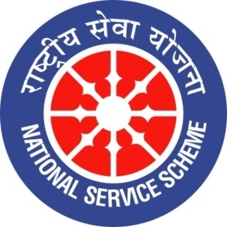


GUJARAT TECHNOLOGY UNIVERSITY
NATIONAL SERVICE SCHEME
SAT KAIVAL COLLEGE OF PHARMACY

A Report on Tree plantation celebration at sat kaival college of pharma

NSS Unit Name/College Name:Tree plantation celebration/sat kaival college of pharmacy
Event NAME: “ Ek ped maa ke naam”
Event Date, Time and Location:29/06/2026 ,10A.M SKCOP,SARSA
Brief Description of the Event: Sat Kaival College of Pharmacy organized a Tree Plantation Programme titled “Ek Ped Maa Ke Naam” on 29th June 2026 with the aim of promoting environmental awareness, greenery, and a sense of responsibility towards nature. The programme encouraged students and staff members to plant and nurture trees as a meaningful tribute to their mothers and as a contribution towards a healthier and greener environment.
The plantation activity was conducted with the active participation of students, faculty members, and college staff under the guidance of the college authorities. Various saplings were planted within and around the college premises. Participants were also encouraged to take responsibility for the proper care and growth of the planted trees.
The event successfully conveyed the message that planting a tree is not only an environmental responsibility but also a symbol of love, gratitude, and respect for our mothers and future generations. The programme created awareness among students about environmental conservation, sustainable development, and the importance of increasing green.
Outcomes of this event:
• Increased Environmental Awareness: Students and staff developed greater awareness about the importance of trees and environmental conservation.
• Promotion of Green Campus: The plantation activity contributed to increasing greenery and improving the natural environment of the college campus.
• Improved Ecological Balance: Trees help in reducing carbon dioxide, releasing oxygen, controlling air pollution, and supporting biodiversity.
• Development of Social Responsibility: Students were encouraged to take responsibility for planting, protecting, and caring for trees.
• Promotion of Sustainable Practices: The programme motivated participants to adopt environmentally friendly and sustainable practices in their daily lives.
• Emotional and Social Connection: “Ek Ped Maa Ke Naam” connected environmental protection with respect, gratitude, and love for mothers.
• Student Participation and Teamwork: The activity encouraged active participation, cooperation, leadership, and teamwork among students and staff.
• Long-Term Environmental Benefit: The planted saplings will contribute to a greener, healthier, and more sustainable environment in the years ahead.
• Community Awareness: The programme inspired participants to spread the message of tree plantation and environmental protection within their families and communities.
• Contribution to Sustainable Development: The event supported the broader goal of creating a clean, green, and environmentally responsible society.
Photograph of event:

