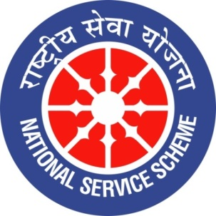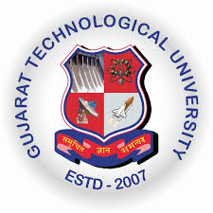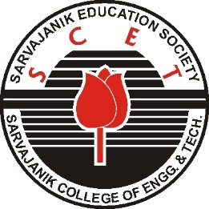
GUJARAT TECHNOLOGY UNIVERSITY
NATIONAL SERVICE SCHEME
Sarvajanik College of Engineering & Technology
A Report on
Interaction Session with “Everest Girls”
on
22nd August 2019 of SCET –NSS

NSS Unit Name/College Name: Sarvajanik College of Engineering & Technology

Event NAME: Interaction Session with “Everest Girls”
Event Date, Time and Location: 22nd August 2019 SCET , 2:30 PM to 4:00 PM

Brief Description of the Event:
Aditi Vaidya and Anuja Vaidya the First Gujarati sisters to scale Mt. Everest and Second sisters in the whole world to do the same were invited at SCET for the for the interactive and inspiring meet. The meet was organised under the banner of NSS on 22nd August 2019 at N J seminar hall.

Aditi Vaidya and Anuja Vaidya planned to climb the top of the world not because the world could see them but because they could see the world.

They described their entire journey by a wonderful audio -video presentation.
It was memorable and exciting experience to go through their journey to scale the Mt. Everest.

Some exciting part of their journey are described here.

Journey to scale Mount Everest

- Preparation:

Before aiming for Mt. Everest, the mountaineering sisters, Anuja Vaidya and Aditi Vaidya have just scaled up Aconcagua in Argentina, the highest mountain in southern and western hemisphere. And their next big mountaineering expedition was the mount Everest which they were planning in the month of April. Aditi and Anuja are also the first sister-duo from Gujarat to complete the expedition to climb the 6,962-metre-high Aconcagua.

After climbing the mount Aconcagua, they had already expressed that their aim is to climb the highest mountain in all seven continents of the world and they had completed the first in South America. They also said that they are confident of scaling the Everest too after good practice in Argentina.

It took them 16 days to climb Aconcagua after battling extreme weather conditions.

Vaidya sisters have been familiar with the mountains since they were toddlers as their mother Anita, a native of Uttarakhand, is a mountaineer herself. She is also the founder member of Bhagirathi Seven Sisters Adventure Foundation, Uttarkashi in association with Bachendri Pal, the first Indian woman to climb Mt Everest.

Before embarking on Aconcagua expedition, they practised by climbing Draupadi Ka Danda II at 5,670 metre height in Uttarakhand. “We practised in Stok Kangri of Ladakh where temperature drops to minus 45 degree in winter before going to Aconcagua expedition. We have been practicing at multiple locations since our childhood to become expert mountaineers,” said Anuja, who completed her BBA recently.

They did various mountaineering courses at Nehru Institute of Mountaineering at Uttarkashi before joining various expeditions. They never worry for the risk involved but practice hard to perform their best in every climb.

“Sometimes the climate and climbing conditions are so harsh that one would desperately want to cut it short and return home immediately. But we can’t resist stop going to mountains at intervals of every few weeks. We would love to explore the field of mountaineering which is not so popular in Gujarat,” said Aditi.

- Expedition to the Mount Everest

The journey towards Everest started on 3rd April. It was a 12 day walk to basecamp. A peak called Lobouche (6119 mts) was climbed before we reached Everest Basecamp as a pre-Everest peak. We reached the basecamp on 15th April. After that, started our journey of rotations; which means walking high and sleeping low. We started for the summit push on 17th May. We spent one night on camp1, second on camp 2, third camp 3, fourth camp 4 and then the fifth day (21st May) in the evening at 5:30 we left for summit. We were standing on the summit at 5:30 a.m on 22nd May 2019. Then began the return journey. We reached back on the camp 4 at 5 in the evening. It was a 24 hour day for us. The temperature was almost — (minus) 50 degree Celsius. We had bad weather days and good weather days. The bad weather days had winds up to 100-170 km/hr. But we came back safely and without injuries. We returned back to base camp on the 24th and then were in Kathmandu on 25th.

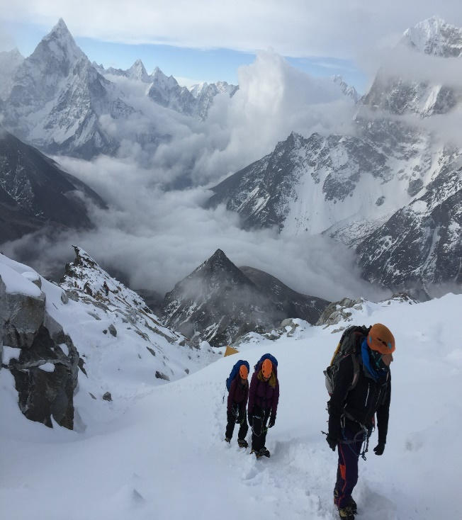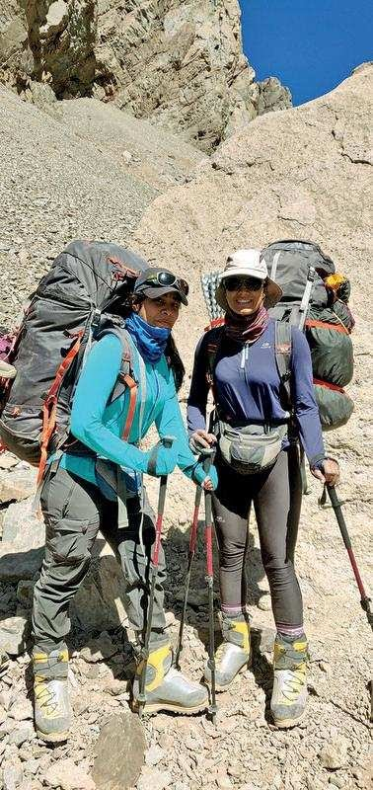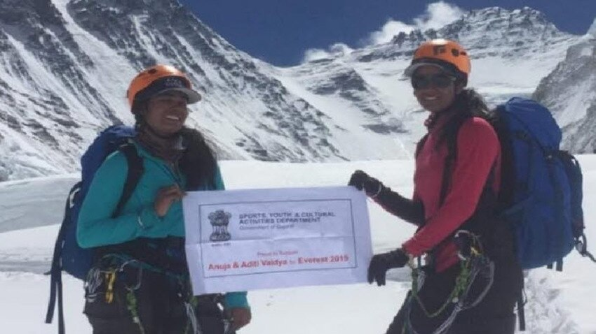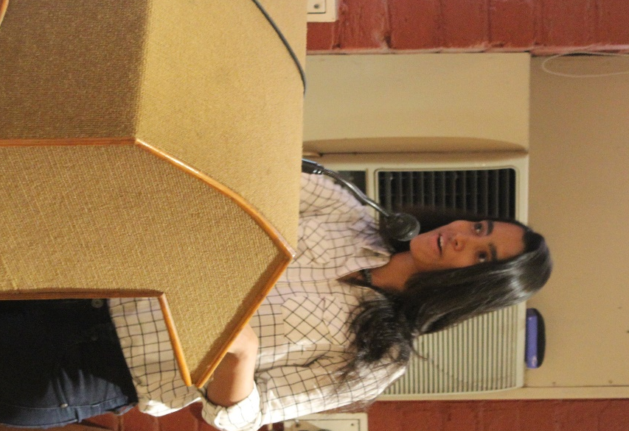
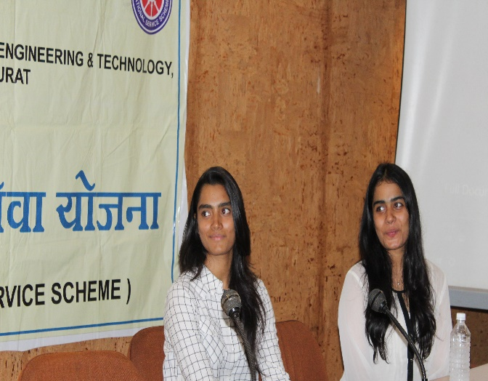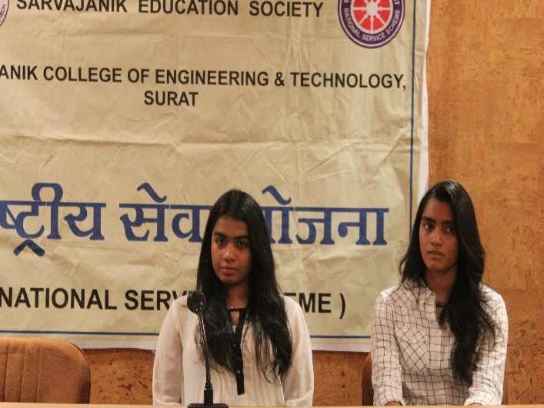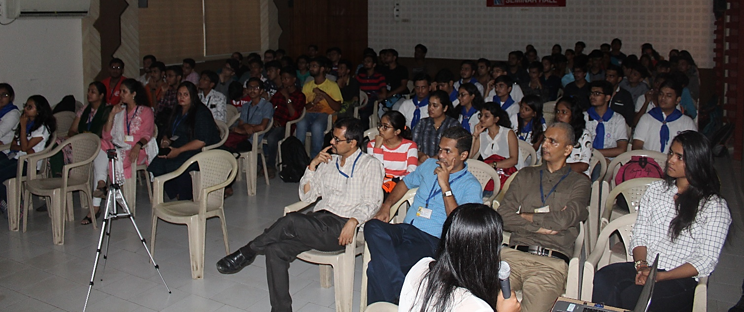

Photograph of NSS Team with “Everest Girls”

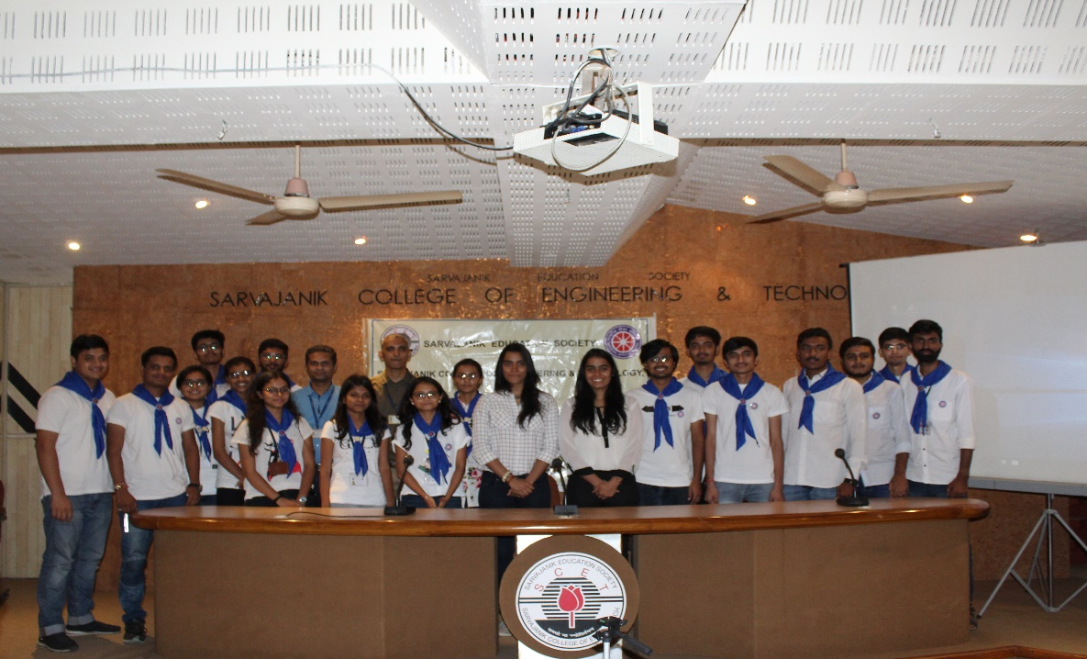
Acknowledgement

We extend our sincere thanks to our principal, Dr. Hiren Patel for his constant support and motivation in facilitating such activities.

We are very much thankful to managing trustees and office bearers of the Sarvajanik Education Society for their support.

We thank one and all for their direct or indirect support.

Prof Niket Shastri Prof Keyur Rana

NSS Program Officer DEAN,SAWC

SCET SCET

