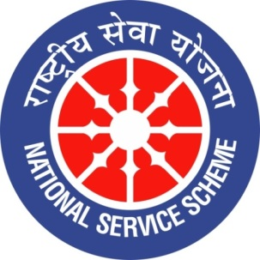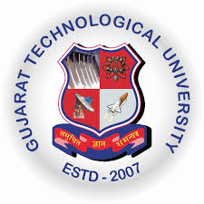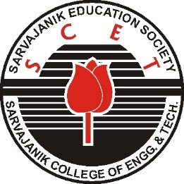
GUJARAT TECHNOLOGY UNIVERSITY
NATIONAL SERVICE SCHEME
Sarvajanik College of Engineering & Technology
A Report on

Fit India Movement
on
29th August 2019

NSS Unit Name/College Name: Sarvajanik College of Engineering & Technology

Event NAME: Fit India Movement
Event Date, Time and Location: 29th August 2019 [SCET

A Report on Fit India Movement

Fit India Movement is a nation-wide movement to encourage people to remain healthy and fit by including physical activities and sports in their daily lives. “Fit India Movement” initiated by Ministry of Youth Affairs and Sports to celebrate National sports Day. It was launched by our honorable Prime Minister Shri. Narendra Modi at Indira Gandhi Stadium in New Delhi on 29 August 2019.

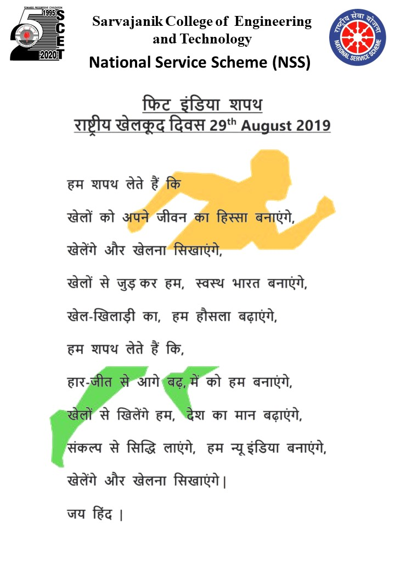
We celebrated the National Sports day
by taking the pledge to be fit and
make the India fit.
With the great support of HODs and
faculty members, students of all the
departments had enthusiastically
taken the pledge. Faculty members
also committed to be fit by signing on
the pledge.

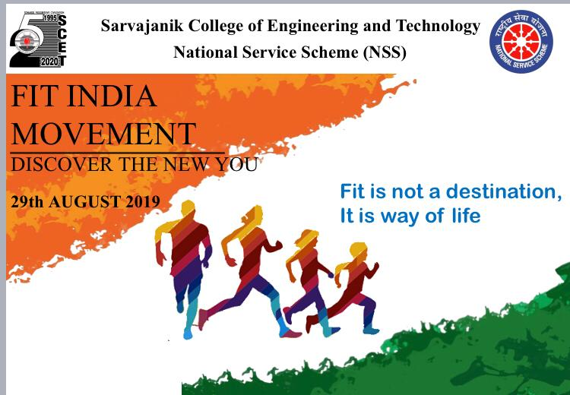

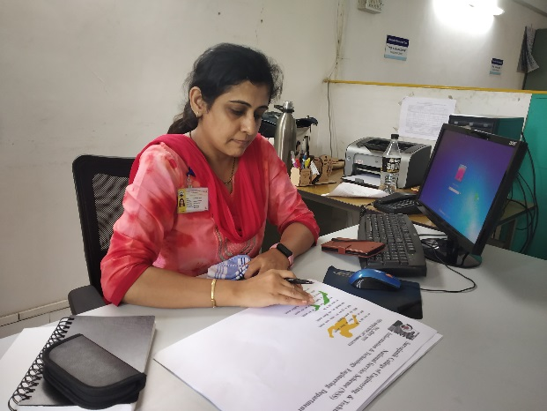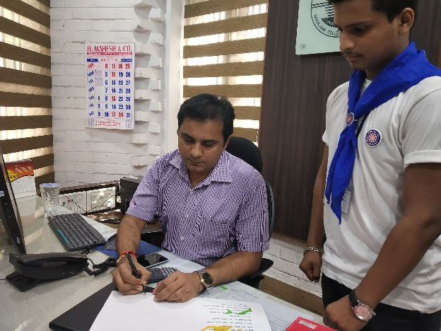

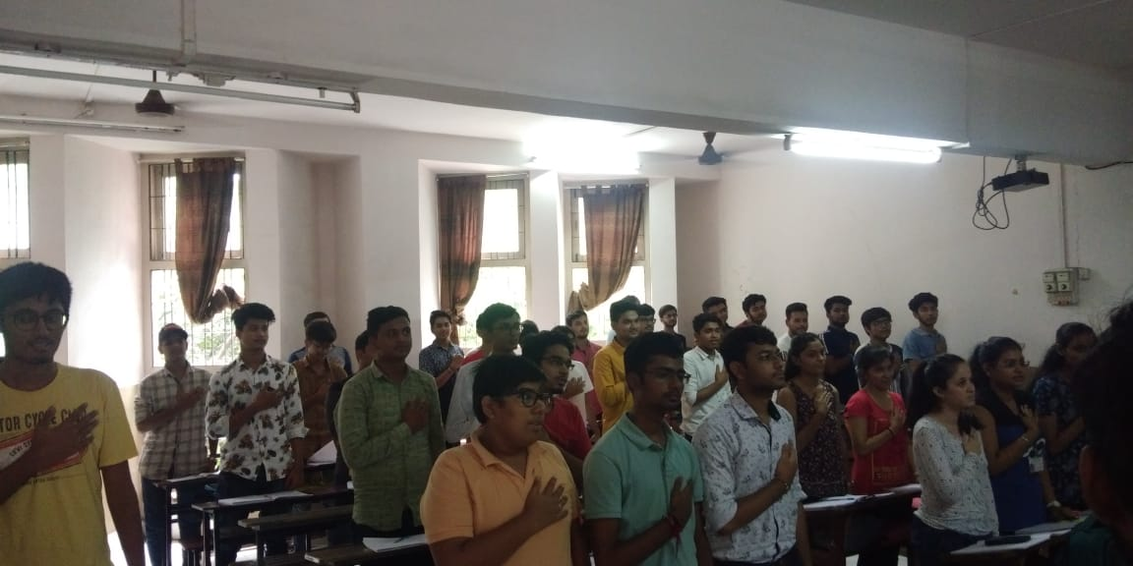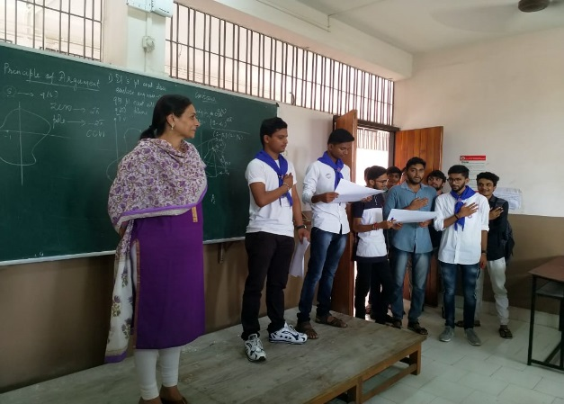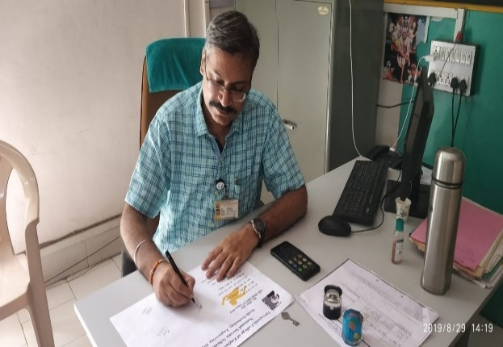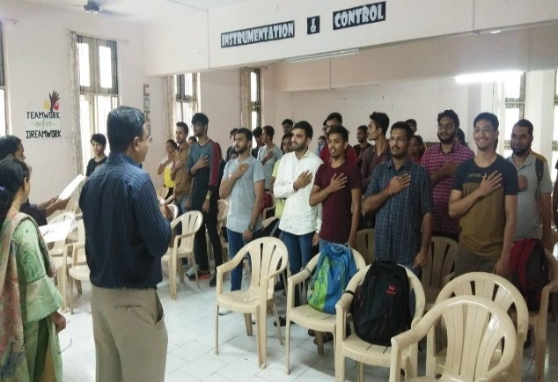

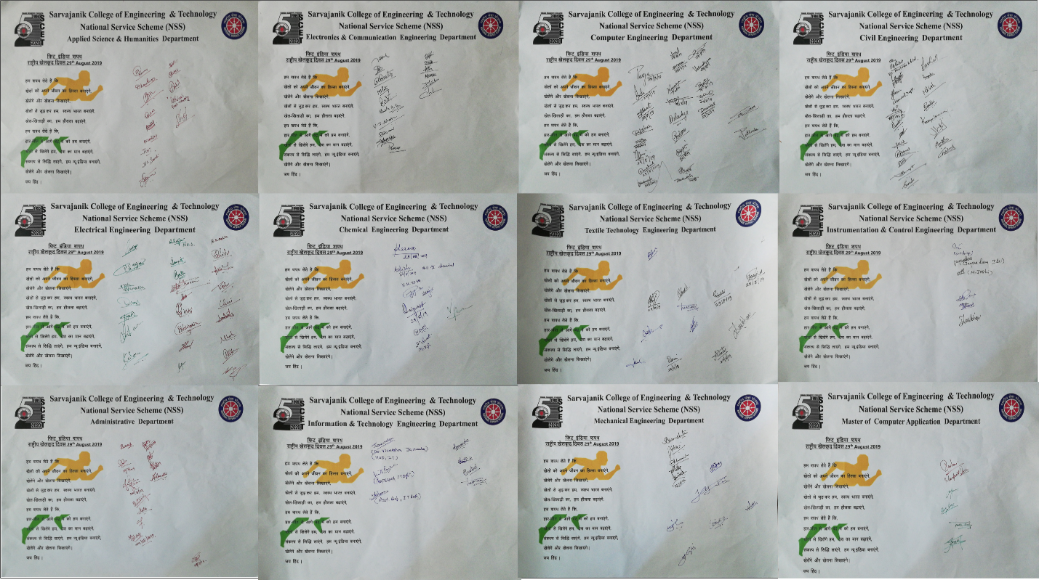

Acknowledgement

We extend our sincere thanks to our principal, Dr. Hiren Patel for his constant support and motivation in facilitating such activities.
We are very much thankful to managing trustees and office bearers of the Sarvajanik Education Society for their support.
We thank one and all for their direct or indirect support.

Prof. Niket Shastri Prof. (Dr.) Keyur Rana
NSS Program Officer DEAN, SAWC
SCET SCET

