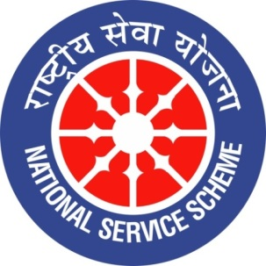 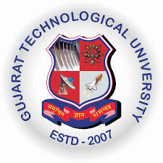 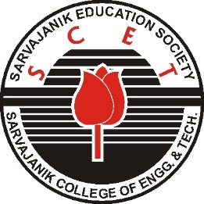

**GUJARAT TECHNOLOGY UNIVERSITY**

**NATIONAL SERVICE SCHEME**

**Sarvajanik College of Engineering & Technology**

**A Report on**

**Master trainer Training on “Digital Literacy ”**

**on**

**31st August 2019**

**NSS Unit Name/College Name: Sarvajanik College of Engineering & Technology**

**Event NAME: Master trainer Training on “Digital Literacy ”**

**Event Date, Time and Location:**  31st August 2019  **[10:00am to 3:00 pm ] SCET**

**Brief Description of the Event:**

**Digital literacy** refers to an individual's ability to find, evaluate, and compose clear information through writing and other mediums on various **digital** platforms. **Digital literacy** is one component of being a **digital** citizen - a person who is responsible for how they utilize technology to interact with the world around them. **Digital** technology allows people to interact and communicate with family and friends on a regular basis due to the "busy constraints" of today's world.

SCET NSS organized the Master trainer training on “Digital Literacy” on **31st August 2019**  in association with the **Leaning Link foundation and Vodafone India foundation.** It is AICTE initiative to create awareness of digital literacy in community. (Letter from AICTE No : 4-4/D-SDC/LLF/2018 dated :June 27 2019) **.** The objective of the training was to empower students as trainer to create awareness of Digital literacy (Financial) in the community. In First phase students learnt various concepts of Digital Literacy during the full day training. The content are described in the table below. Total 65 students enthusiastically attended the training. In next phase each student will educate 15-20 people in nearby community.





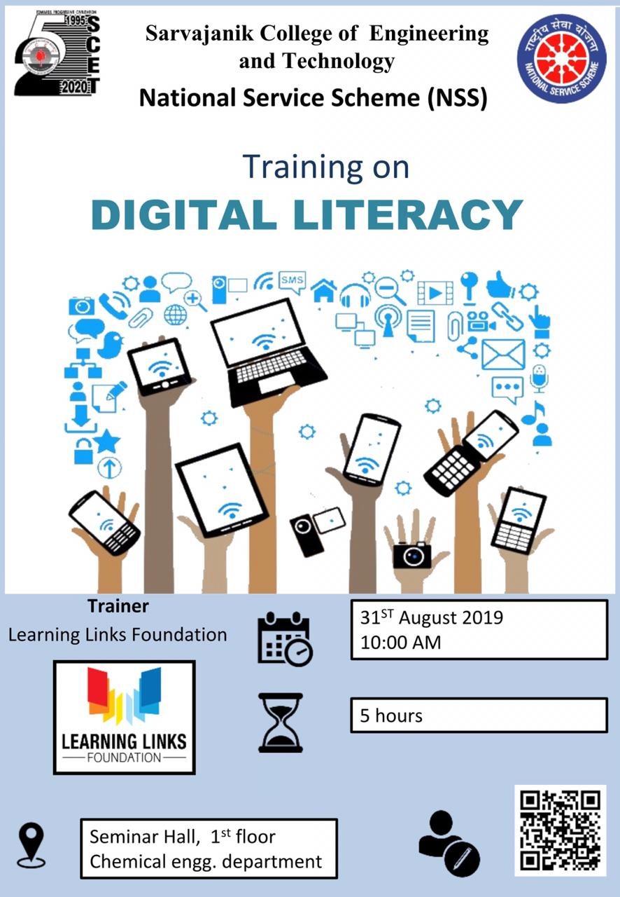

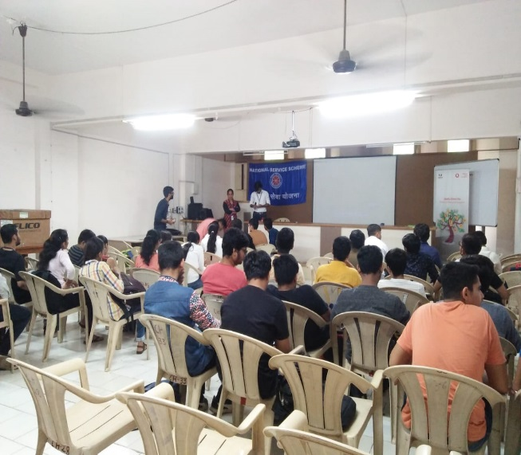 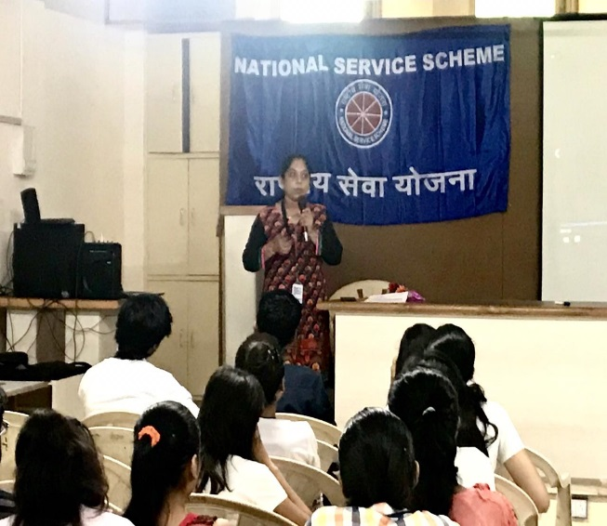

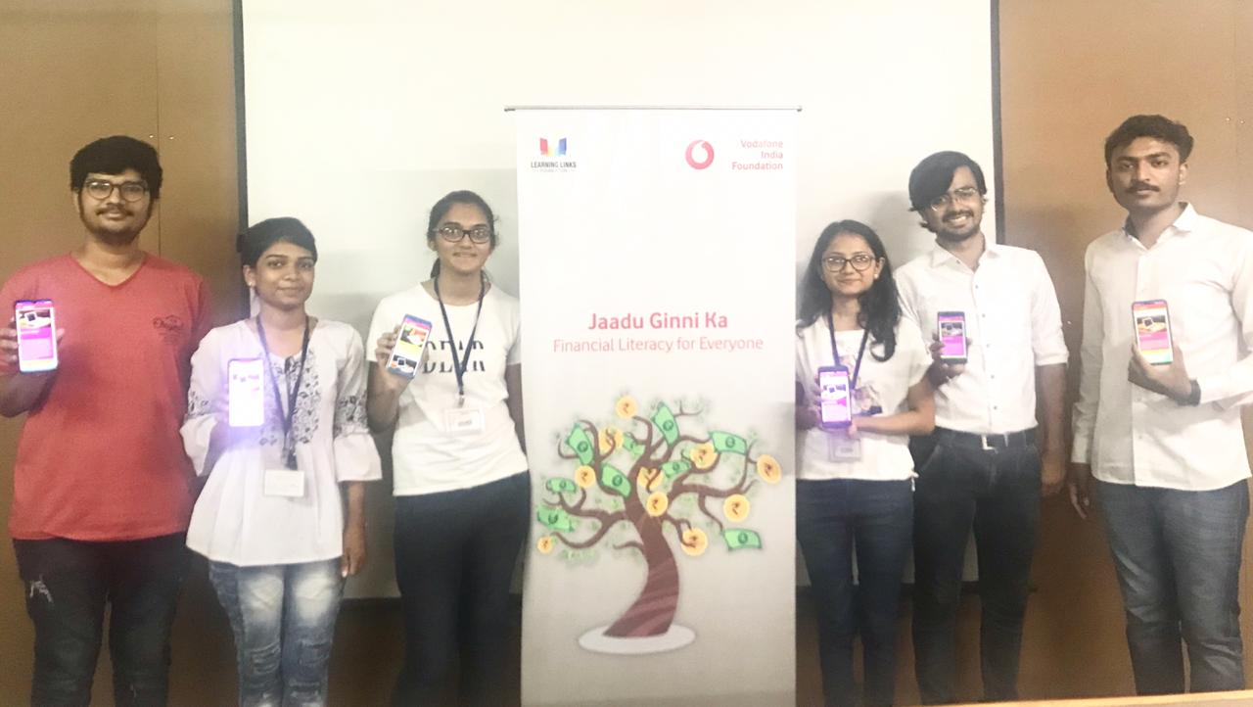 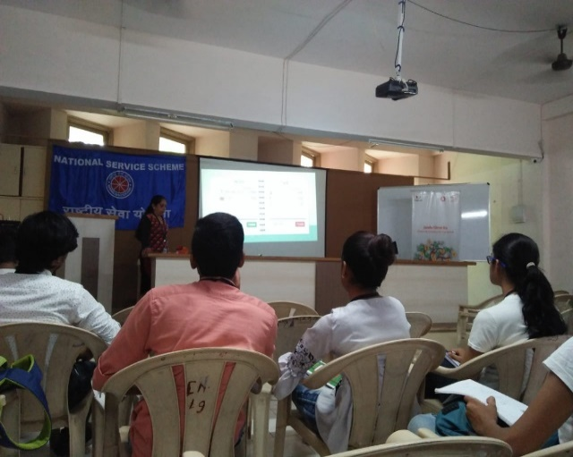

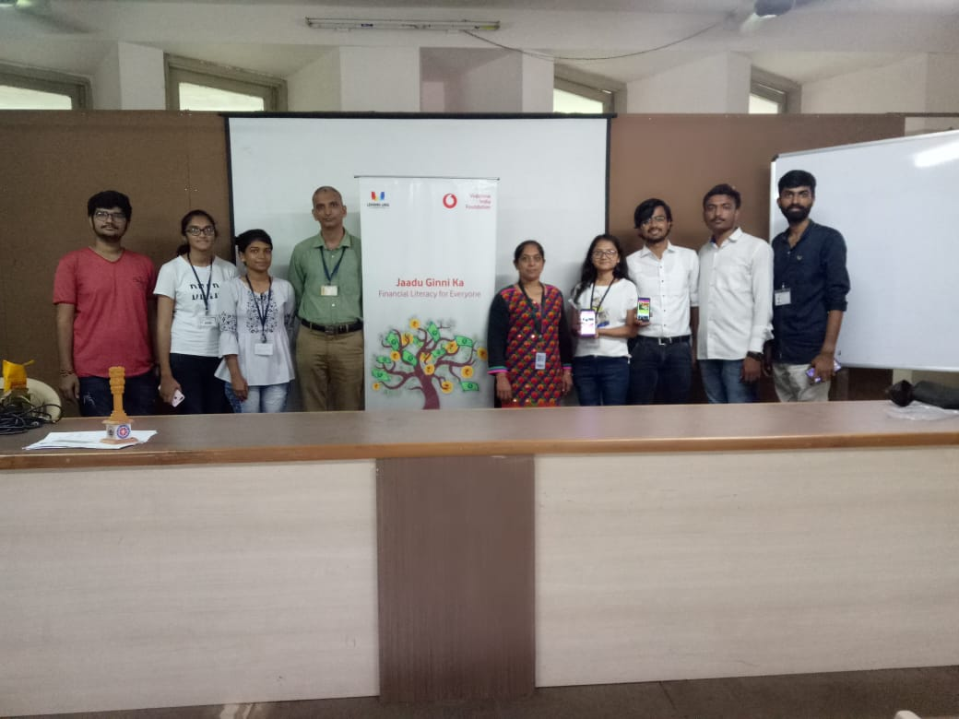

NSS TEAM

**Acknowledgement**

We extend our sincere thanks to our principal, Dr. Hiren Patel for his constant support and motivation in facilitating such activities. We are very much thankful to managing trustees and office bearers of the Sarvajanik Education Society for their support.

We thank one and all for their direct or indirect support.

**Prof Niket Shastri Dr. Keyur Rana**

**Program Officer , NSS DEAN , SAWC**

**SCET SCET**