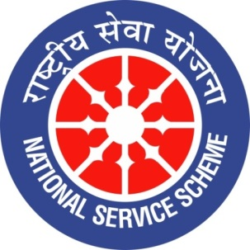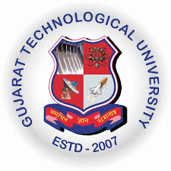
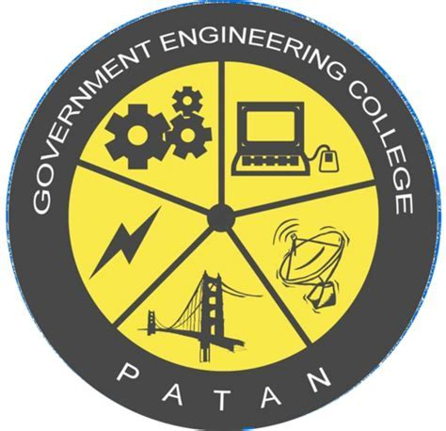
GUJARAT TECHNOLOGY UNIVERSITY
NATIONAL SERVICE SCHEME
GOVERNMENT ENGINEERING COLLEGE PATAN
A Report on nss state day selection on 24th September 2019 of NSS GEC,PATAN

NSS Unit Name/College Name: Government Engineering College, Patan
Event name:nss state day selection
Event Date, Time and Location: 13 th September 2019 ,8:00 a.m., at gtu campus
Brief Description of the Event:
24th September ,1969
NSS DAY
Nss was formally launched on 24th September,1969,the birth centenary year of mahatma Gandhiji ,the father of nation .Therefore ,24th September is celebrated every year as Nss day with appropriate programmes and activities.
Nss aims at arousing social consciousness of the youth with an overall objective of personality development through community sevice. Nss enables students to participate in various programmes of social service and national development, and to help the community.
On 13th September , Friday. All gtu included college's volunteers were called for selection of state NSS day activities. 20 different competition were organization in state NSS day celebration.
Many of the volunteers from our college participated in the selection of state NSS day so that the selection of which 11 volunteers were selected in garba and folkdance compitition.
On 15th September, Monday . All the volunteers of different colleges who selected

for state NSS day were called at gtu campus for one week practice . All girls had to stay in the gtu staff quarters and all boys had to stay in the boy's hostel. Choreographers were hired to teach us dance and garba . We all worked very hard during practice week
Finally, on the morning of 22nd September . We were taken as a team gtu from gtu campus to anual vallabh Vidhyanagar by bus. Then after the identity process is completed, we all took breakfast. Then we gethered at welcome function .they were many volunteers from different colleges . Our minister of education shree Bhupendrasinh Chudasama was a chief guest . Some professors and managing director gave speeches . Then shree Bhupendrasinh Chudasama gave a wonderful speech and motivated us . Then all the compitaters of our team reached their place of competition was at 5pm so we went to see other competitions. We learned a lot from different competition. Then at 5 pm out compitition was stated our dance performance were third . After the competition we took dinner and then we all left the place to stay . Then On 23rd September in the morning we had breakfast then we all went for our compititions . Even that day, our compititions was at 5 o'clock . We had performance our garba. After all the competition complited . We had dinner then we all left the place to stay.
Finally, on 24th September, NSS day we gethered at vallabh Vidhyanagar and then we did a rally from around the vallabh Vidhyanagar our slogans were like this..." NSS....NSS...we are success " " aage dekho NSS... Piche dekho NSS.... Sab jagah dekho NSS " etc.. after rally , there was a prize distribution ceremony, we were very excited for results the cheif guest gave speech and there professors and managing director shared their experience with us . Then the results were declared one by one of all the competitions.
Our team gtu won the 10 trophies in essay writing , slogan making , folk dance , poster making , short story , short movie , photography , traditional costume , power point presentation , quize competition .then we had lunch and we went back to gtu campus.

Major Outcomes of Event :
From this event we learned a lot . We met people of different cities and most important thing we learned from this event was team work and unity.

Photographs of the Event:

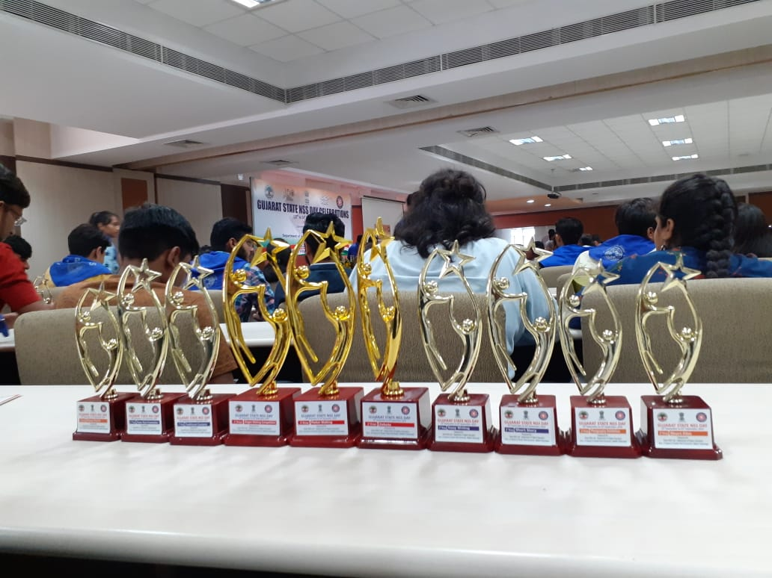
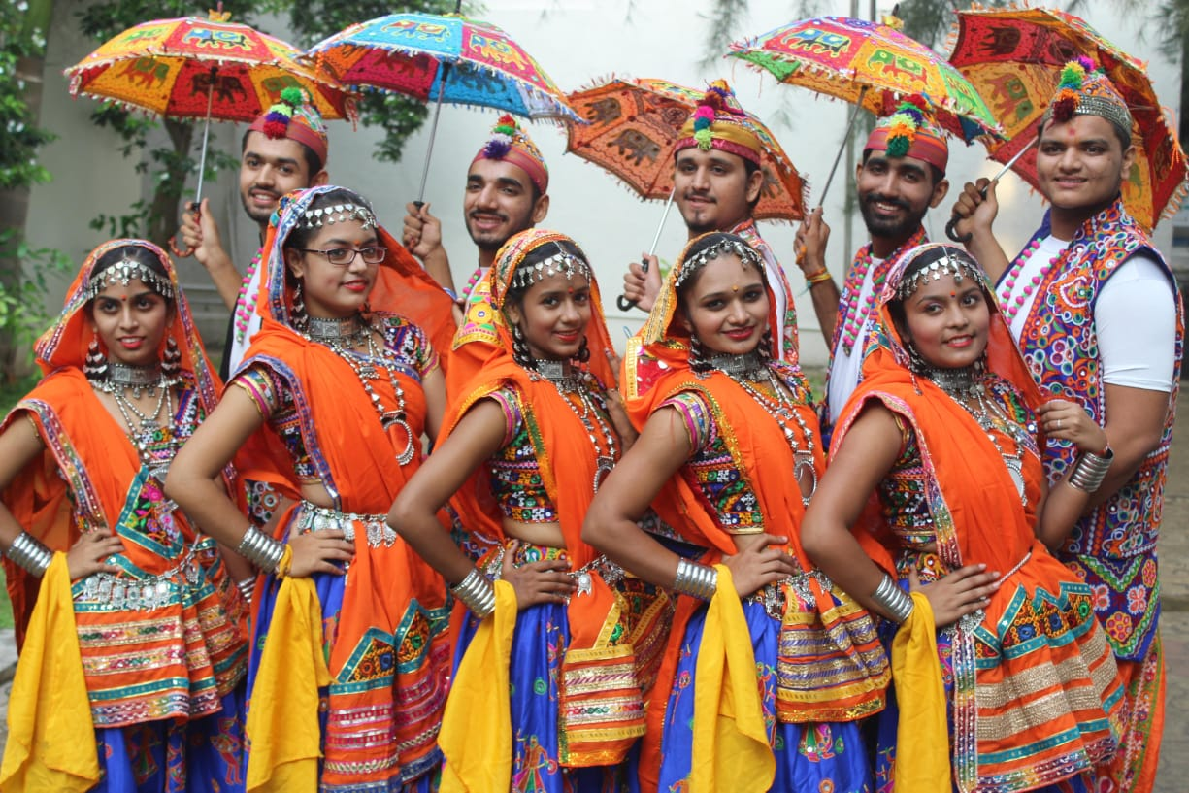
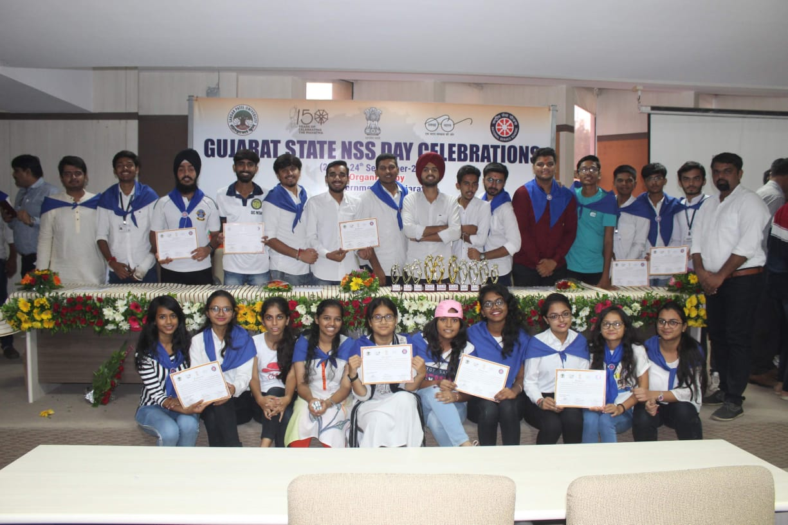
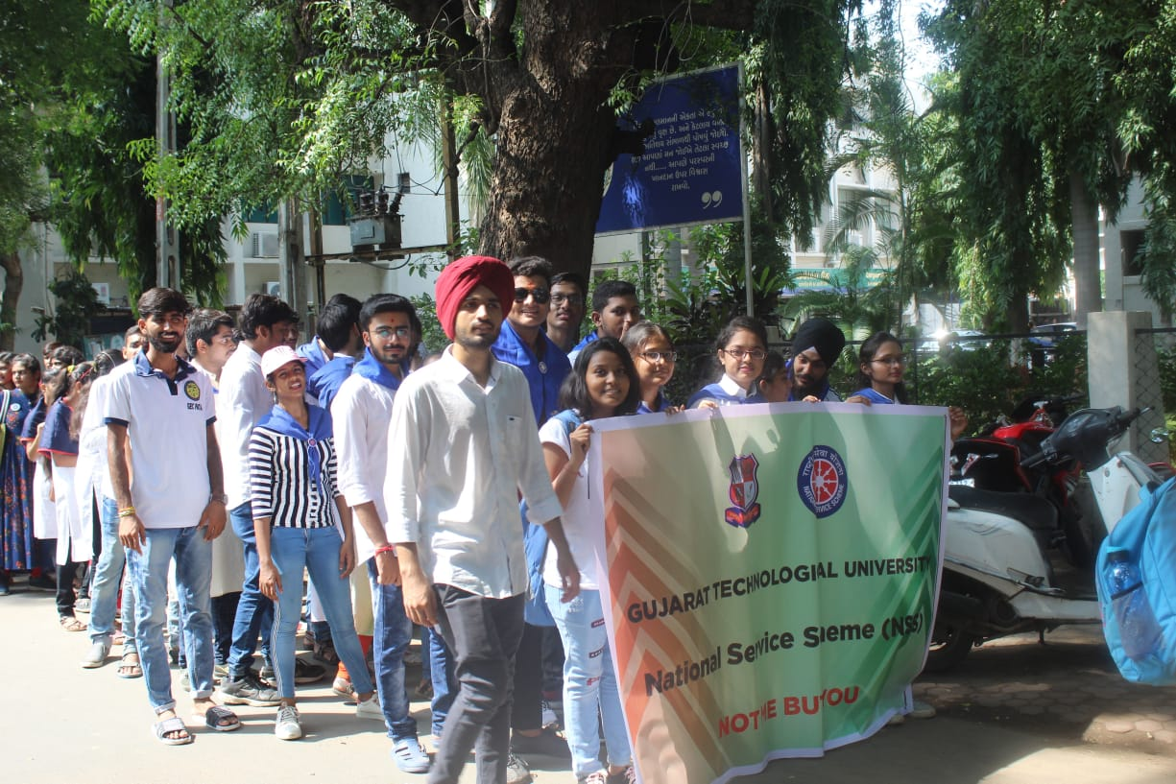
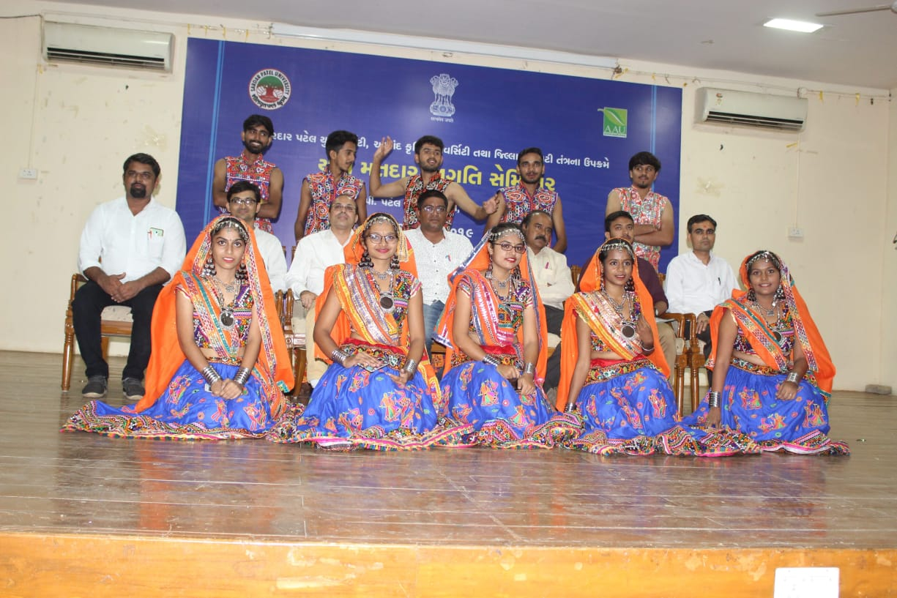

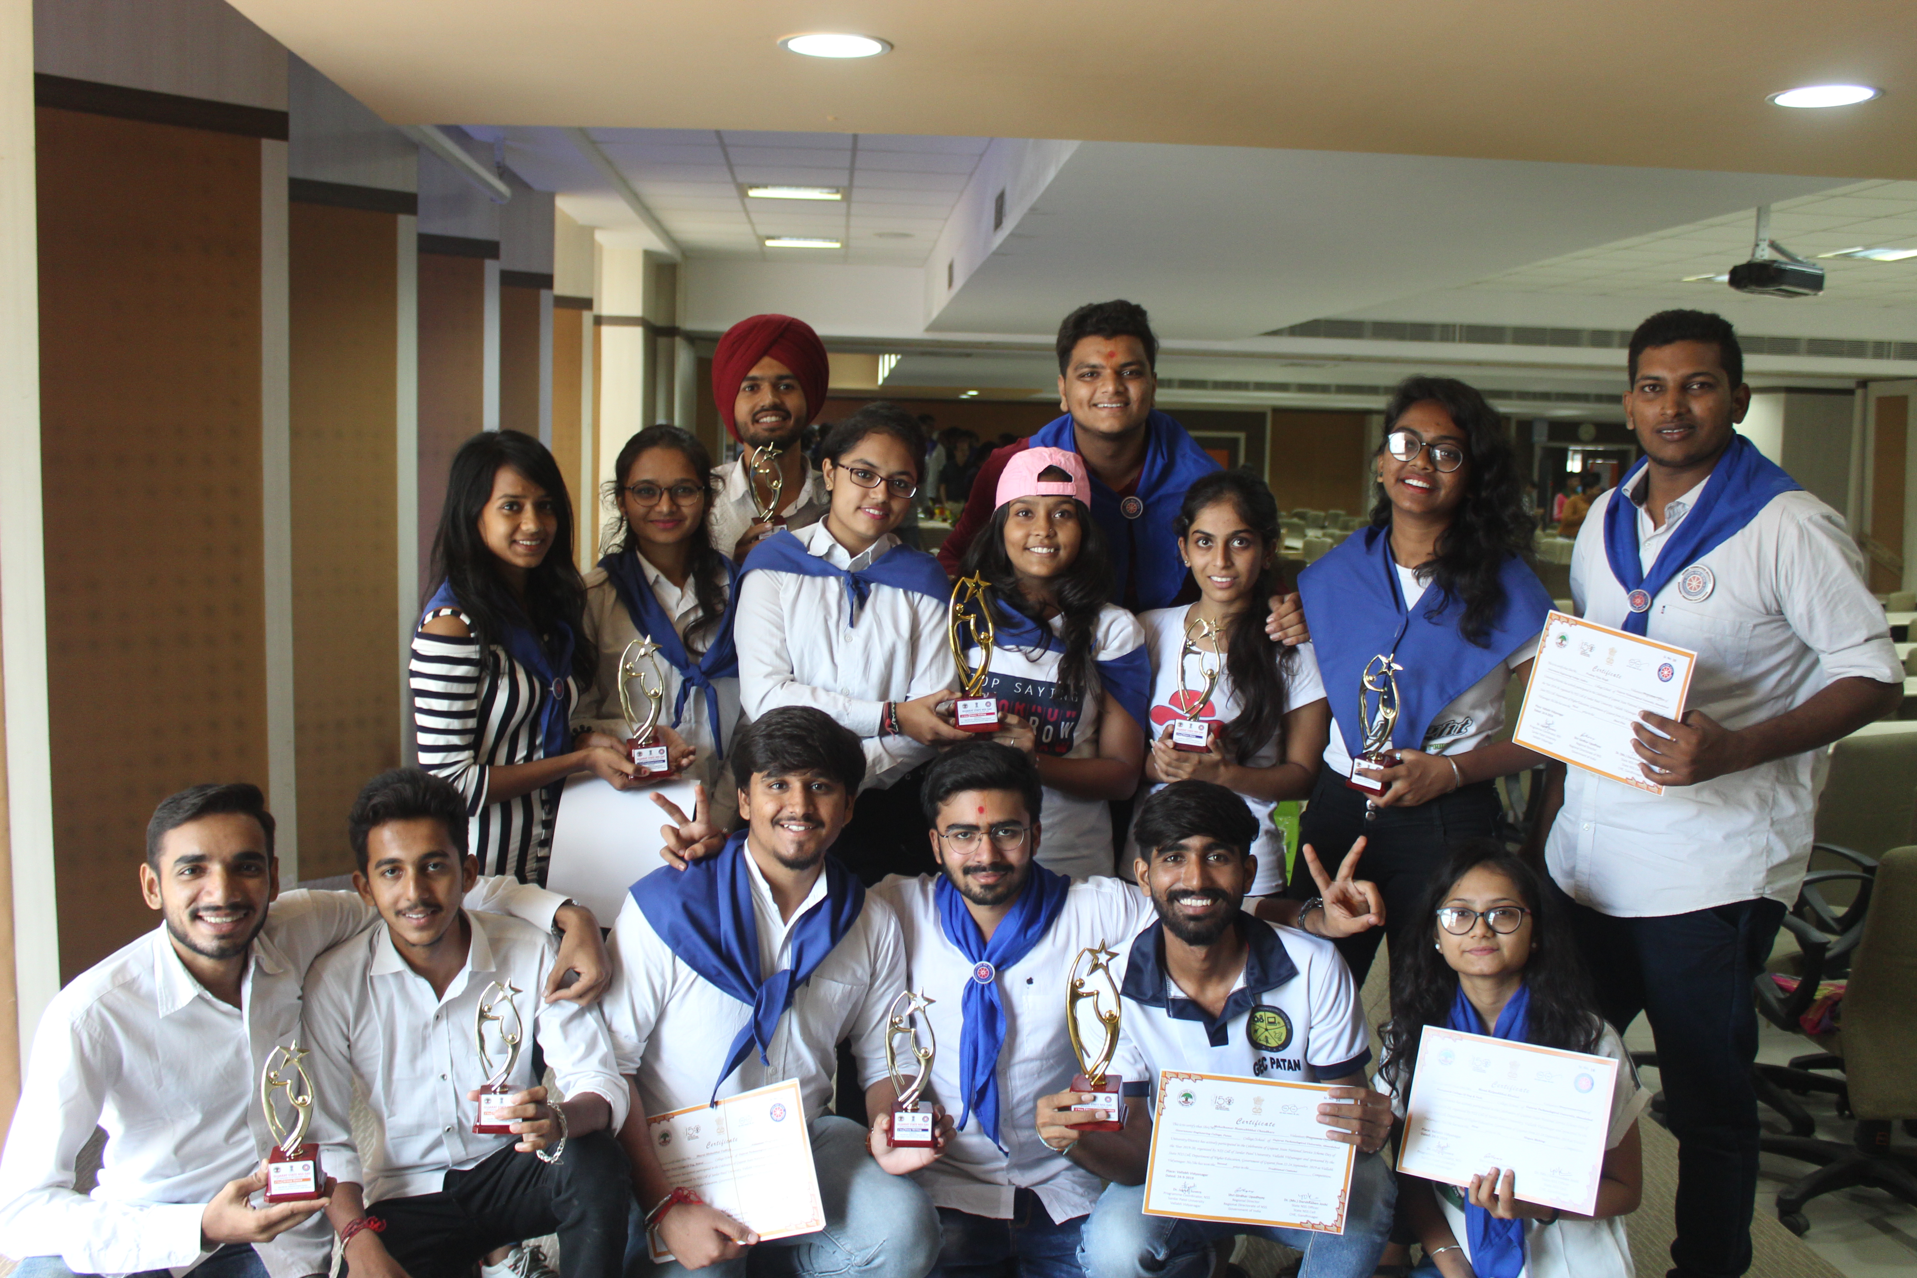

Written by-
Akanksha Shroff
Janki Prajapati

