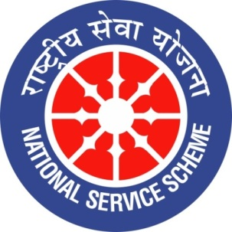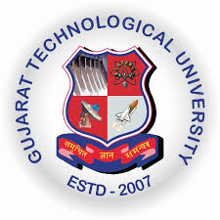
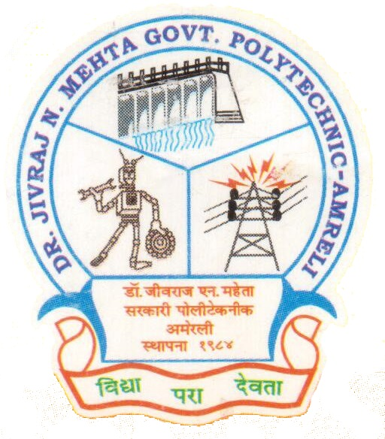
GUJARAT TECHNOLOGY UNIVERSITY
NATIONAL SERVICE SCHEME
DR.J.N.MEHTA GOVERNMENT POLYTECHNIC-AMRELI
A Report on Tree Plantation

On 27/08/2019

NSS Unit Name/College Name: Dr. JNMGPA - NSS unit

Event NAME: Tree Plantation

Event Date, Time and Location: 27/08/2019, 04:00 pm, College Campus (Entrance).

Brief Description of the Event:
Dr. JNMGPA - NSS unit organized Tree Plantation program at our Institute. In this program the volunteers of NSS organized a seminar on Needs & Advantages of Trees in a Human Life, our principal sir and our program officer (Prof. A.D. Mehta) delivered speech on the same and motivate students about tree plantation so, that students will able to participate in such kind of activities where one can aspect better environment for better future. Afterward NSS Student volunteers together with principal sir and program officer planted tree in the college premises. Here in this report we are attached some photographs of our program activity. At the end we must say that we really enjoyed doing such kind of noble and social activity for stronger and healthy society.
Honourable Principal B.P. Raval Sir, Lect. A.D. Mehta Sir (NSS-P.O) , Lect. M.D. Mathukia Sir (NSS-Committee Member) with all other staff members of our institute were participated in this program.
Photographs of the Event:
