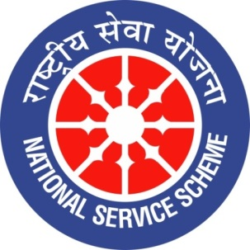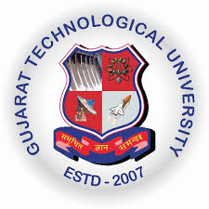
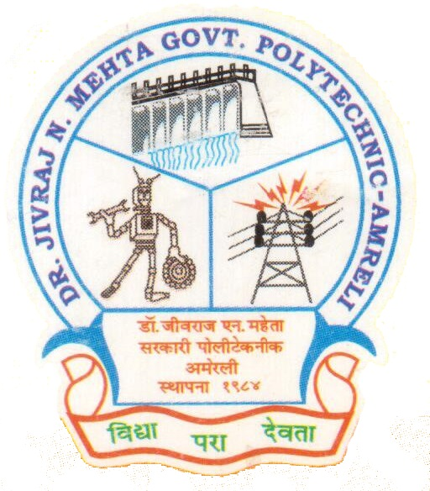
GUJARAT TECHNOLOGY UNIVERSITY
NATIONAL SERVICE SCHEME
DR.J.N.MEHTA GOVERNMENT POLYTECHNIC-AMRELI
A Report on Celebration of Hindu Digvijaya Din

On 11/09/2019

NSS Unit Name/College Name: Dr. JNMGPA - NSS unit

Event NAME: Celebration of Hindu Digvijaya Din

Event Date, Time and Location: 11/09/2019, 04:00 pm, Old Building-Room No.-317.

Brief Description of the Event:

Dr. JNMGPA - NSS unit celebrated a Hindu Digvijaya Din, on this occasion we invited Shree Govindbhai Timbadiya as a chief guest to deliver a speech on Swami Vivekananda as well as Hindu Digvijaya Din. He is retired science teacher and now serving his life as a social worker in our district. After the welcome ceremony, He told a lot many inspirational stories and the ideology of Swamiji to the students. After completing his speech he was taken the feedback from the students and inspired them to implement the things at an extent up to which it is possible in real life.
Honourable Principal B.P. Raval Sir, H.O.D (Mech.) H.R. Sapramer Sir, Lect. A.D. Mehta Sir (NSS-P.O) , Lect. M.D. Mathukia Sir (NSS-Committee Member) with all other staff of our institute were present on this occasion.
Photographs of the Event:

