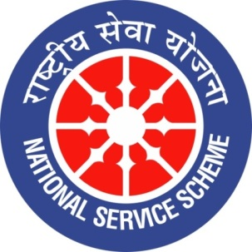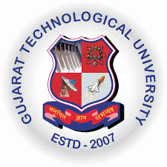
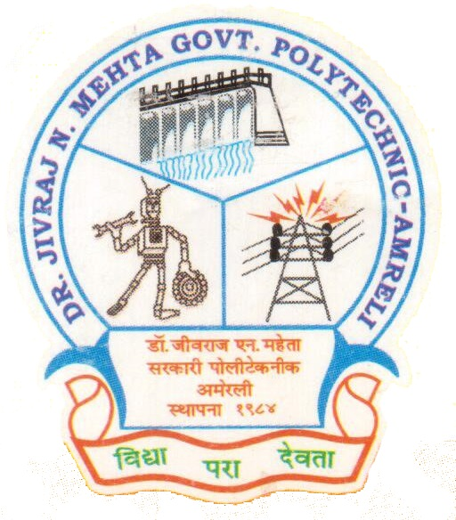
GUJARAT TECHNOLOGY UNIVERSITY
NATIONAL SERVICE SCHEME
DR.J.N.MEHTA GOVERNMENT POLYTECHNIC-AMRELI
A Report on Guest Lecture on 150th Birthday Anniversary of Mahatma Gandhiji

On 09/09/2019

NSS Unit Name/College Name: Dr. JNMGPA - NSS unit

Event NAME: Celebration of 150th Birthday Anniversary of Mahatma Gandhiji

Event Date, Time and Location: 09/09/2019, 12:30 pm, New Building-Room No.-101.

Brief Description of the Event:

Dr. JNMGPA - NSS unit arranged a guest lecture on 150th birth anniversary of Mahatma Gandhi. Guest name is Janma Vasavda. She is an empanelled trainer (English) from KCG, GoG. She completed her education as got Master degree in Arts with English literature, pursuing Ph.D. as of now and also interested in classical kathak dance. She is very intelligent and influencing personality.
She explained the all aspects about the ‘Satyagraha’ and ‘Non-violence’. Gandhi's vision of an independent India based on religious pluralism. She told that there are very much people in society having not a good opinion about Mahatma Gandhiji but she explained that Non-violence has a great history since Gautama Buddha and Mahavir Jain. Coming with the brief history she explained the Gandhiji and his priceless principles. We all studied the Gandhiji but very few understand, there is much surety that many students will read the proper books and understand Mahatma Gandhiji. After the lecture she took a small question and answer session with students and all students are satisfied with her answers.
Honourable Principal B.P. Raval Sir, Lect. K.D. Ramanuj Sir, Lect. A.D. Mehta Sir (NSS-P.O) , Lect. M.D. Mathukia Sir (NSS-Committee Member) were present for the guest lecture.
Photographs of the Event:
