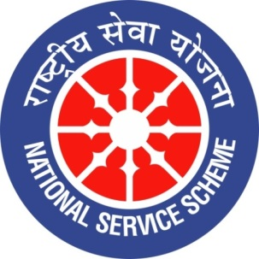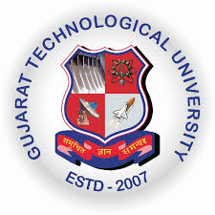
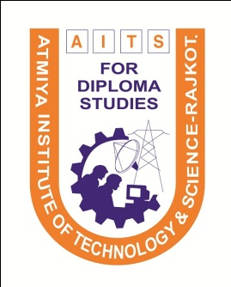ollege Logo
GUJARAT TECHNOLOGY UNIVERSITY
NATIONAL SERVICE SCHEME

A Report on “One Student One Tree Campaign” on 31st August 2019 at Atmiya Institute of Technology & Science For Diploma Studies, Rajkot

NSS Unit Name/College Name: Atmiya Institute of Technology & Science For Diploma
Studies, Rajkot
Event NAME: “One Student One Tree Campaign”
Event Date, Time and Location: 31-08-2019, 08:00 AM at Railway Loco Colony, Rajkot.
Brief Description of the Event:
Atmiya Institute of Technology & Science for Diploma Studies, Rajkot had organized One Student One Tree campaign on date 31/08/2019 (Saturday) in which 27 students of NSS unit had taken participation along with two faculties.
This campaign was organized at Railway Loco colony Rajkot with the help of Navrang nature club and total 50 number of trees were planted.
Major Outcomes of Event:
Students got awareness regarding importance of trees for future betterment of our nature and total 50 numbers of trees were planted.

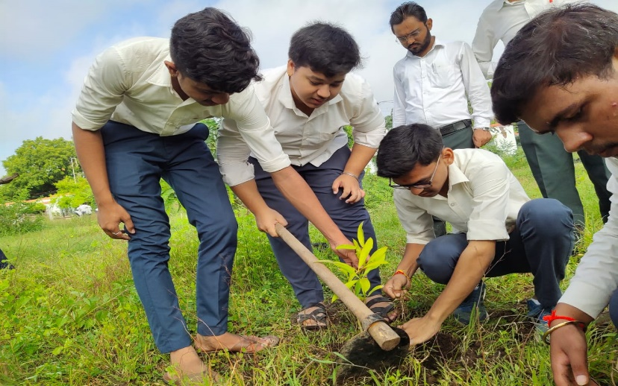
Photographs of the Event:
