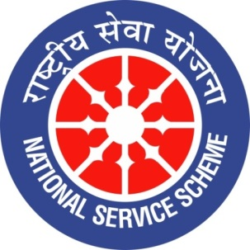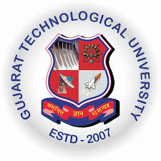
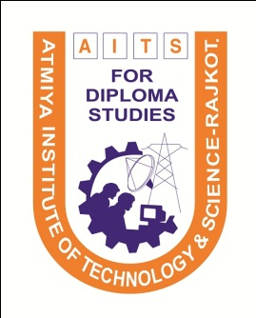ollege Logo
GUJARAT TECHNOLOGY UNIVERSITY
NATIONAL SERVICE SCHEME

A Report on Celebration of Atmiya Swachhata Abhiyan on 15th December 2019 at Atmiya Institute of Technology & Science For Diploma Studies, Rajkot

NSS Unit Name/College Name: Atmiya Institute of Technology & Science For Diploma
Studies, Rajkot
Event NAME: “Atmiya Swachhata Abhiyan”
Event Date, Time and Location: 15-12-2019, 08:30 AM at different areas of Rajkot city.
Brief Description of the Event:
“Atmiya Swachhata Abhiyan” on an occasion of punyatithi of Sardar Vallabhbhai Patel was organized by Atmiya Institute of Technology & Science For Diploma Studies on date 15/12/2019 in which 46 students along with faculties of Diploma studies had taken participation. This Abhiyan was organized at different areas of Rajkot.

Major Outcomes of Event:
Swachhata Abhiyan at different areas of Rajkot was carried out by NSS students and faculty members.

Photographs of the Event:
