On Occasion of
"Azad Hind Sarkar Divas" Gujarat Technological University

had organized
“Fit India Freedom Run 2.0" to embody the

"Azadi ka Amrut Mahotsav" programme.

Date: 21/10/2021 Time: 08:00 AM

Venue
Gujarat Technological University
B-0, Conference Hall, GTU Chandkheda Campus, Nr. Visat Three Roads, Visat - Gandhinagar Highway, Chandkheda, Ahmedabad – 382424 – Gujarat.

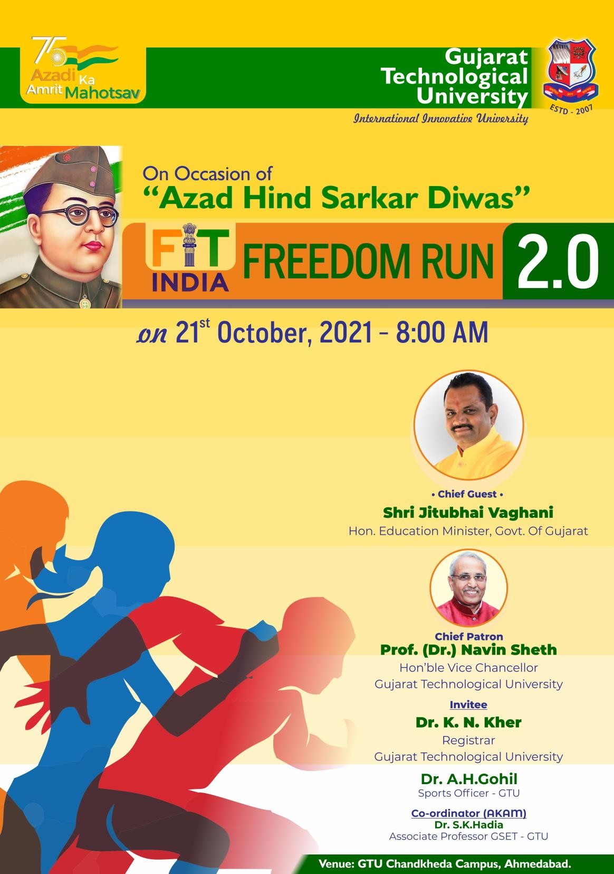

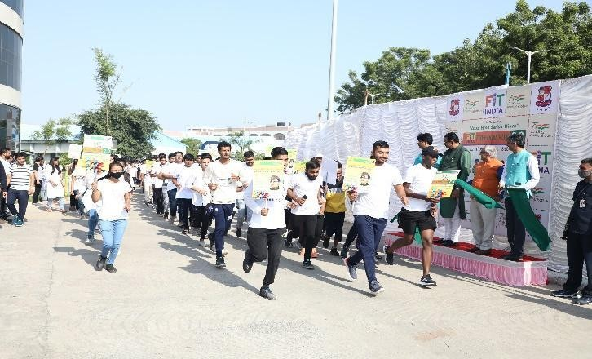
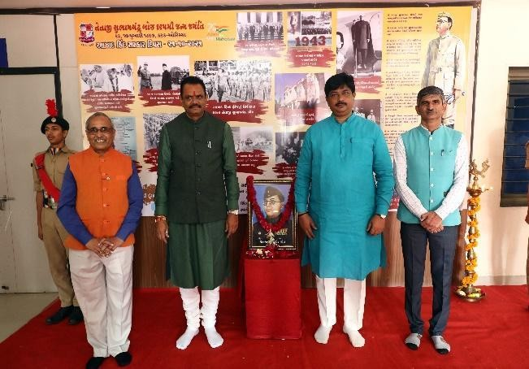
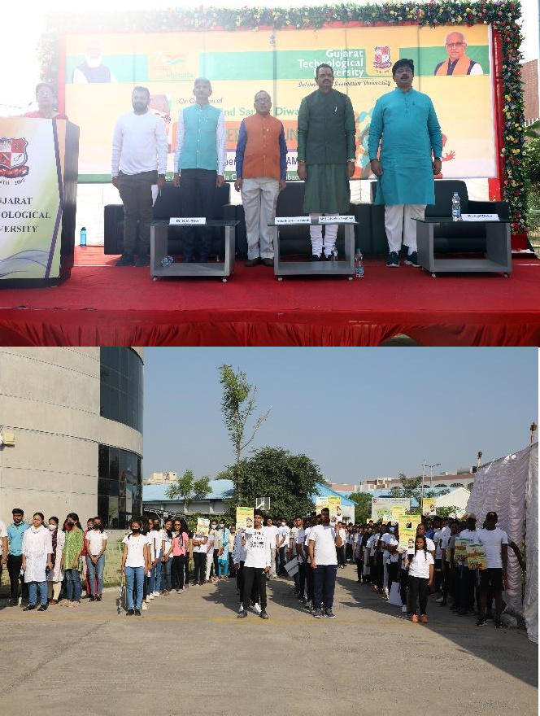
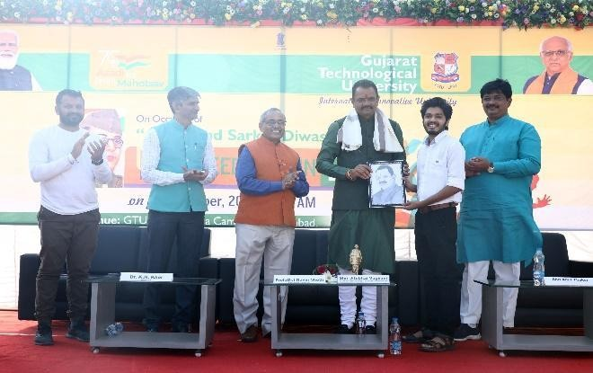
Fit India Freedom Run 2.0

On Occasion of "Azad Hind Sarkar Divas" Gujarat Technological University had organized “Fit India Freedom Run 2.0" to embody the "Azadi ka Amrut Mahotsav" programme. more than 820 GTU Students/Faculty/Staff were participated in ““Fit India Freedom Run 2.0".The aim of “Fit India Freedom Run 2.0" give message to society aware for fitness and remember the Freedom fighters who sacrifice their lives for freedom of our Nation.Hon’ble Education Minister shri Jitubhai Vaghani were come as a Chief Guest in “FIT INDIA FREEDOM RUN 2.0”.

Invited Dignitaries

Shri jitubhai Vaghani Prof. (Dr.) Navin Sheth
Education Minister, Vice Chancellor, GTU Gujarat, India. Gujarat, India.

Dr. K. N. Kher Shri Sanjay Joshi
Registrar, GTU Registrar, GTU

Dr. Aakash Gohil Sports Officer, GTU

