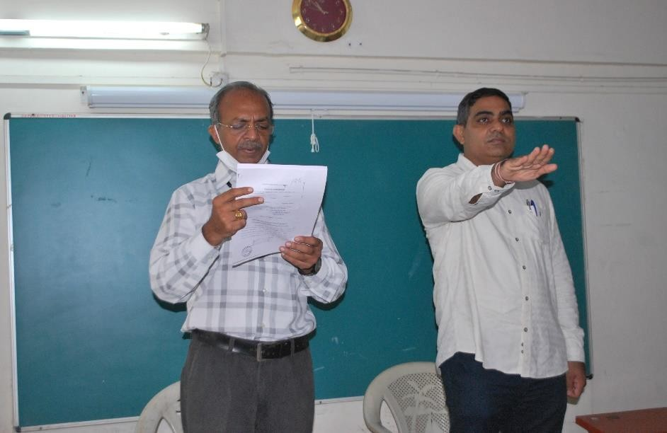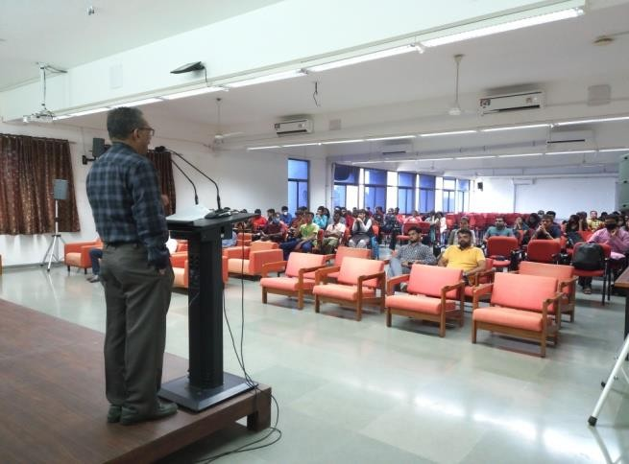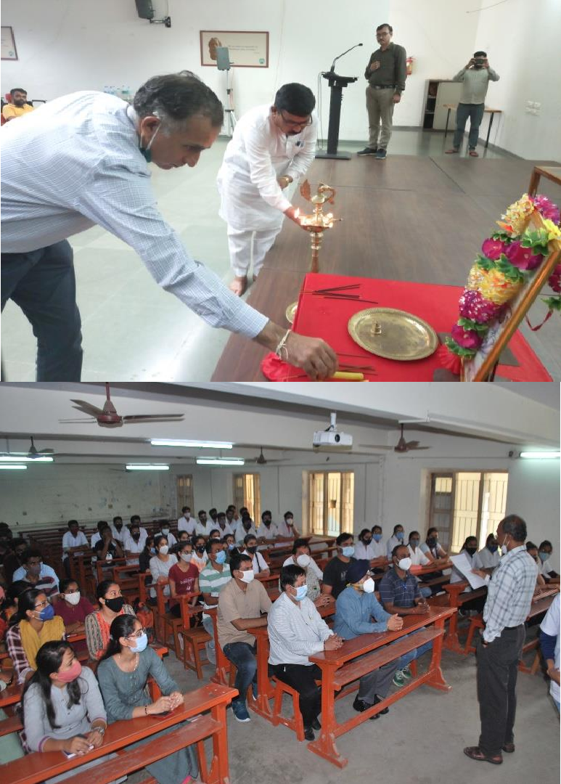Angdaan Report

< Angdaan >> conducted on <17/09/2021>

Gujarat Technological University in association with Angdaan Charitable Trust, Media club and Institute of Kidney Disease &amp;
Research Centre (IKDRC) had organized “Angdaan Pledge
programme”on the occasion of 71th Birthday of “Prime Minister – Narendra Modi. GTU Affiliated colleges had participated Angdaan pledge program on 17 September. 168 GTU PG School’s students also participated in this event GTU had spread awareness and importance of Angdaan by sharing “man ki bat” to students and through media by #pledge4angdaan.More than 50000 Students had participated and benefited for points under 100 point activities through Major head of activity : Community outreach and Social initiatives and made the event successful.

