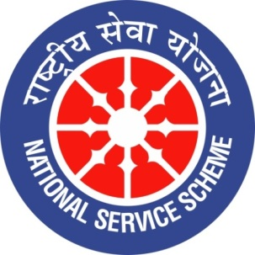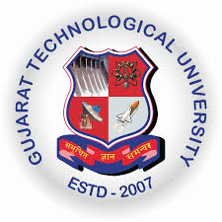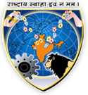
GUJARAT TECHNOLOGY UNIVERSITY
NATIONAL SERVICE SCHEME
V.V.P.ENGINEERING COLLEGE, RAJKOT
A Report on Traffic Awareness Activity on 23rd July, 2019 of V.V.P. Engineering College.
NSS Unit Name/College Name: V.V.P. Engineering College, Rajkot
Event NAME: Traffic Awareness Activity
Event Date, Time and Location: 25th July, 2019 6.00pm at KKV Circle
26th July, 2019 6.00pm at Jilla Panchayat Circle
27th July, 2019 6.00pm at Trikon Baug
Brief Description of the Event:
TRAFFIC AWARENESS activity was organized by our NSS unit. Following points were emphasised on during the Activity
1 - Wear Helmet
2 - Using seat belts.
3 - Letting go vehicle through left side during closed signal.
4 - Spitting on roads.
5 – Don’t use of mobile while driving
6 - Wrong side
RJ Jay from MYFM also stayed with us during this activity and appreciate letter was provided from him to our NSS Unit.
The prime location and prime time was selected for the activity as at KKV circle, Jilla Panchayat circle and Trikon Baug at 6.00pm have maximum traffic and hence our reach would be maximum.

Major Outcomes of Event:
- Get aware and make others aware of traffic rules
- Give emphasis on the road safety.
- Help society by reducing accidents (if possible)
Photographs of the Event:
