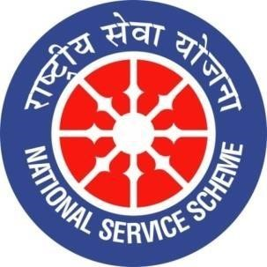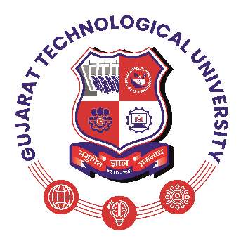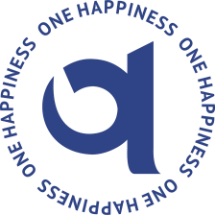

GUJARAT TECHNOLOGY UNIVERSITY
NATIONAL SERVICE SCHEME
LAXMI INSTITUTE OF TECHNOLOGY, SARIGAM. (086)
A Report on Hands-on CPR (Cardiopulmonary Resuscitation) Workshop Organized by NSS Unit, Laxmi Institute of Technology, Sarigam
Date: 11/09/2026
NSS Unit Name/College Name: NSS UNIT LAXMI INSTITUTE OF TECHNOLOGY, SARIGAM. (086)
Event NAME: Hands-on CPR (Cardiopulmonary Resuscitation) Workshop
Event Date, Time and Location: 11/09/20256, 10:30 am Lit Dhwani Auditorium.
Participant: NSS Volunteers, students, staff.
Total Participant : 300+ Students and Faculty Members.
Brief Description of the Event:
The NSS Unit of Laxmi Institute of Technology (LIT), Sarigam, in association with Valsad Raktadan Kendra, organized a Hands-on CPR (Cardiopulmonary Resuscitation) Workshop on 11 September 2026 at Dhwani Auditorium on the occasion of World First Aid Day 2026. The programme was conducted under the presence and guidance of Dr. Basavaraj Patil, Director, Laxmi Institute of Technology, Sarigam. More than 300 engineering students and faculty members participated in the workshop. Dr. Abhishek Mistry, First Aid Trainer, Valsad Raktadan Kendra, conducted the session through live demonstrations and practical hands-on training. Participants were introduced to basic CPR procedures, emergency response techniques, and the importance of immediate action during life-threatening situations. Mr. Bhavesh Raicha, Director, Valsad Raktadan Kendra, also addressed the gathering and highlighted the importance of voluntary blood donation and social responsibility.

Objectives of the Event:
The programme commenced at 10:30 AM at Dhwani Auditorium. The session began with an introduction to CPR and the importance of providing immediate assistance during an emergency. Dr. Abhishek Mistry, First Aid Trainer, Valsad Raktadan Kendra, explained the basic steps of CPR and conducted a live demonstration using a CPR manikin. Participants were then given hands-on practice to understand the correct procedure, sequence, and technique of performing CPR. The practical session helped students and faculty members gain better understanding and confidence in responding to emergency situations. The programme also included an awareness session on voluntary blood donation and social responsibility. ‘
The main objectives of the CPR Workshop were:
- To provide students and faculty members with basic knowledge of Cardiopulmonary Resuscitation (CPR).
- To demonstrate the correct procedure and sequence of performing CPR through a live practical demonstration.
- To provide participants with hands-on practice of CPR techniques under the guidance of a trained First Aid Trainer.
- To explain the appropriate response and immediate actions to be taken during life-threatening emergencies.
- To develop confidence and readiness among participants to respond effectively during cardiac and other emergency situations.
- To create awareness about the importance of first aid and timely emergency response.
- To promote a culture of safety, care, volunteering, and social responsibility among students.
- To create awareness about voluntary blood donation and its importance as a social responsibility.
Outcomes Of The Event:
The workshop successfully enhanced the awareness and practical understanding of CPR and emergency response techniques among more than 300 participating students and faculty members. Through live demonstrations and hands-on practice, participants gained basic knowledge of performing CPR and responding appropriately during medical emergencies. The session helped improve participants’ confidence and preparedness to provide immediate assistance when required. The programme also created awareness about voluntary blood donation and encouraged students to develop a sense of social responsibility. Overall, the workshop contributed to promoting first-aid awareness, emergency preparedness, and a culture of helping others within the institute.

Photographs of the Event:
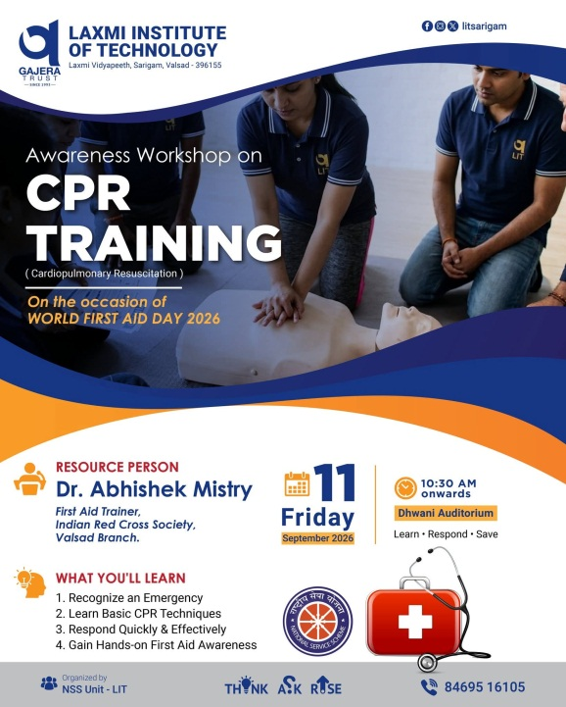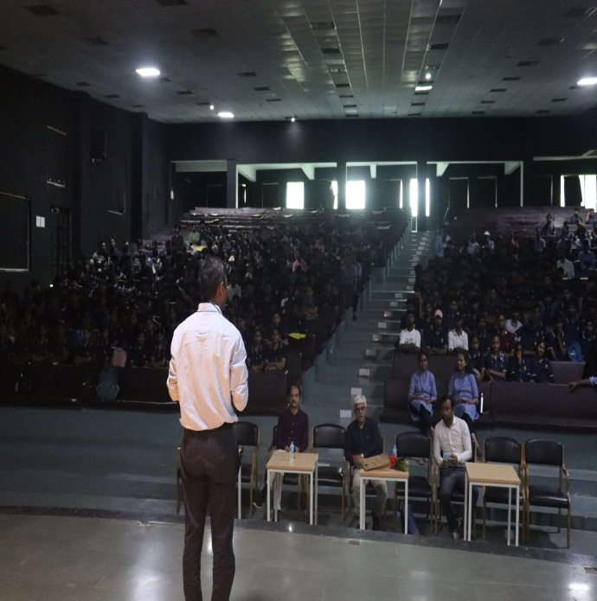

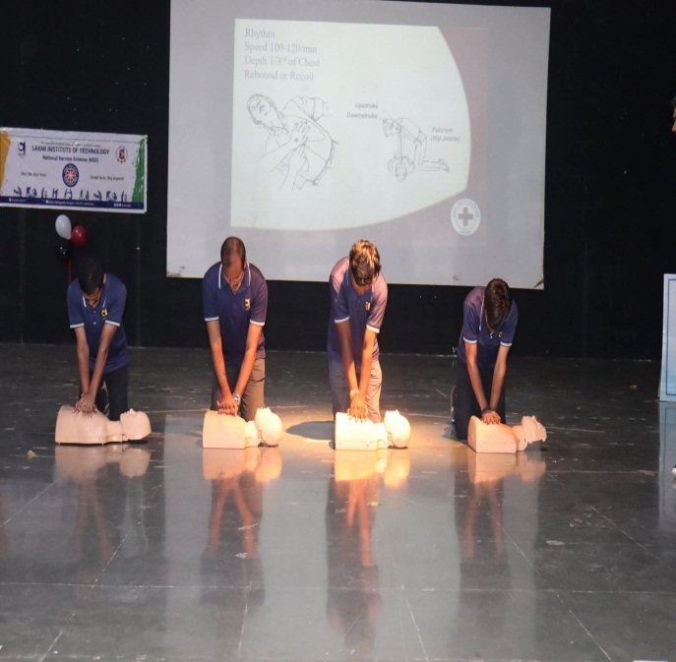
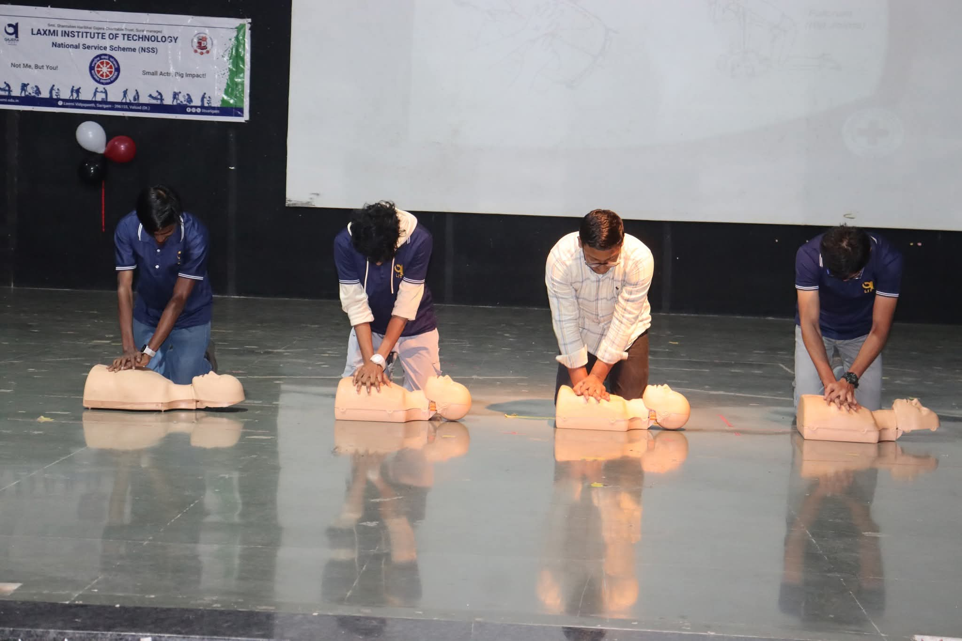
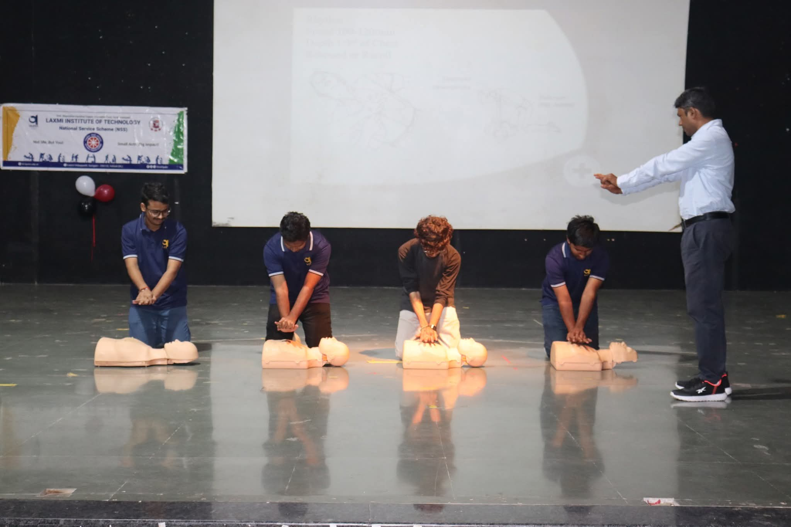
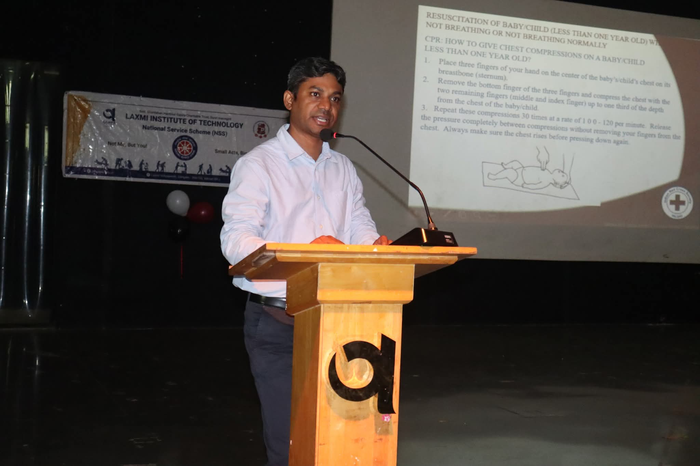
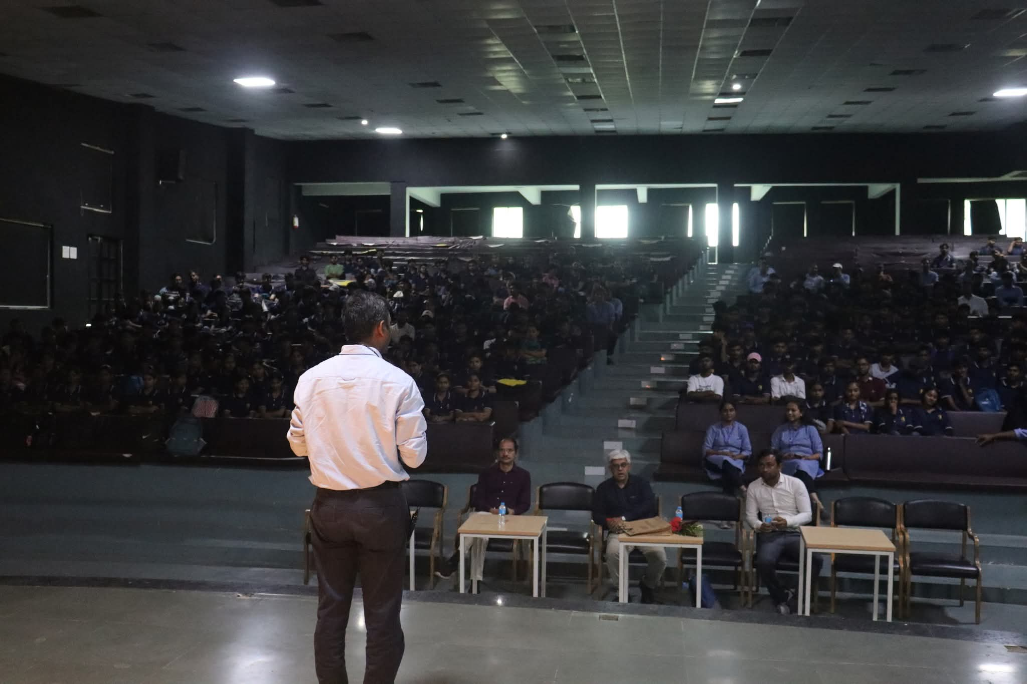
Social Media / Media Coverage:
The CPR Workshop was also covered by Divya Bhaskar. The media coverage can be accessed through the following link: https://divya.bhaskar.com/dZdXmn8vl6b

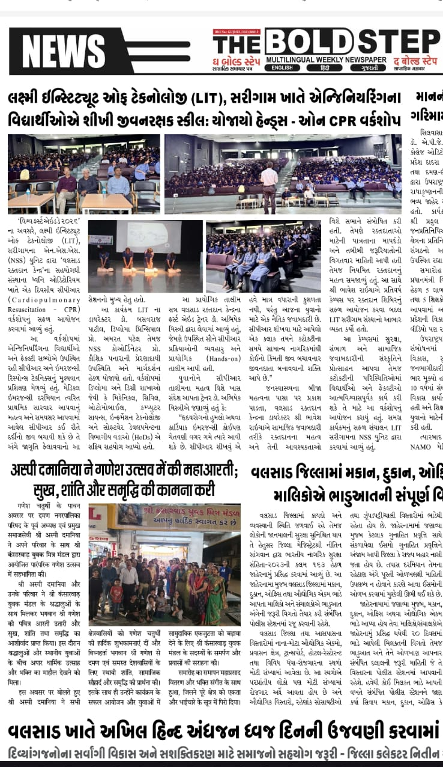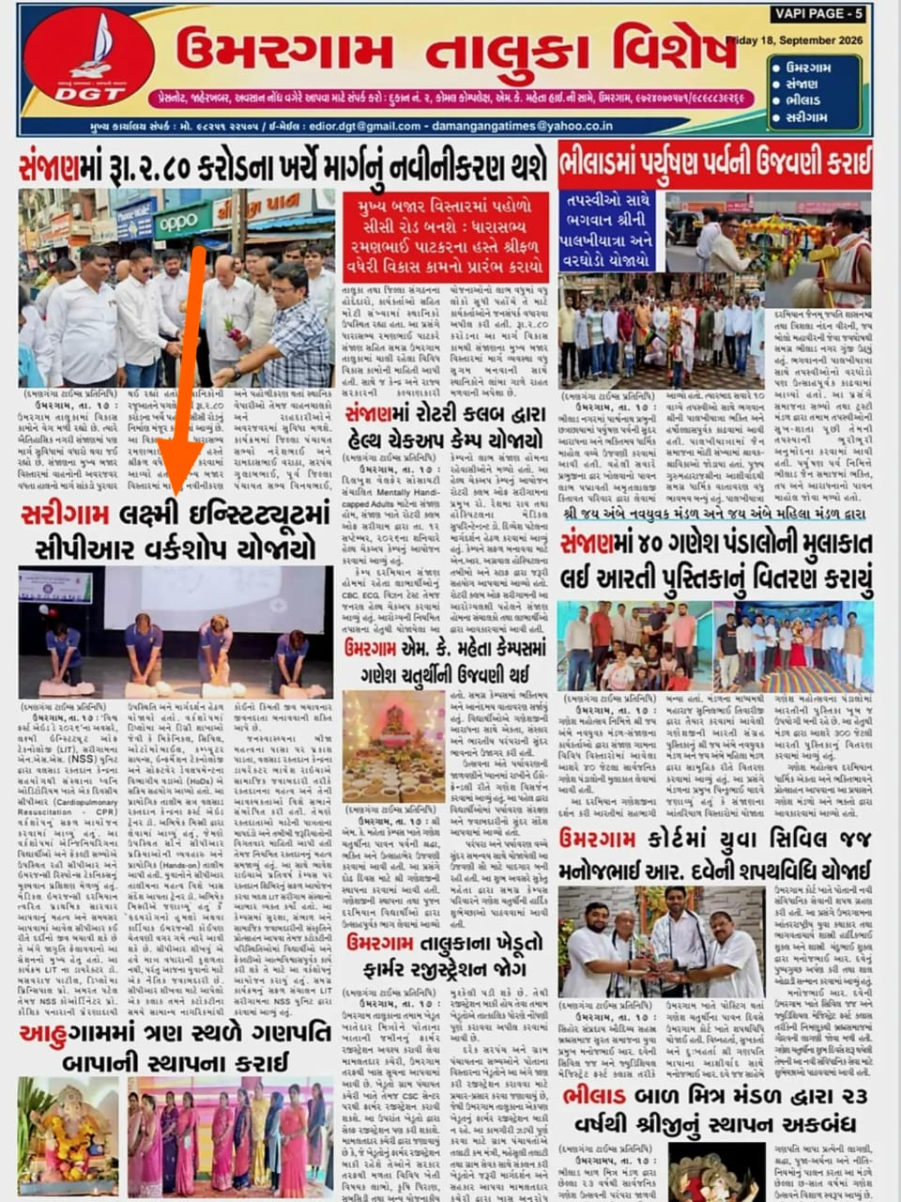
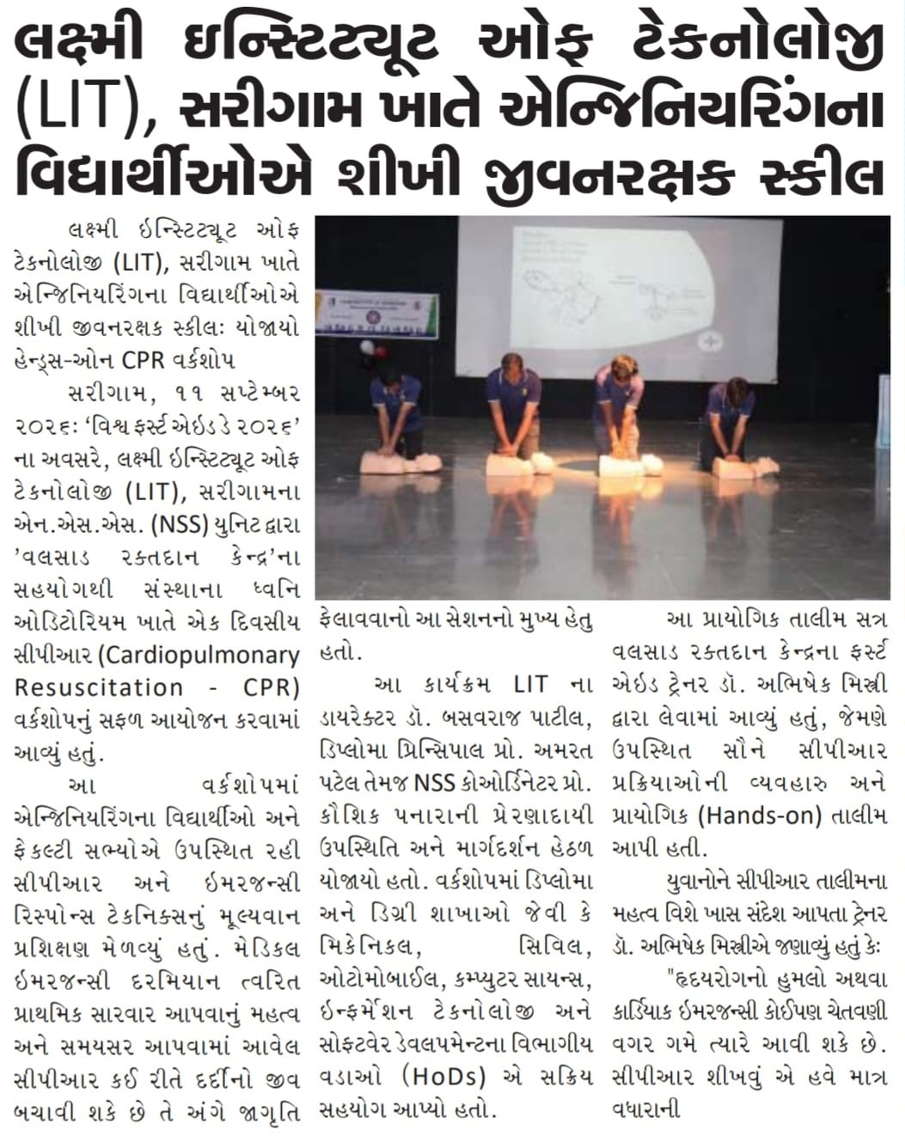

— END OF REPORT —

