INDEX
A. Glimpse of NSS 2021-22 Achievements 03
B. Activities done By GTU NSS Units 04
C. GTU - No of NSS Unit 05
D. Regular and Special Campaign Activities 06-16
E. NSS State Day celebration -2021” 17-18
F. National and State NSS Award for NSS-GTU (2019-20) 19
G. NSS-GTU Armed forces fund collection Award (2020-21) 20
H. Fundamental Rights Report 21-25
I. One day NSS Workshop GTU-NSS 26-30
J. 8th International Yoga Day 2022 31-35
K. Seed ball project 36-46

FROM THE VICE CHANCELLOR DESK
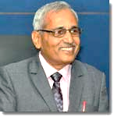

Dear NSS Volunteers, Principals and Program Officers,
Greetings

Social service has been included by the Education Ministry as an important parameter to adjudge a student for his/her graduation. Being part of NSS not only makes students’ mind creative and active but also keep them connected to the society and its problems. It is this connect that will enable the NSS students to find the solutions one day as a part of his/her responsibility towards developing the nation. This NSS portal is designed to coordinate all NSS activities like NSS volunteer registration, NSS Grant, Completion of NSS volunteer-ship, NSS event reports etc. centrally through GTU. Hopefully it will make NSS-GTU stronger and brighter.
Regards,
Prof. (Dr.Navin Sheth)
Vice Chancellor, GTU

Dear NSS Volunteers, Principals and Program Of

Social service has been included by the Education Ministry as an important parameter to adjudge a student for his/her graduation. Being part of NSS not only makes students’ mind creative and active but also keep them connected to the society and its problems. It is this connect that will enable the NSS students to find the solutions one day as a part of his/her responsibility towards developing the nation. This NSS portal is designed to coordinate all NSS activities like NSS volunteer registration, NSS Grant, Completion of NSS volunteer-ship, NSS event reports etc. centrally through GTU. Hopefully it will make NSS-GTU stronger and brighter.

Glimpse of NSS 2021-22 Achievements:

B. Activities done by GTU NSS Units:

- National Integration Camp-2022  - Cyber Jagrukta Divas July 202  - Tree Plantation  - Seed Balls Making  - Plastic Bag Free Day Celebration  - Training For Efficienty Use Of Fire Extinguisher  - International Yoga Day 2022  - Aazadi Ka Amrit Mahotsav  - Thalassemia Camp  - One Week Yoga Camp  - World Environmental Day  - Cyber Crime Awareness Seminar  - International Women Day  - Blood Donation Programme  - Republic Day  - International Day Of Sports For  - World Health Day 2022  - World Bicycle Day Celebration  - Yoga Shibir-Yoga & Meditation For Staff  - Save Soil Movment  - Importance Of Mediclaim In Life  - Save Soil Pledge Programmed  - Online Jignyasa The Heritage Quiz Competition  - Self-defence training  - Visit To Mother Teresa Orphan Age  - Vyasnmukti Program  - Addiction And Bad Custom Prevention Awareness Program  - Rappelling  - Women Empowerment  - Sainik Welfare Fund  - World Water Day  - Fire Safety Day  - Collection Of Sainik Welfare Fund - 2021  - Aids Awarness Programme  - Swachh Bharat Abiyan | - Drawing Competition Foe Village School Kids  - Initiative By NSS Cell For Community Awareness On Plastics Banned  - Save Electricity Campaign  - Helping Birds In Summer-Have You Installed Water Feeder?  - Mini Marathon  - Farm Visit  - Homeopathic Paediatric Medication And Health Awareness Program  - A Webinar On “India’s Freedom Struggle” And “Dandi March Ek Sankalp  - Road Safety Awareness Program  - My Cabin Clean Cabin Competition  - Fit India Freedom Run 2.0  - Pharmacist Day  - Visit To Andhjan Mandal (Blind People Association)  - EVM Demonstration  - Rashtriya Ekta Diwas Pledge  - Zumba Activity For Slum Children  - Impact Of Animal Culture On Global Warming  - Vaccination Drive  - Hygiene Kit Distribution On Women's Day  - Clothes Donation  - Feed Bird To Bring Them Happiness  - Awareness Program On "Bhartiya Sashakt Nari"  - Pulse Polio Vaccination Program  - Health Check Up Camp  - Mask Distribution  - Sankalp Day  - Kasumbi No Rang Utsav  - Engineer's Day Celebration  - Speech Competition  - Fit India Run

C. GTU – No.of NSS Unit

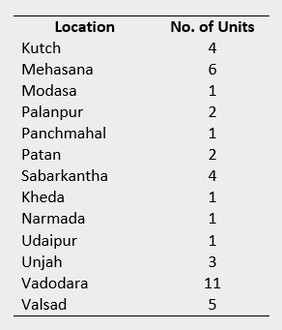
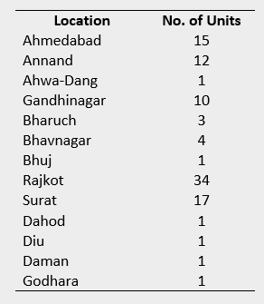

D. Regular and Special Campaign Activities:

During the Academic Year 2021-22 Gujarat Technological University and its affiliated Institutes have performed several regular and special campaign activities such as Tree Plantation, Awareness Drives, Shramdaan and Special camps. The details regarding each of the mentioned activities are as below:

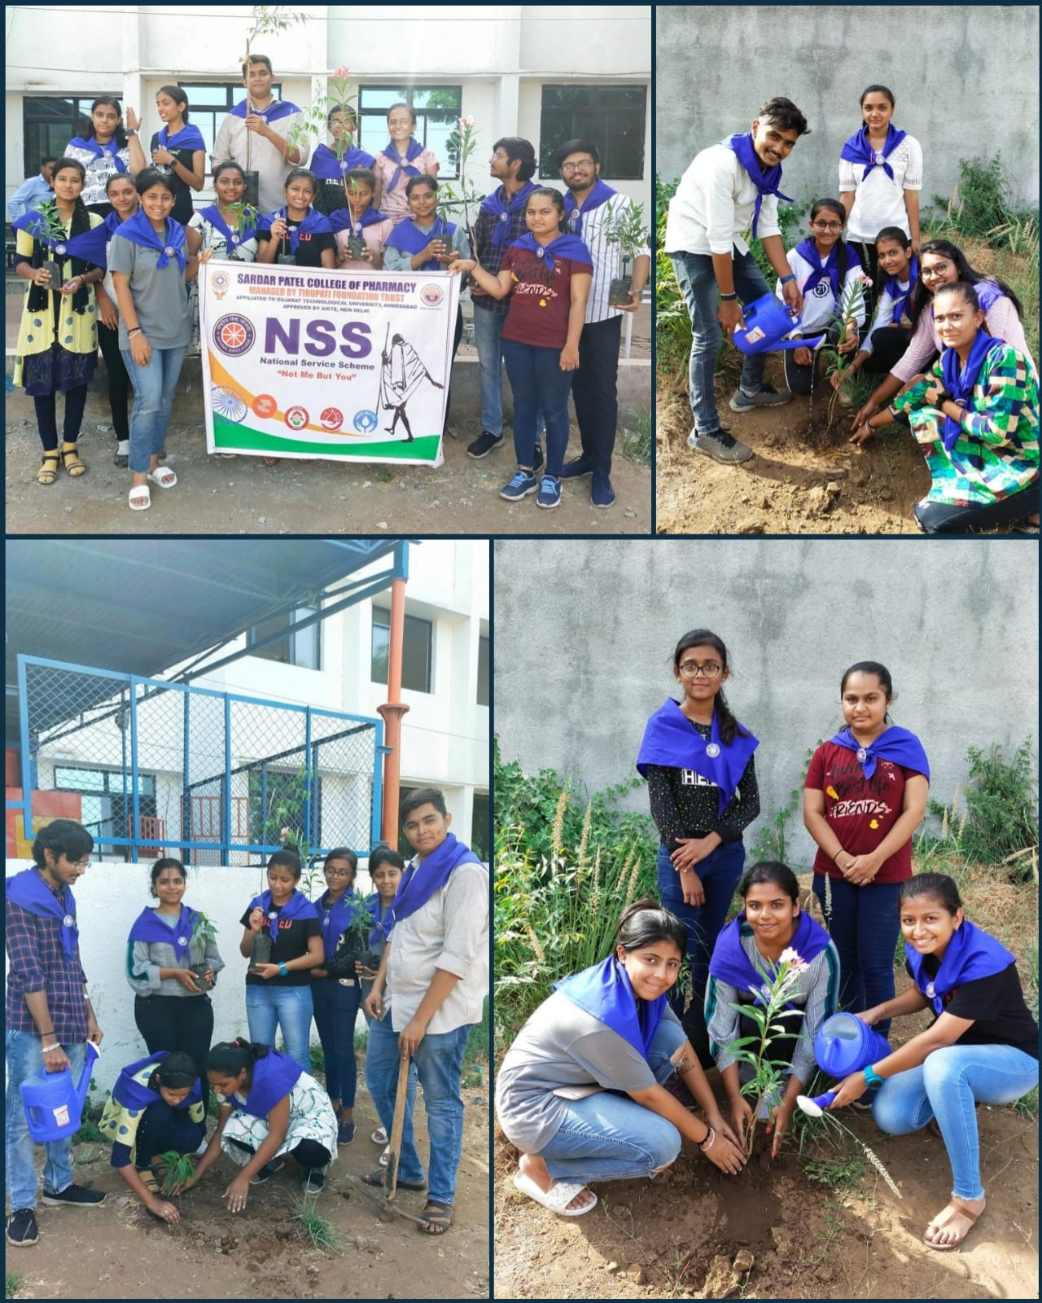
1. Tree plantation:

Tree Plantation Drive was organized dated 03rd June, 2022 GTU NSS – SPEC Campus, Bakrol (244)

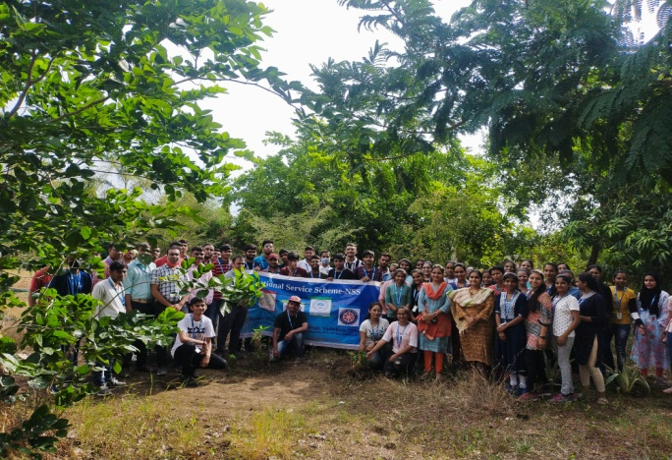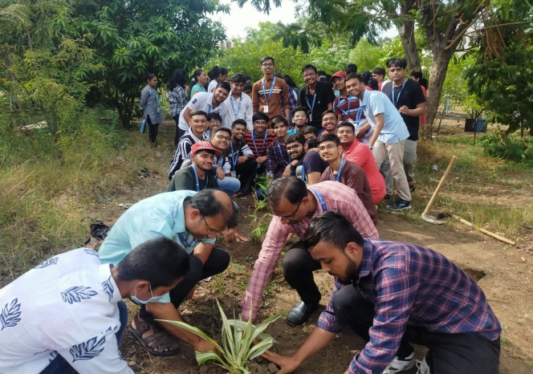

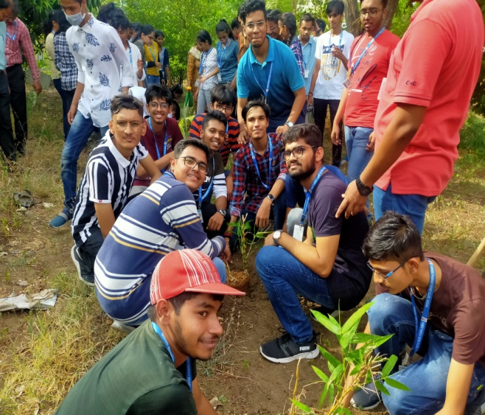
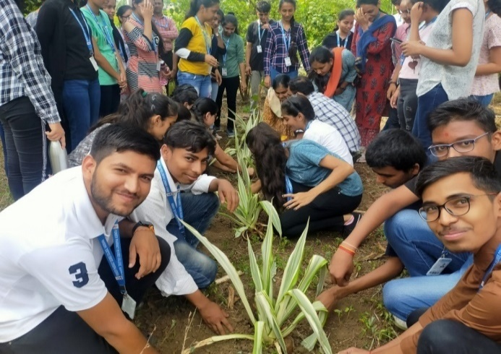
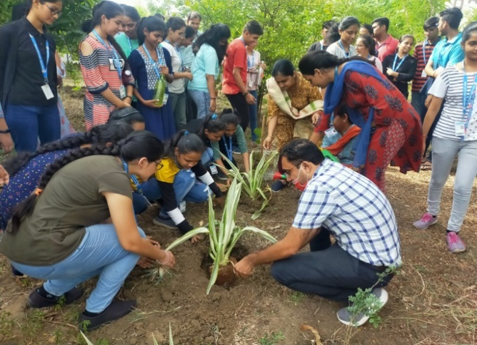
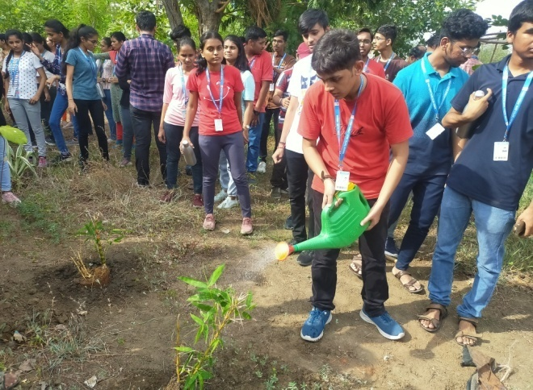
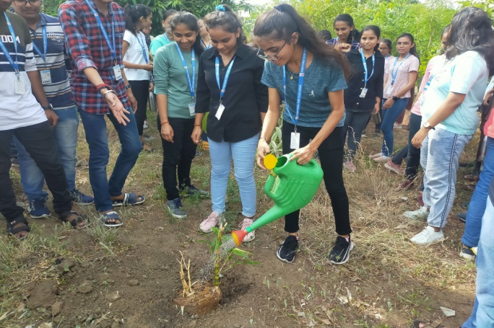
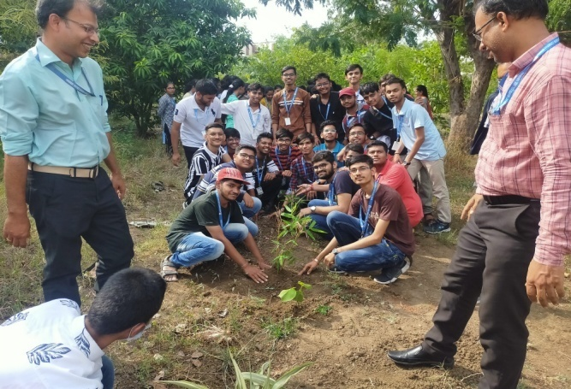
Sapling plantation was organized dated 4thJune, 2022 by GTU NSS Unit Pioneer Pharmacy Degree College, Vadodara -235
2. Blood Donation:
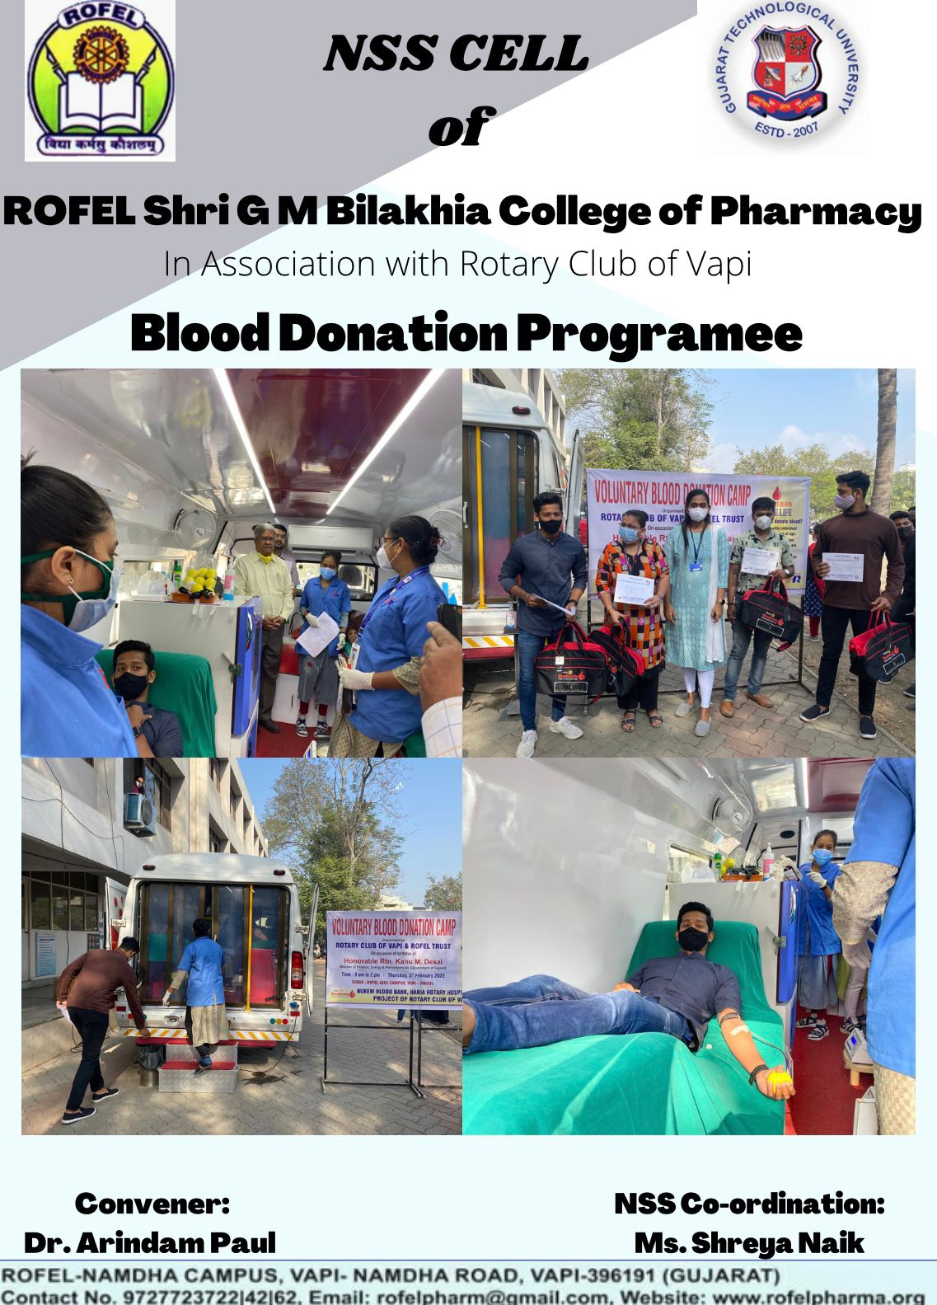
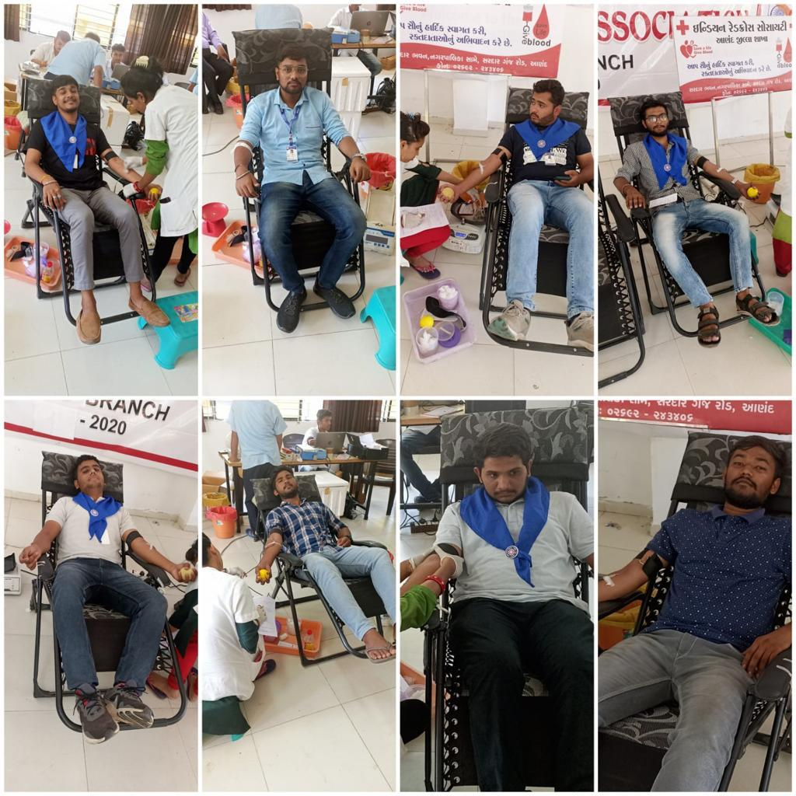
Blood Donation Camp was organized dated 3rdFebuary, 2022 by GTU NSS Unit, ROFEL Shri G M Bilakia college of Pharmacy(239) at 10:00 Hrs. Vapi, Surat
Blood Donation Camp was organized dated 2nd May, 2022 by GTU NSS Unit, SPCAM,Bakrol –(755) at 09:30 Hrs. SPEC Campus Bakrol.
3. Awareness Drives:
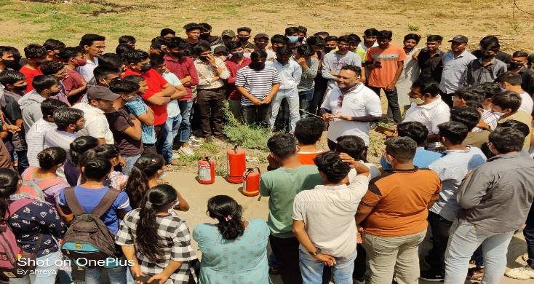
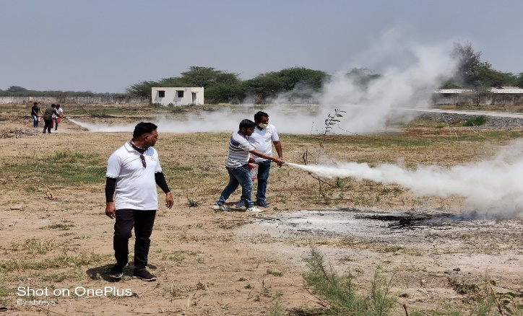
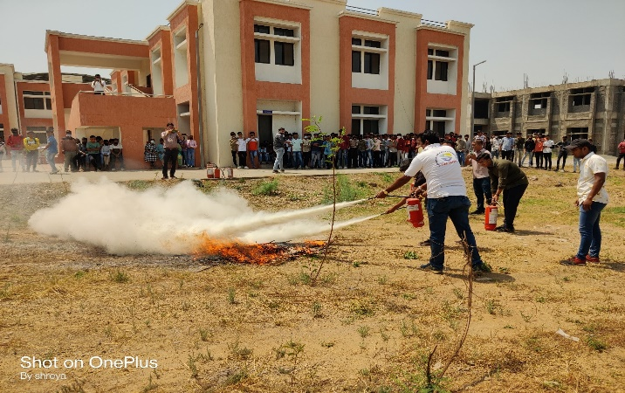
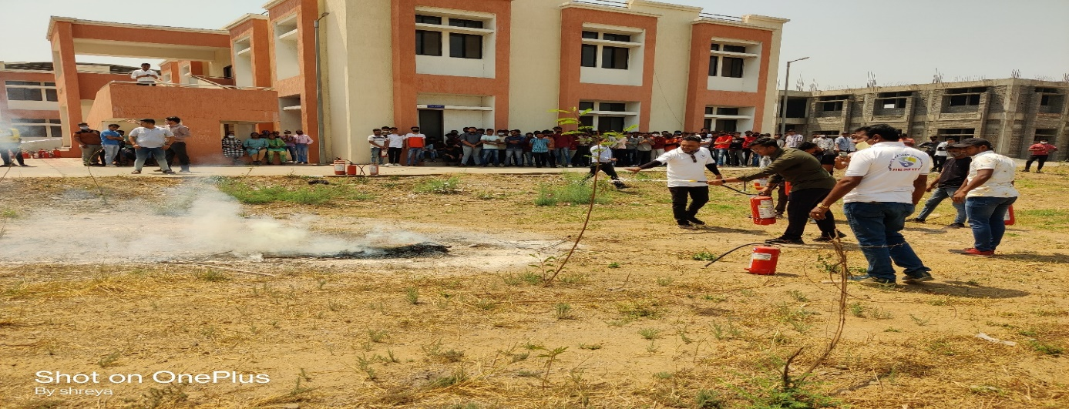
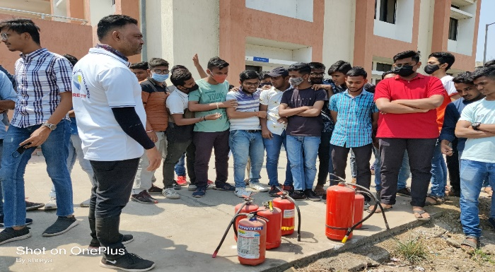

Fire Safety Awareness was organized dated 15THMarch, 2022 by GTU NSS Unit, Government Polytechnic Navsari, and Navsari (975)

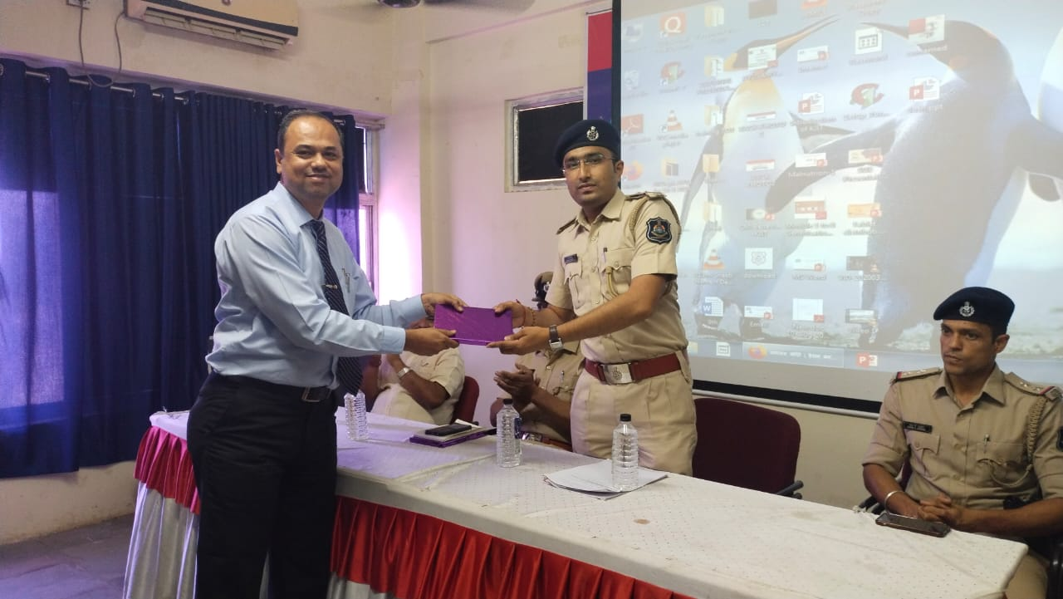
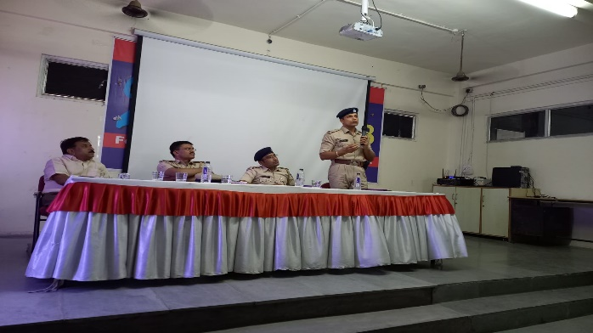
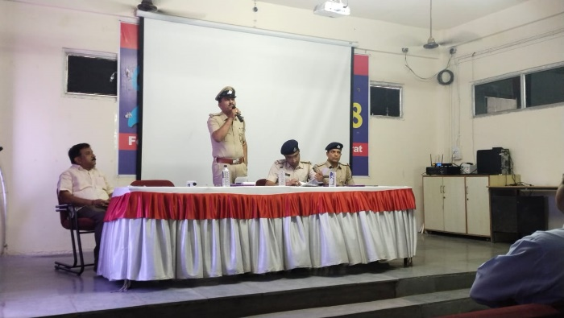
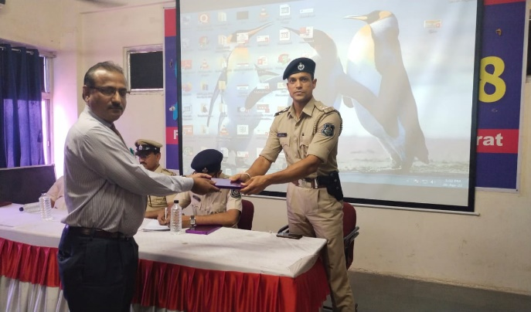

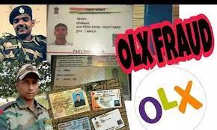

Awareness Session on “Cyber Crime Awareness” was organized dated 26thMarch 2022 by GTU NSS Unit, KJIT, Savli (064)

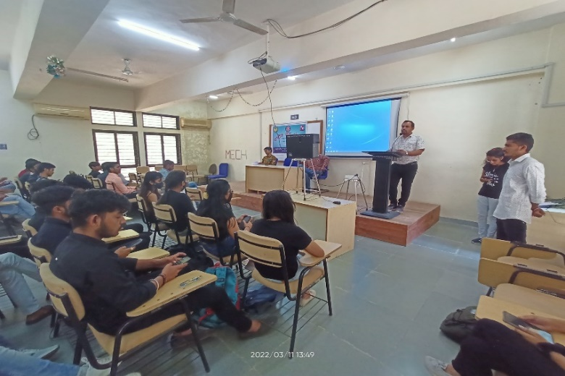
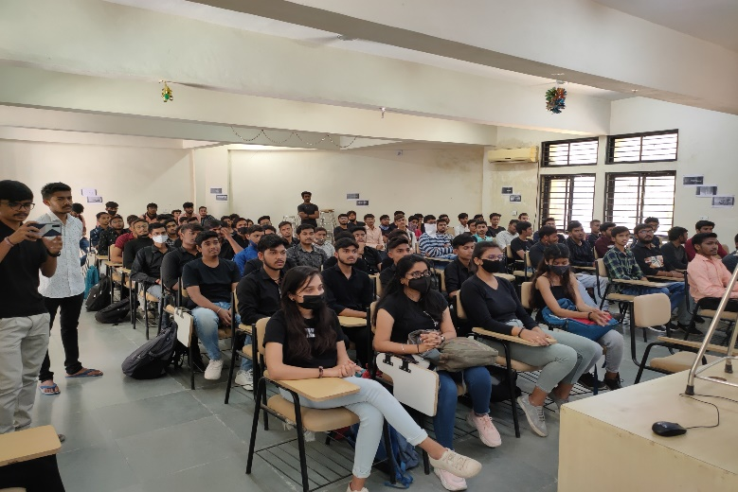
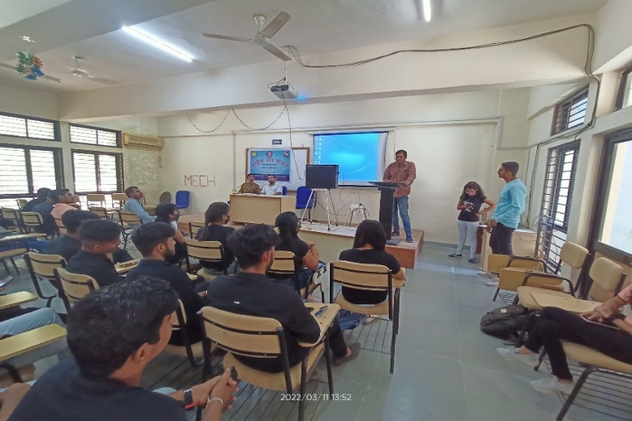
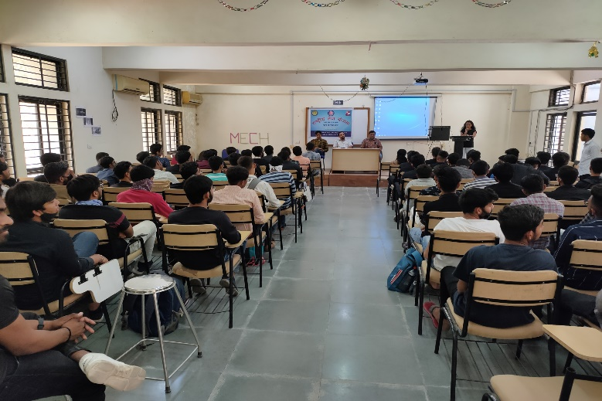
Voter Awareness Program was organized dated 11THMarch, 2022 by GTU NSS Unit, GEC, Patan (022)

4: Awareness Drive:
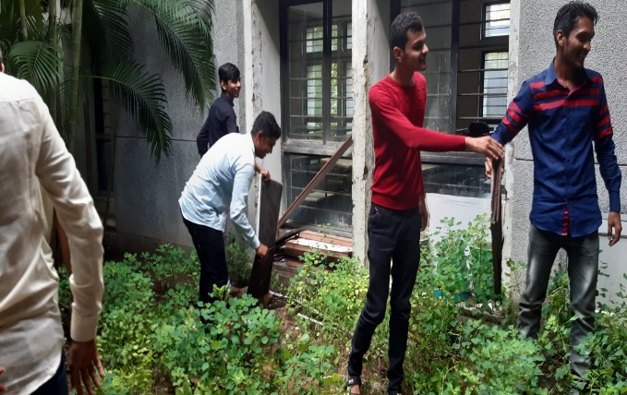
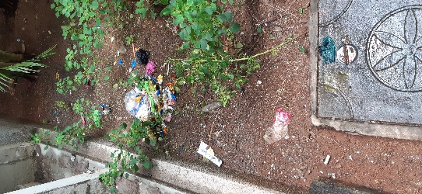
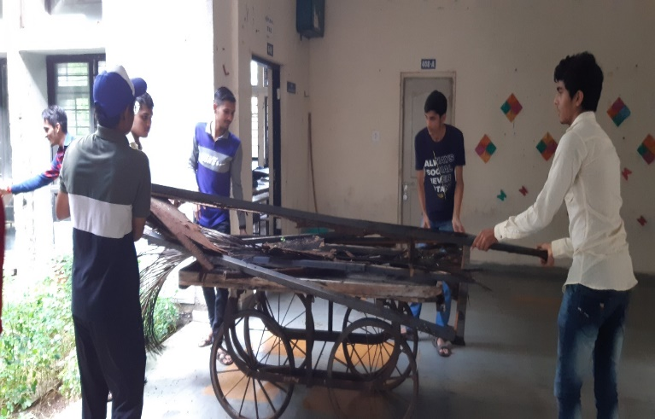
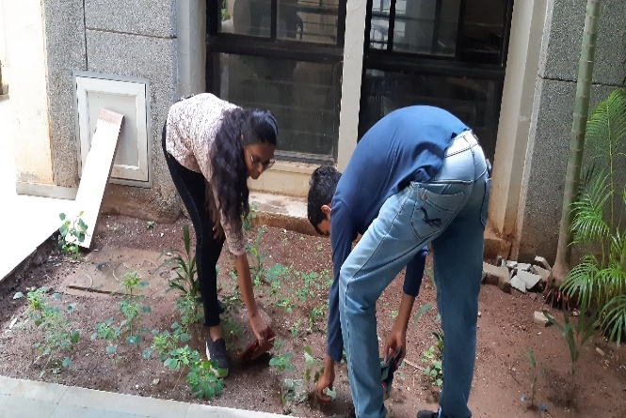

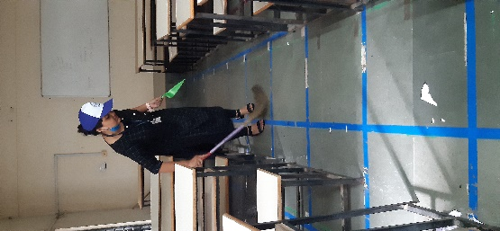
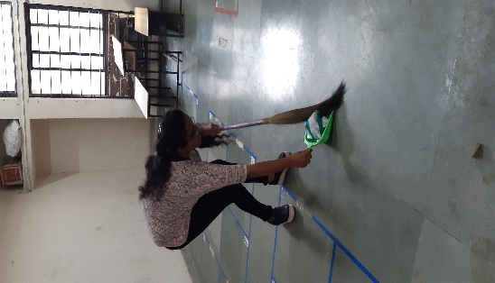
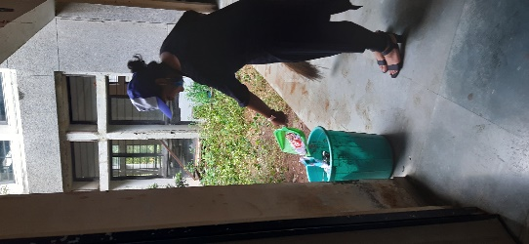
Azadi ka Amrut Mahotsav organized under the uplifting Theme of SWATCHTA MISSION on 1st of OCT, 2021. By GTU NSS Unit, Government Engineering College, Bhavnagar (021).

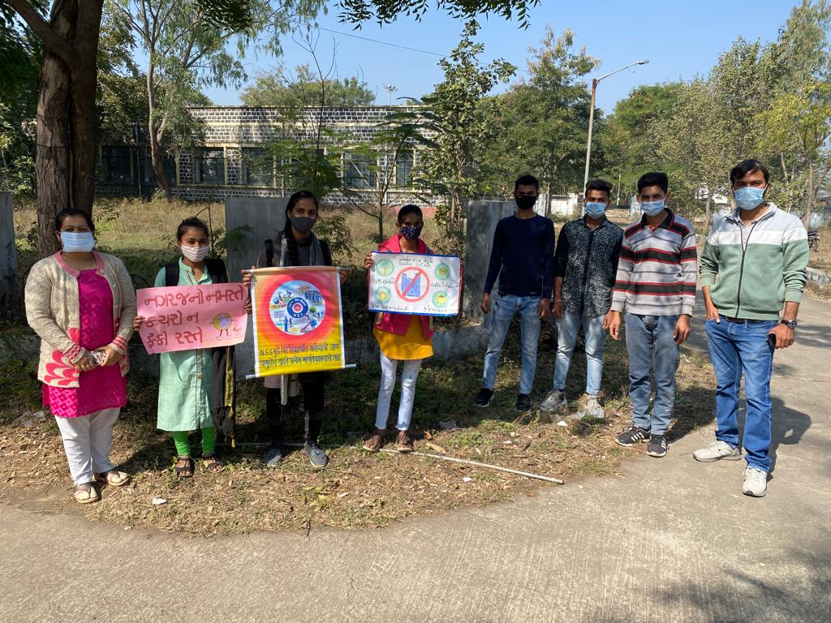
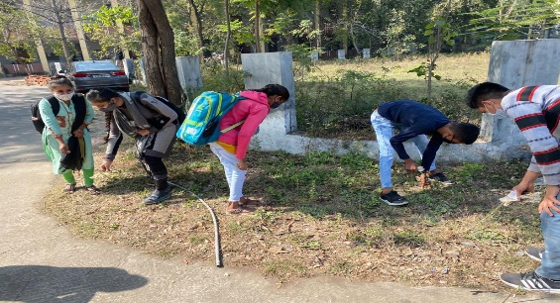
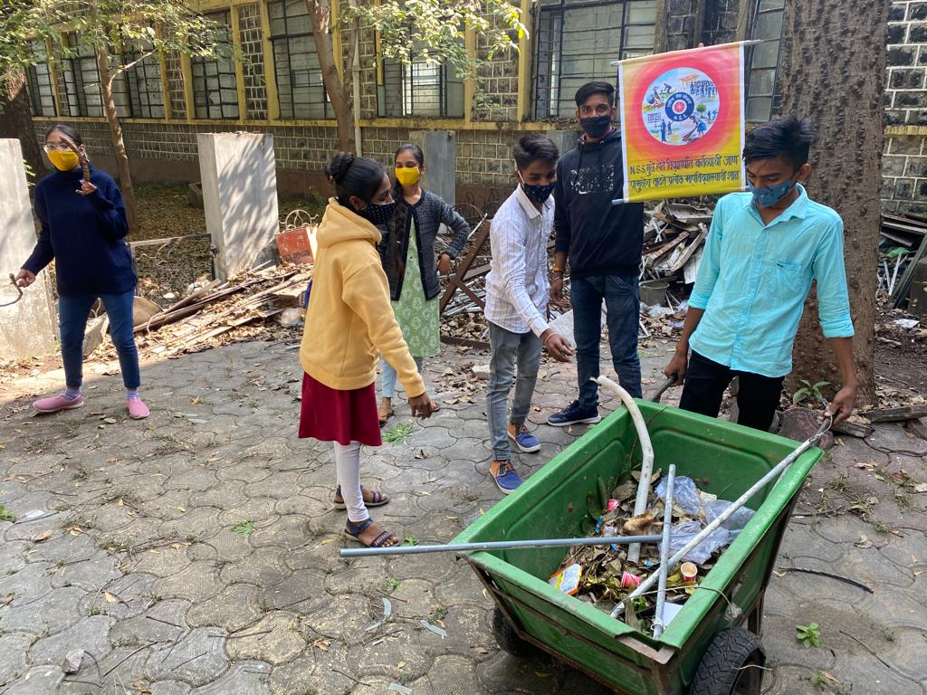
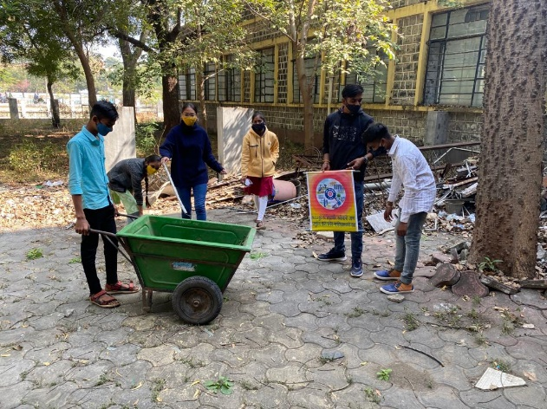
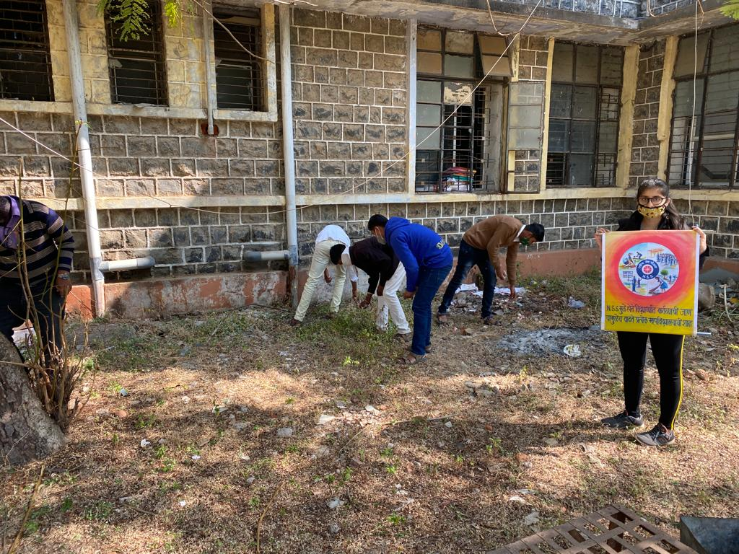
Swacha Bharat Cleanliness drive in GTU NSS Unit, Government Polytechnic, Dahod (630) campus and nearby premises was organized dated 18th January, 2022 to 20th January, 2022 as a part of Azaadi Ka Amrut Mahotsav- as per the directives of Directorate of Technical Education, Gujarat State and Ministry of Youth Affairs & Sports, Government of India.

5. Special Camp:
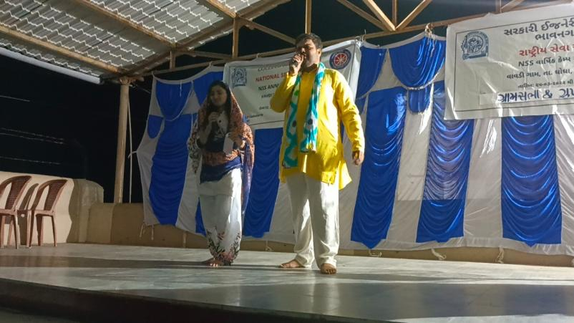
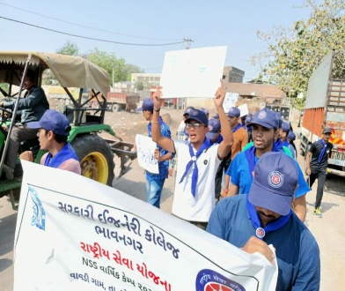
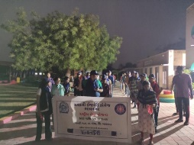
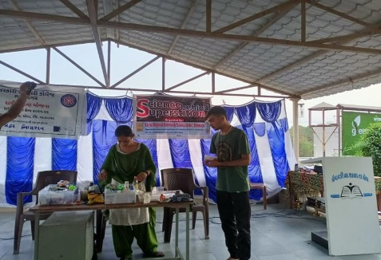
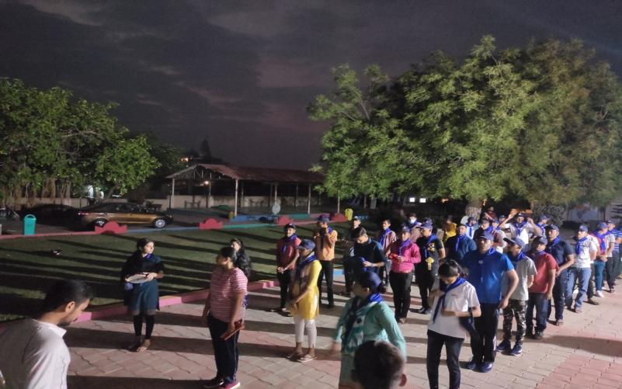
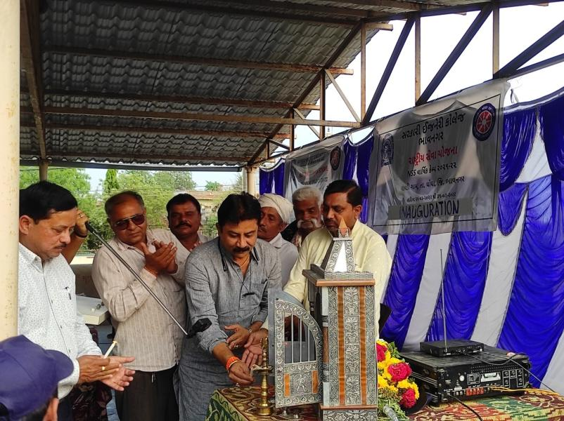
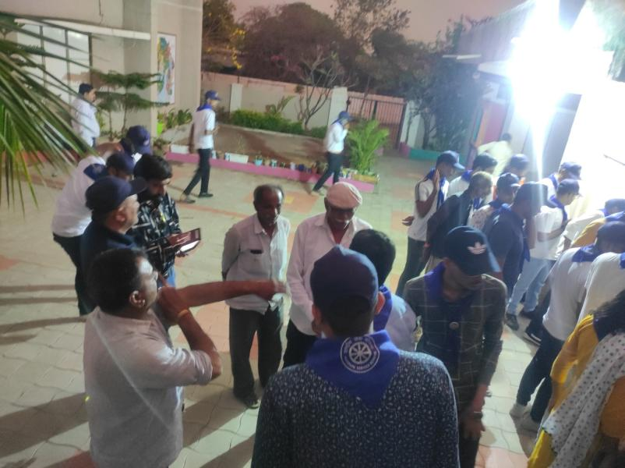
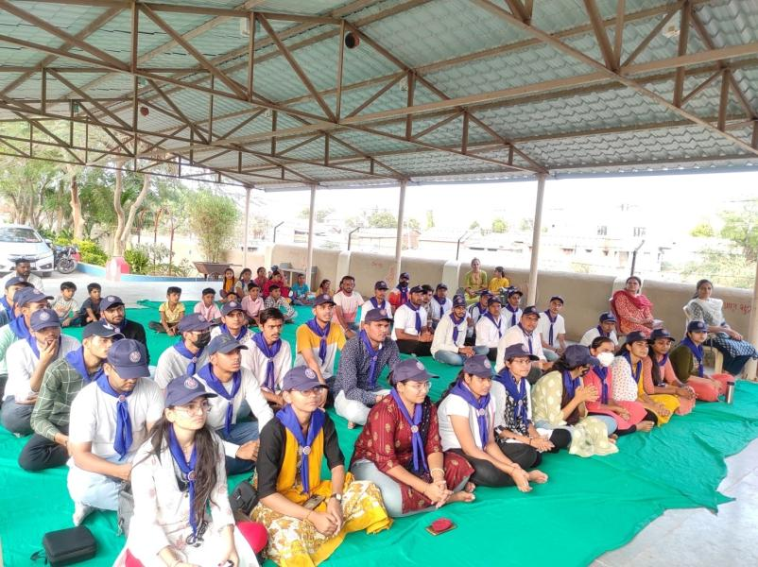
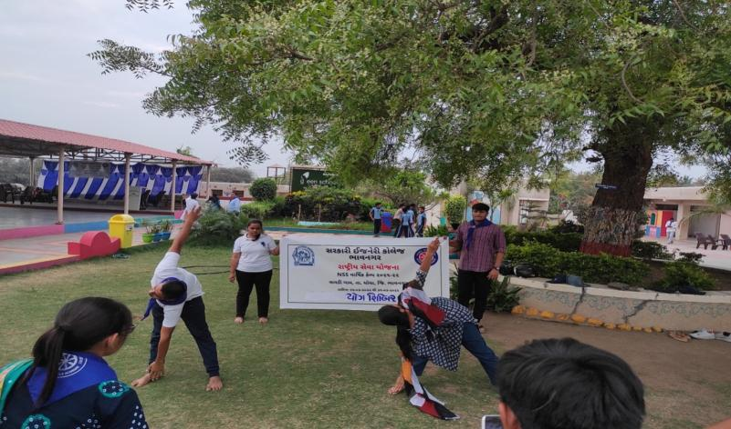
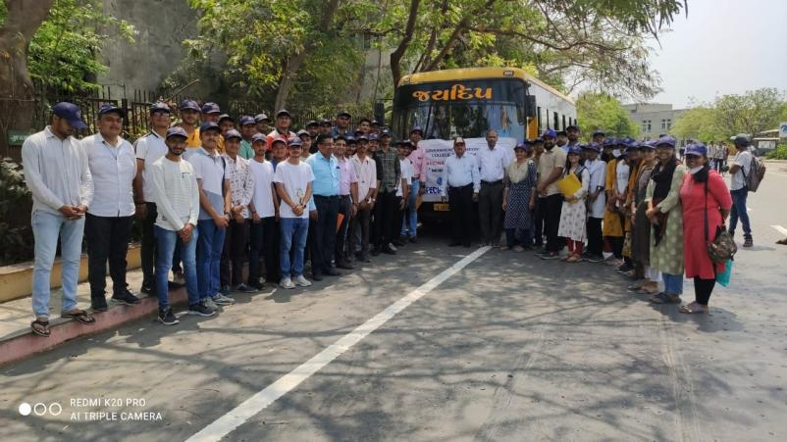
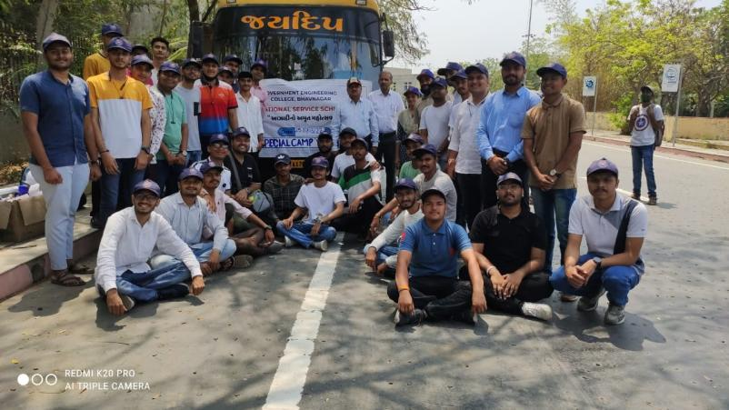
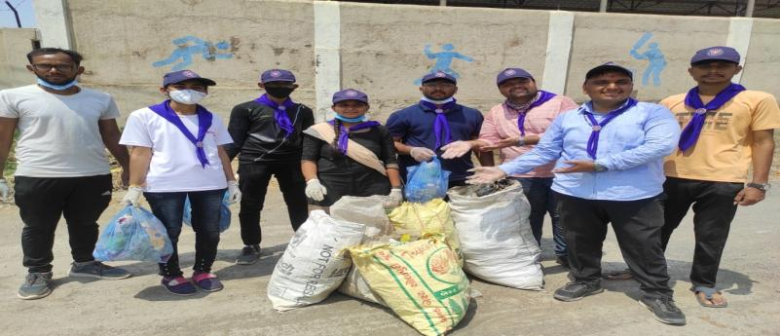
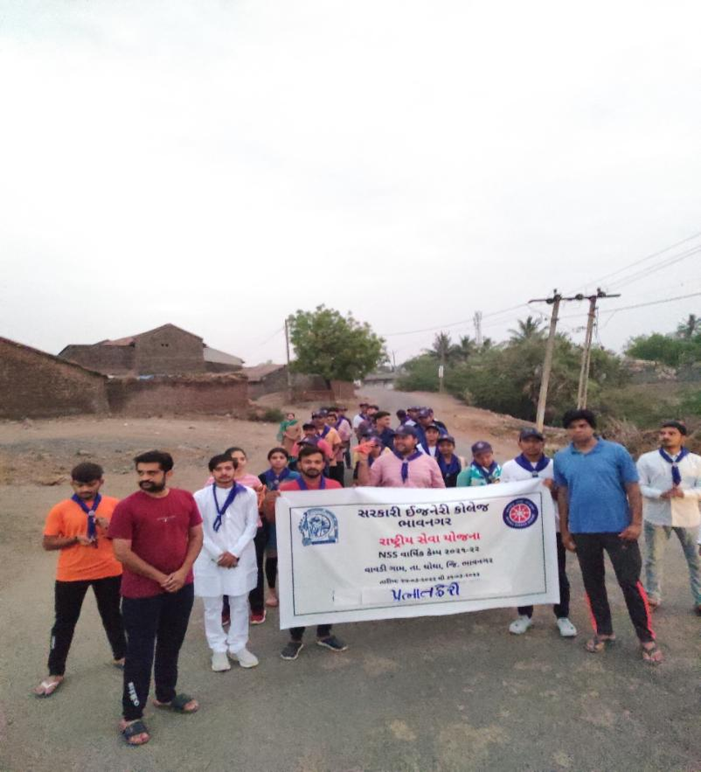
Special camp was organized from 25th March, 2022 to 31st March, 2022 by GTU NSS Unit, Government Engineering College, and Bhavnagar (021)

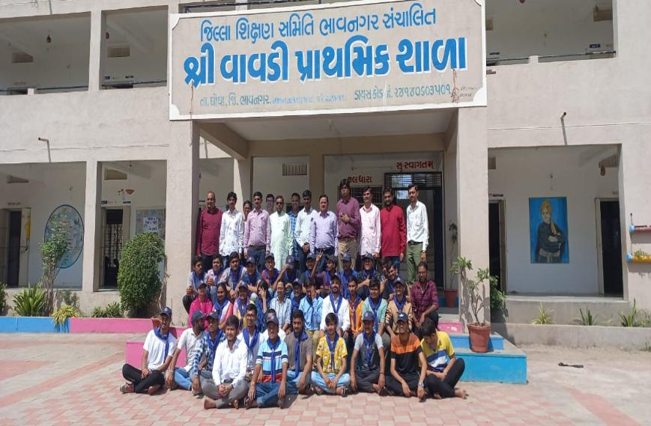
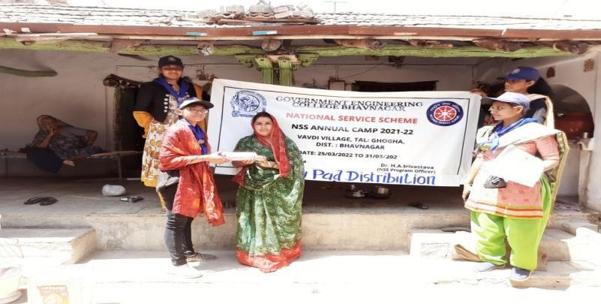
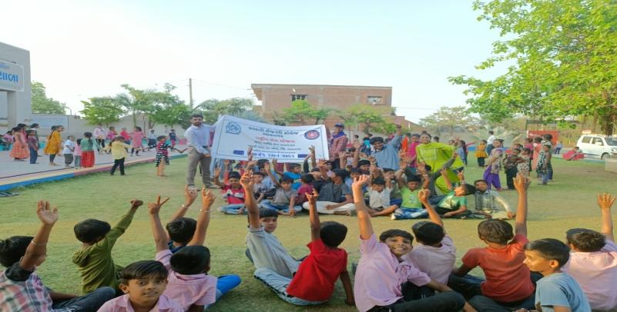
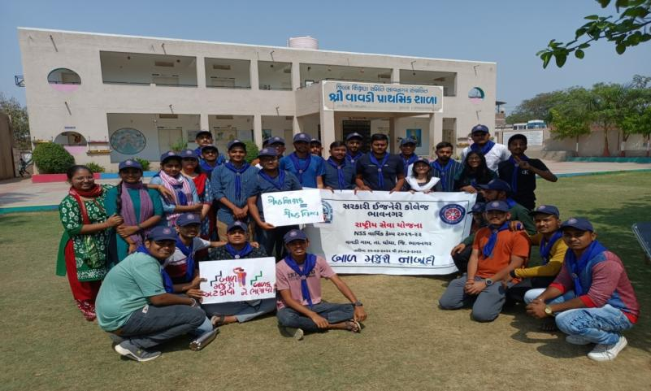
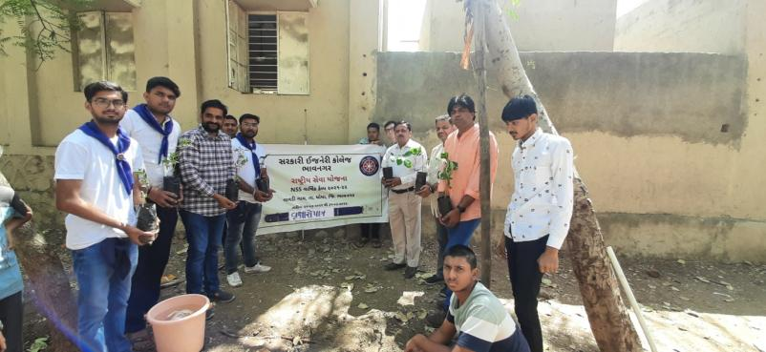
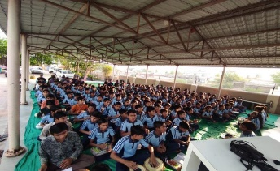
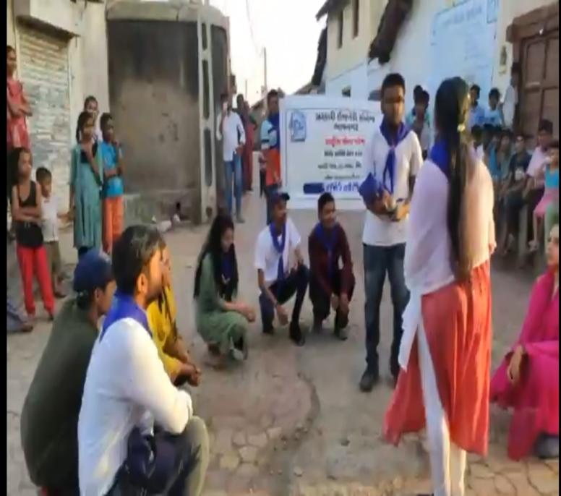
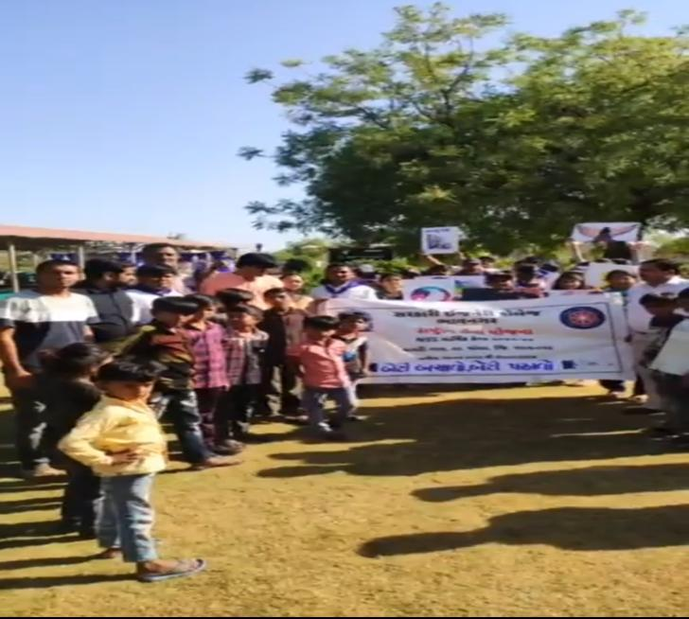
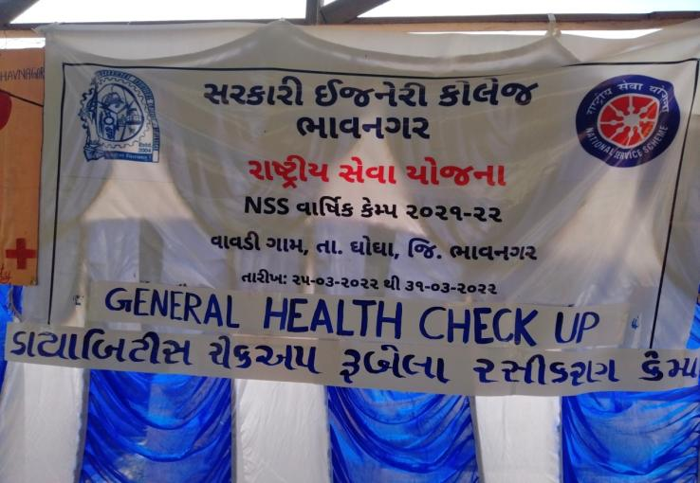
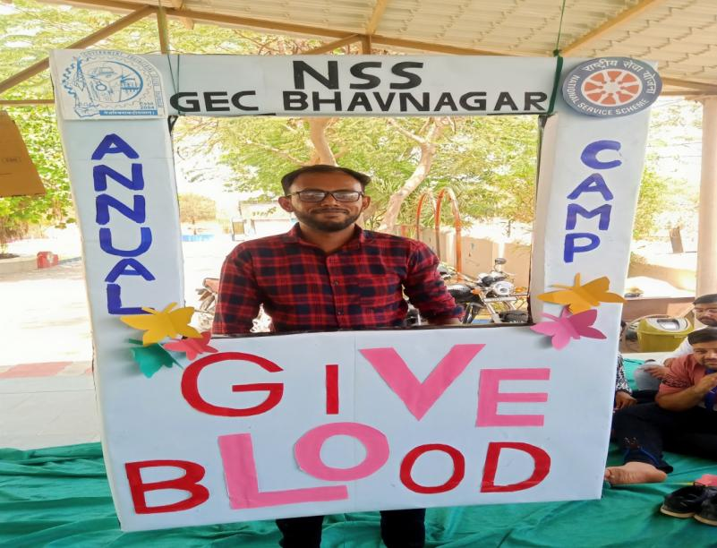
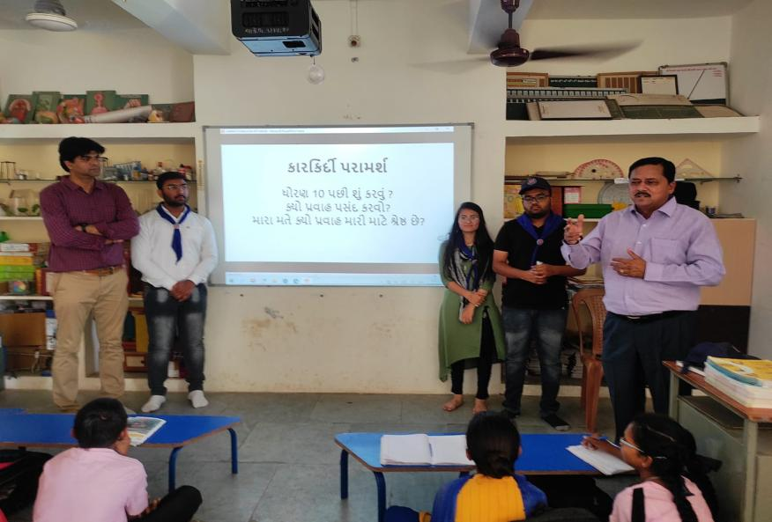
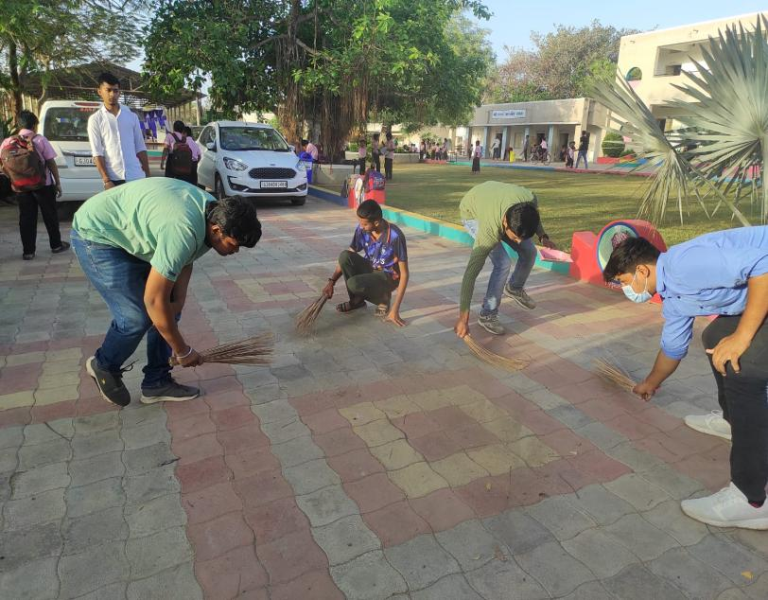
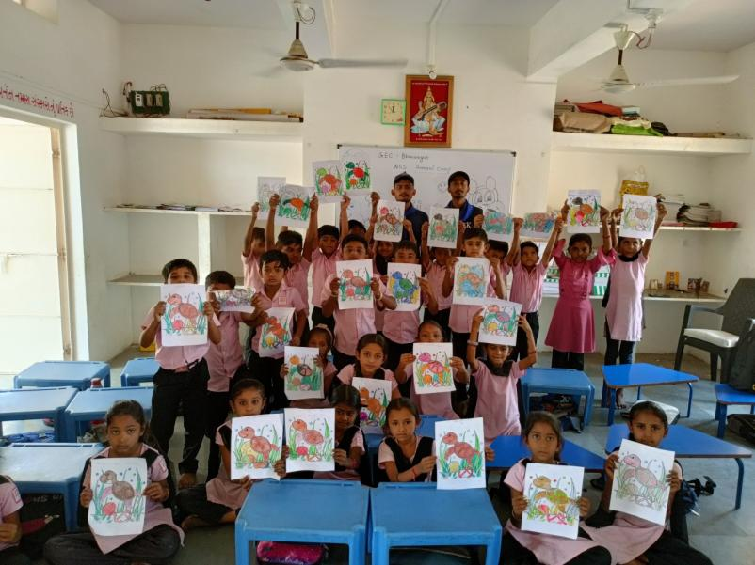
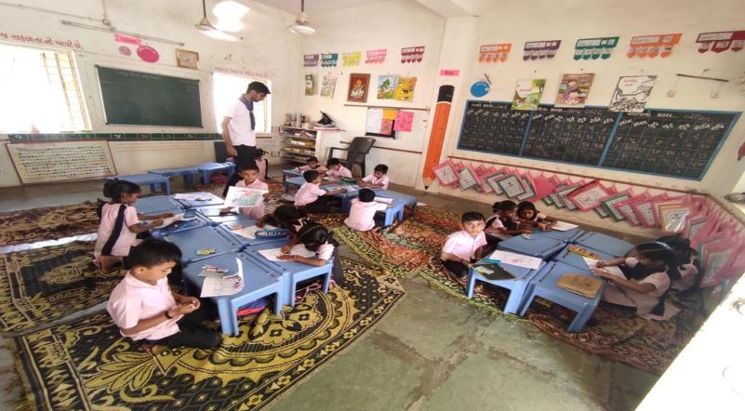
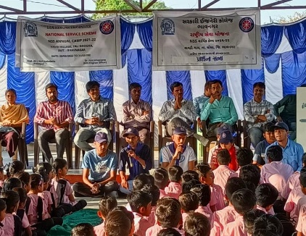
Special camp was organized from 25th March, 2022 to 31st March, 2022 by GTU NSS Unit, Government Engineering College, and Bhavnagar (021)

E.NSS State Day Celebration at 2021
The NSS State Day Celebration 2021 was held at Krantiguru Shyamji Krishna Verma Kachchh University, Kachchh. On 22nd to 24th September 2021. Many Universities from all over Gujarat had participated in it. 25 students from various universities of Gujarat Technological University were selected in different activities.
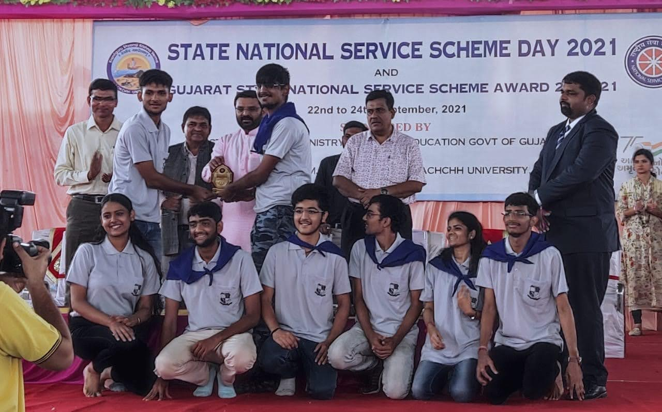

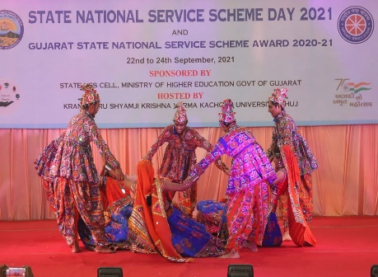

Team GTU at Garba Competition
GTU Students won in 7 activities (out of 15) consisting of Photography, Elocution Competition, Slogan Writing, Group Song, Group Dance , Poster Painting and PO’s Competition on “My Unit and Adopted Village”
Sr .No | Name of Event | Position | Name of Student/PO
1 | Photography | 3rd | Yadav Vikas Jaiprakash (060)
2 | Elocution Competition | 2nd | Chavda Vedant Dipakkumar (060)
3 | Slogan Writing | 3rd | Ishita Tannarana (205)
4 | Group Song | 3rd | Bhargavkumar A Pandya  Patel Ayush Gordhanbhai  Shlok Mandaliya  Palak Joshi  Meet Khatri  Prapti Pandya  Harsh Patel  Darshan Pathak
5 | Group Dance | 2nd | PatelNevilkumar Sureshbhai  Bhakti Patel  Dhruvi Pandit  Master Yagni Hiteshbhai  PatelBansari Dharmendrakumar  Manan Giri Goswami  Shubham Hirani  Riya Gamit Shashikant  DesaiNishantkumar Mohanlal  Patel Ayush Gordhanbhai
6 | Poster Painting | 2nd | Padhariya Milan Vikrambhai (028)
7 | My Unit & Adopted Village | 2nd | Mr. Bharat K Vadhiya (124)
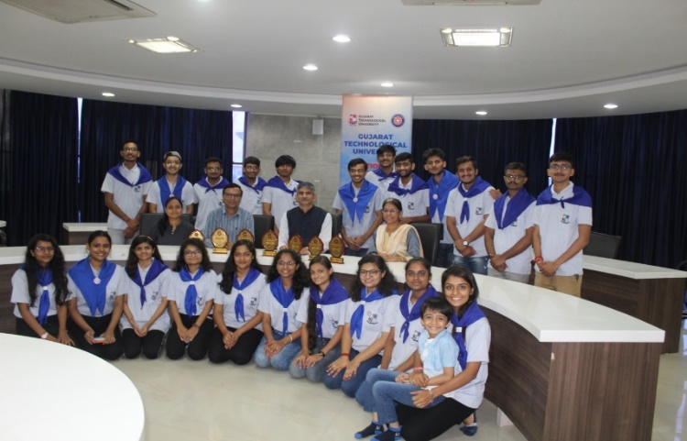
A team of State NSS Day Celebration reached at GTU at 11:30 PM on 24th September 2021 and arranged welcome Function for the motivation and appreciation of NSS Volunteers’ achievements on 27th September 2021. Dr. K.N. Khersir, Prof. Alpesh Dafda sir and other GTU Staff of NSS and Sport were present and appreciated student’s achievements. Dr. K. N. Kher, Registrar of GTU was a chief guest of this program. He welcomed NSS GTU team and motivated.
Some Glimpses of Welcome Function at GTU

F. National and State NSS Award for NSS-GTU (2019-20)

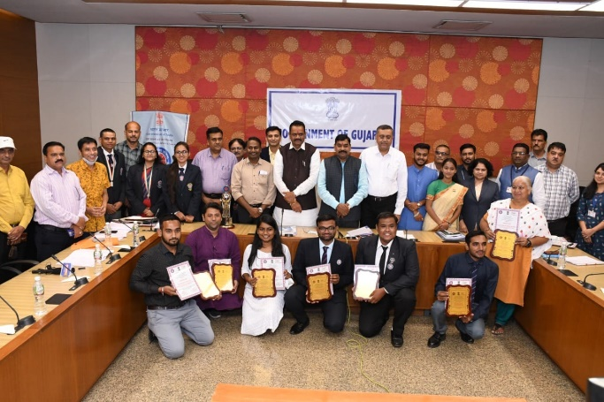
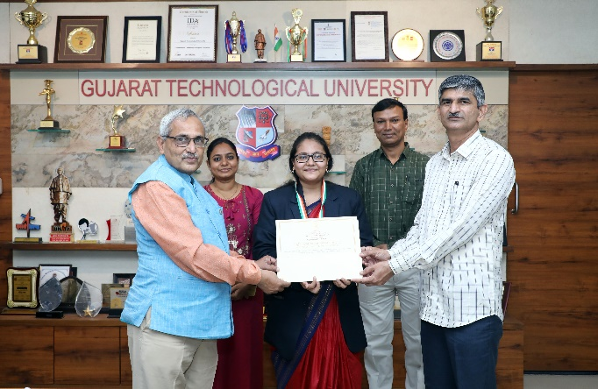
On 24th September, 2021 on the occasion of NSS day NSS volunteer Zankhana Joshi received National NSS award-2019-20 by honorable President Shri Ramnath Kovind Sir of India. and 3 volunteers of GTU and 1 programme officer of GTU were Zankhana Joshi VGEC (017), Viral Taral LDCE (028) & Chirag Jesang Solanki –GEC-Patan (022) were awarded with State NSS award for best NSS volunteers 2019-20 and NSS Programme officer Dr Niket Shastri - (042) were awarded with State NSS award for best NSS Programme officer 2019-20 by honorable –Education Minister Shri jitubhai Vaghani of Gujarat.Award Winner taking blessings from honourable VC Prof.(Dr.) Navin Sheth Sir, GTU
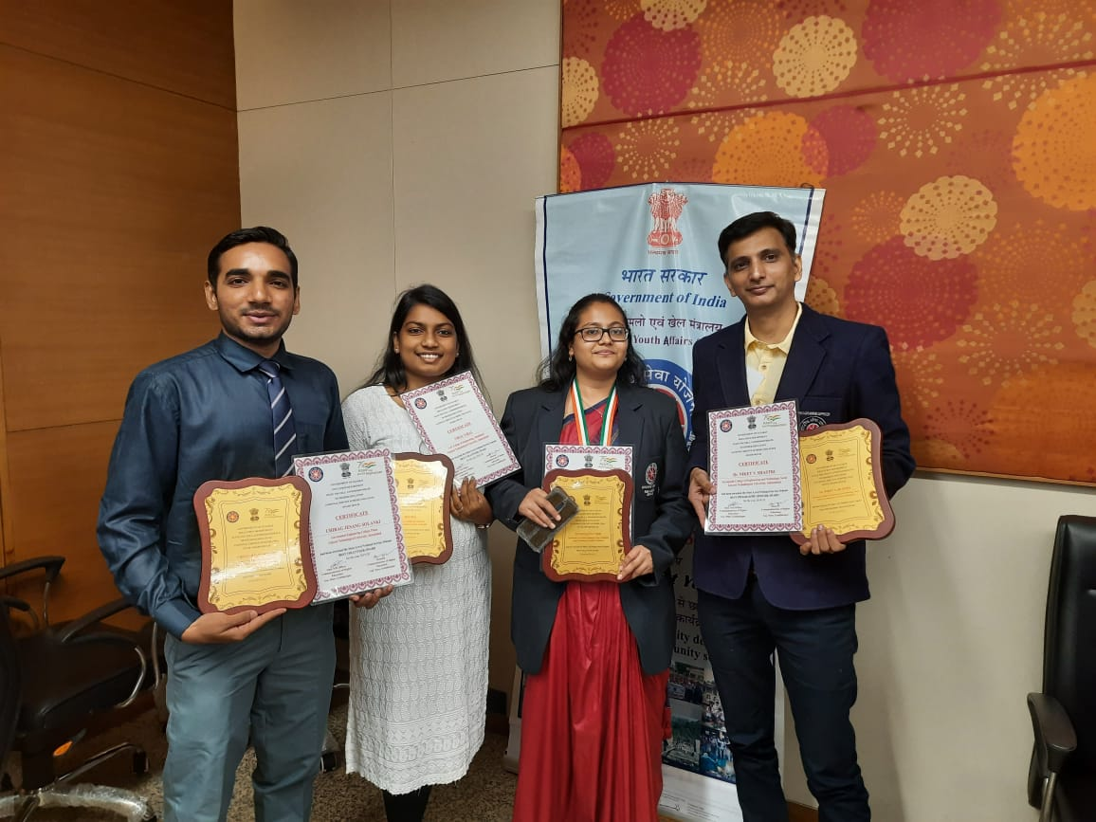

G. NSS-GTU Armed Forces Flag Fund Collection Award (2020-2021):

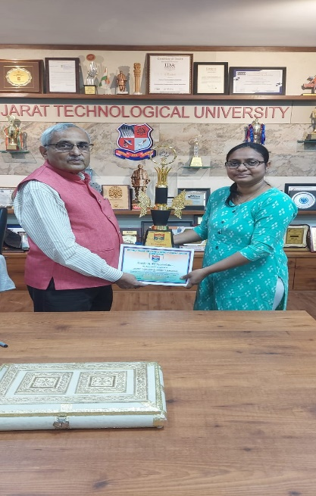
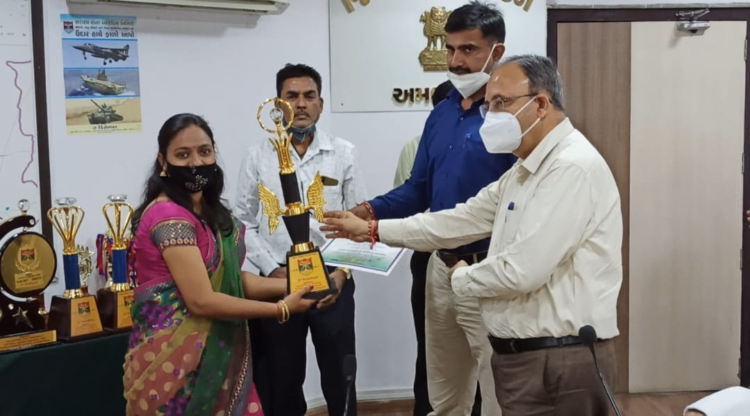

Sainik Welfare Fund is collected for the welfare of Soldier’sfamilies. It is our little contribution to them who contributes theirlives for our country. NSS-GTU actively collected Sainik WelfareFund this year also like every year. GTU was appreciated by
District Sainik Welfare & Resettlement Office for excellentcontribution towards Armed Forces Flag Fund collection 2020-2021 on 23rd February, 2022 at Collector Office. From NSS-GTU Mithila Patel attended this felicitation ceremony and collected the award for NSS-GTU.GTU has received 3rd rank in District Sainik Welfare &Resettlement Office on dated 23-02-2022 at 5:00 pm collectorOffice, Ahmedabad.GTU has given trophy for excellent contribution towards Armed Forces Flag Fund Collection Of Amount Rs. 4,83,791/-

H. An Expert Lecture Report on “Fundamental Rights and Duties under
Constitution”
(November 26, 2021)
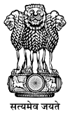

Introduction

We all are aware that NSS Cell of GTU organizes various social and academic activities for the social awareness and social upliftment of the people. Therefore, on the occasion of “Constitution Day”, GTU has organized an Expert Lecture on “Fundamental Rights and Duties under Constitution” with the motto, to make aware about our Indian Constitution including 06 Rights of Indian citizens. The Schedule of this guest lecture was below.
Date: November 26, 2021
Day: Friday
Time: 11:00 Am onwards
Venue: B-0 Hall, GTU Campus Chandkheda, Ahmadabad
A Brief Report on “Fundamental Rights and Duties under Constitution”.
An expert lecture started with the welcome address of Speakers, Ms. Shailee Shah (Legal officer TCPL Packaging Ltd) and Mr. Meet Shah (Advocate, High Court of Gujarat). The Chief Patron of this program was Prof. (Dr.) Navin Sheth (Hon’ble Vice Chancellor) Gujarat Technological University and Invitee was Dr.K.N.Kher, Registrar, Gujarat Technological University.
This program was started with the welcome speech Prof. (Dr.) Navin Sheth (Hon’ble Vice Chancellor) Gujarat Technological University; he spoke about the Motto to celebrate this constitution day on 26th November. Ms. Shailee Shah (Legal officer TCPL Packaging Ltd) discussed on the importance of fundamental duties and their relevance in the 21st century. She said, we should be aware of our constitutions and its provisions. Especially the provisions which have been included in light of experiences earned after implementation of constitution in the last 72 years

In addition, Mr. Meet Shah (Advocate, High Court of Gujarat), he also shared his idea regarding Fundamental Rights known as …

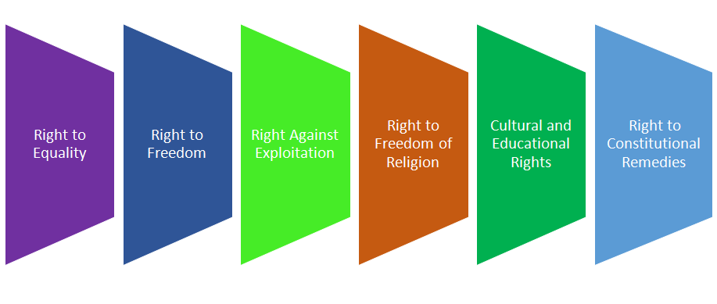
Hence, all the Students and GTU Faculties learnt with zeal and zest about their rights as the citizen of India. More than 100 Students and Faculties were present and cooperated to make this program successful. At the nutshell, Dr. Alpesh Dafda , GTU NSS University Program Coordinator , gave vote of thanks for the success of this Program.

Conclusion
We conclude this expert lecture after question –answer session. We are very much thankful to all the NSS Volunteers’ and Staff of GTU who involved with zeal and zest to make this program successful. At the nutshell, we are very much thankful to Prof. (Dr.) Navin Sheth (Hon’ble Vice Chancellor) and Dr.K.N.Kher , (Registrar ) for giving us permission and motivated a lot to organize this Expert lecture .

Flyer of the Event
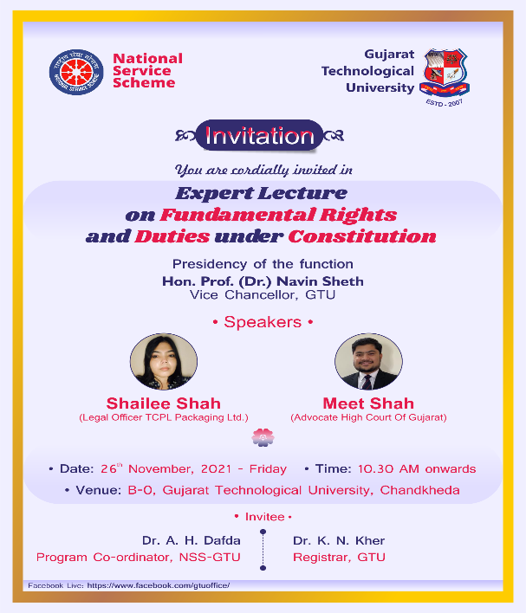

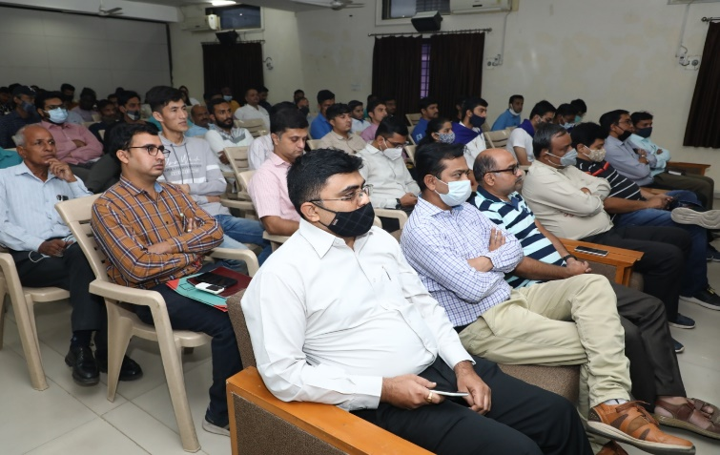
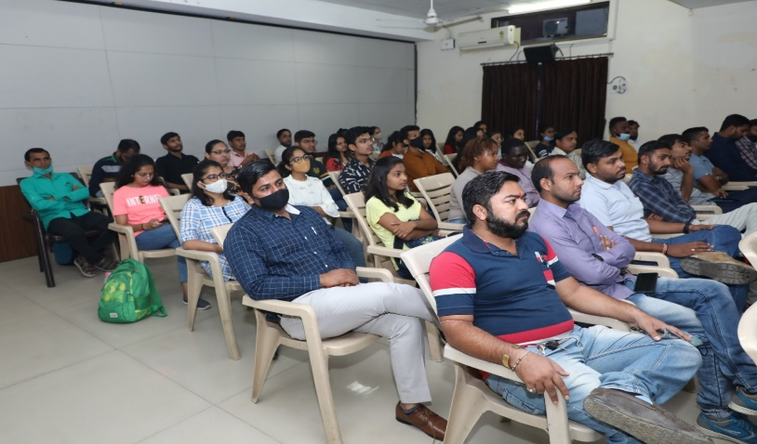
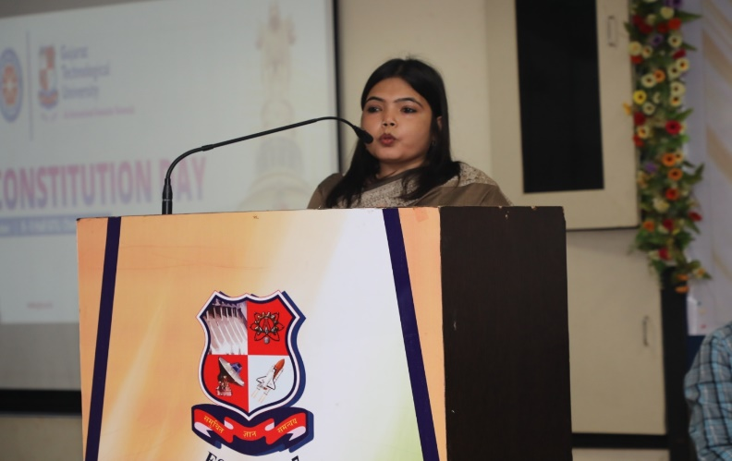
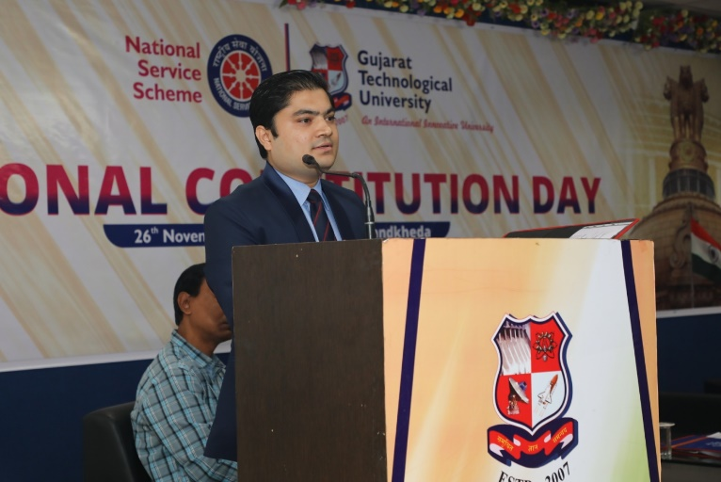
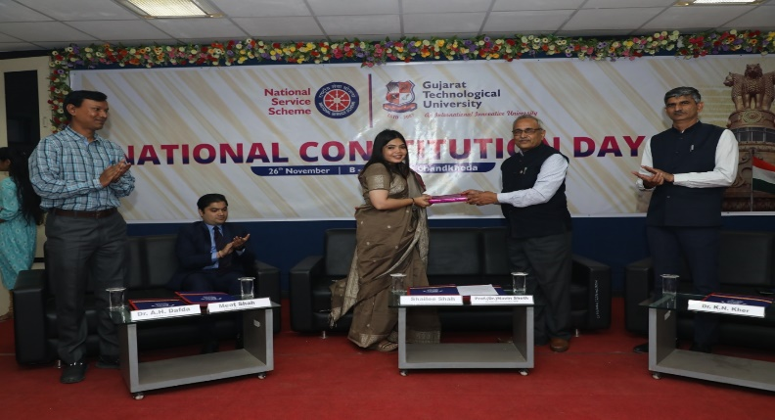
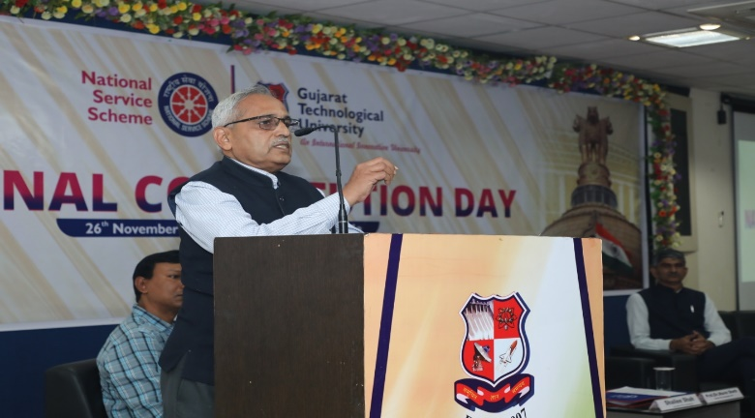
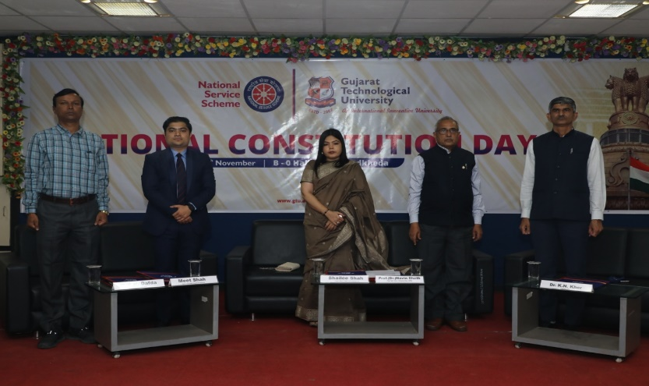
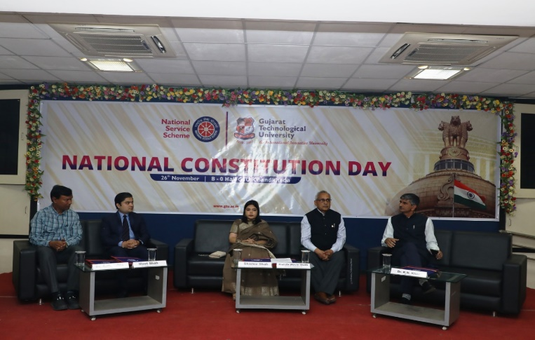

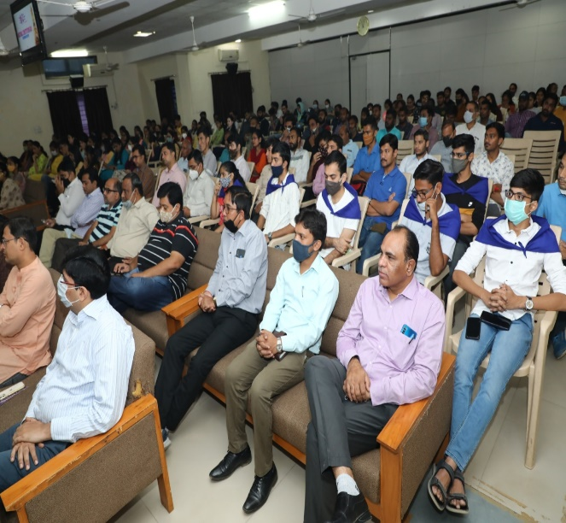
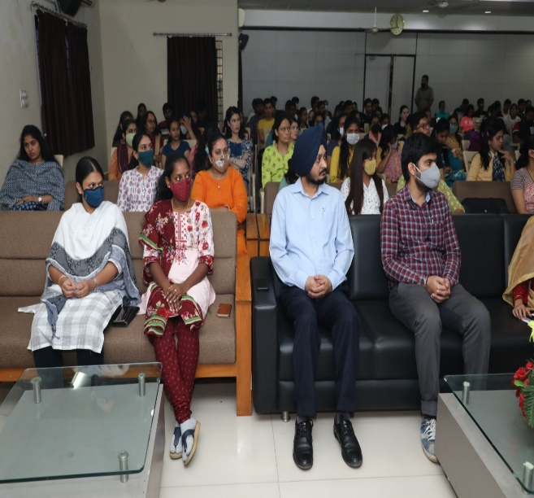
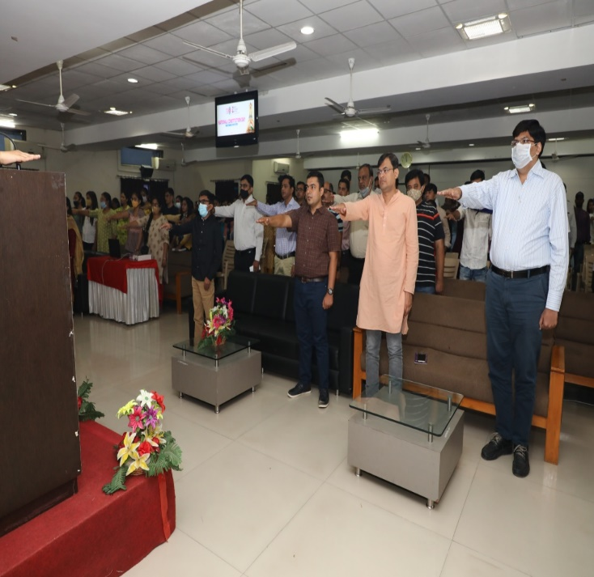
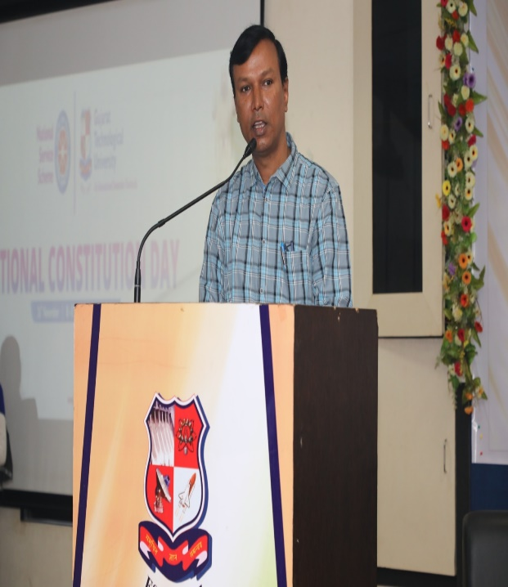

I. One-Day Workshop” for NSS Program Officers Organized by NSS
Cell of Gujarat Technological University & Sponsored by State
NSS Cell, Commissionerate of Higher Education, and Government
of Gujarat.
(17th December 2021)
Introduction
We all are aware that NSS Cell of GTU organizes various social and academic activities for the social awareness and social upliftment of the people. Therefore, NSS Cell of GTU organized one-day Workshop” for NSS Program Officer which was sponsored by State NSS Cell, Commissionerate of Higher Education, Government of Gujarat and main motto was to make aware about the role of NSS Program Officer, how and which types of activities can be organized during Special Camp as well as How we (NSS Cell) can contribute to the society and nation
The Schedule of this one-day Workshop was below.
Date: December 17, 2021
Day: Friday
Time: 08:30 Am onwards
Venue: B-0 Hall, GTU Campus Chandkheda , Ahmadabad

Report of one-Day Workshop” for NSS Program Officers.

This One day workshop was started with the welcome address of Speakers and delegates including the lamp lighting and GTU as well as NSS Song. After that all the delegates were felicitated with the shawls and gift as a part of token of love and respect. The president of this function was Prof. (Dr.) Navin Sheth ,Honourable Vice Chancellor , GTU. Chief Gust of this Workshop was Narayan Madhu , Joint Commissioner, Higher Education and guest of the honor was Shri Mahesh Mehta , State NSS Officer , Commissioner ate of Higher Education. In addition, the invitees were Dr. K.N. Kher , Registrar of GTU and Dr. A.H. Dafda , Program Co-Coordinator , NSS-GTU.
This workshop was started with the Prize Distribution of National Awardees Students and NSS Program Officer .A trophy and certificates were given by the State NSS Officer and delegates to the entire Award winner.
After that Prof.(Dr.) Navin Sheth , honourable Vice Chancellor, GTU gave welcome speech as a President of the function. He state that its our duty to do social work for the upliftment of the society and to save care our nation.

In addition , Mr. Amit Vasava , who is serving as a ACP , Cyber Crime , Ahmadabad. He talked about “Cyber Safe mission” and which things we shpud keep in mind during online payment and where and how to concat to the nearest police station. Morover, Dr. Twinkal Patel talked about “Mental Health and some issued ” we have been facing at presernt era. She mentioned that we should care and give sufficent love to our childrens in this era of tecchnology. She also mentioned that What is Mental Health ? , How to overcome mental health issue and how to behave with such typess of abnormal childrens. Next speaker of this program was Ms. Archna Gondaliya , she talked about the registration and some important process of “Panch Prakalp” because after the conductiong activities , we have to upload all the datas on this portal. She explain this concept with practical .
However, next speake of this program was Shri Mahesh Mehta , State NSS Officer , Commissioner ate of Higher Education , Gandhinagar. He talked about the imporatnce of “Panch Prakalp” , which activites we can conduct in adopted village , who to do registration of the studetns and faculties and many more impotant aspect he covered in his discussuion. In addiiton , we were fortunated to get knowledge about “New Education Policy ” from Dr. K.R. Parmar , Ex. Joint director of DTE. He talked about Advantages of this education policy as well as how we can apply at various level. Morover, he also mentioned that what is the requirement of this new policy . At last but not least, NSS Program officers gave their presentation with the motto to motivate all the NSS Program officers for the conducting result oriented activities at various level.
Hence, all the NSS Program officer learnt with zeal and zest about “Panch Prakalp , Cyber Safe mission , Mental health and “New Education Policy:2020 . More than 100 NSS Program officers were present and cooperated to make this program successful. At the nutshell, Dr. Alpesh Dafda , GTU NSS University Program Coordinator , gave vote of thanks for the success of this Program.

Conclusion
We conclude this workshop after question –answer session. We are very much thankful to all the NSS Program Officers who involved with zeal and zest to make this program successful. At the nutshell, we are very much thankful to Prof. (Dr.) Navin Sheth (Hon’ble Vice Chancellor) and Dr. K.N. Kher , (Registrar ) for giving us permission and motivated a lot to organize this Workshop .

Flyer of the Event

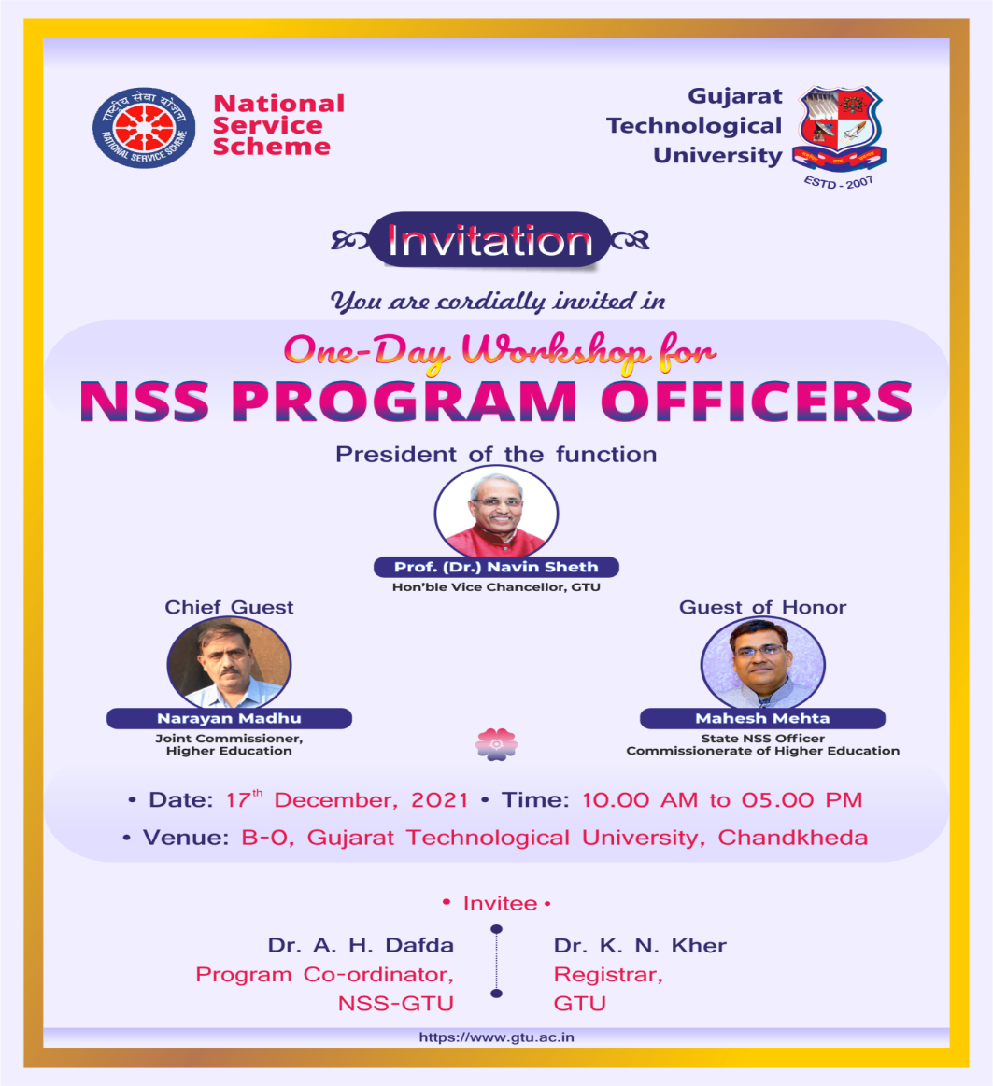

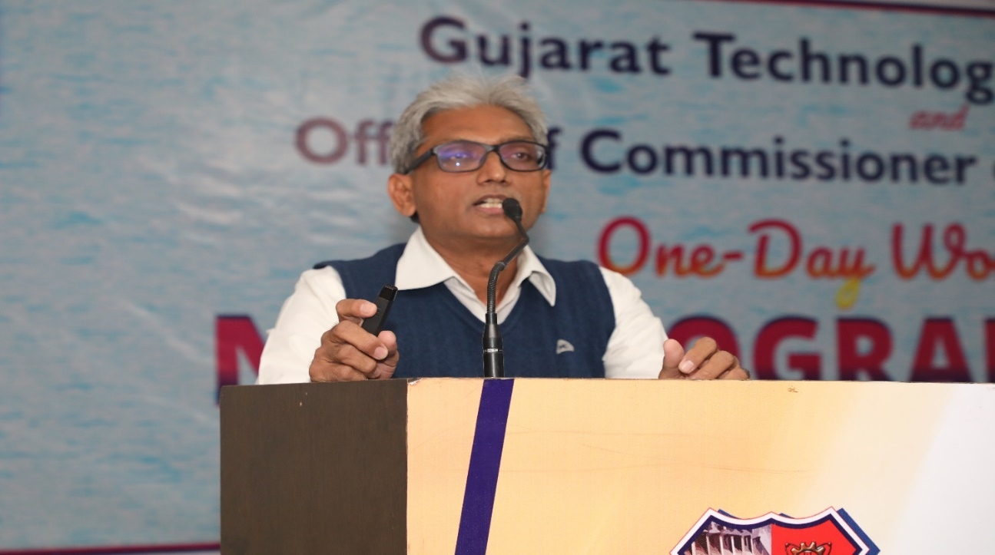
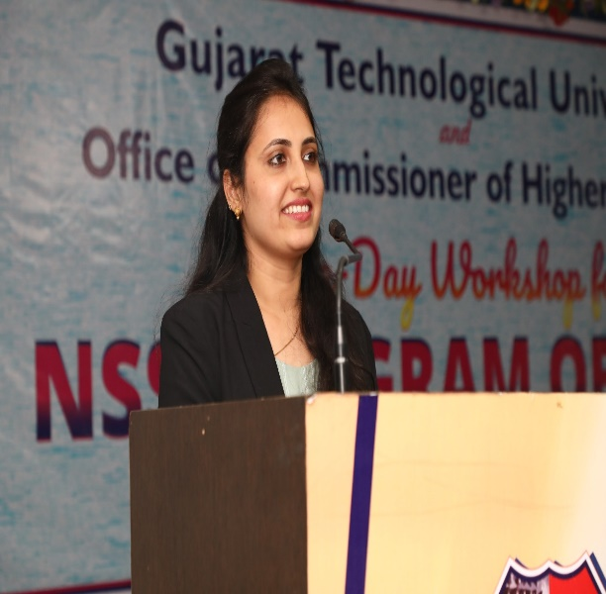
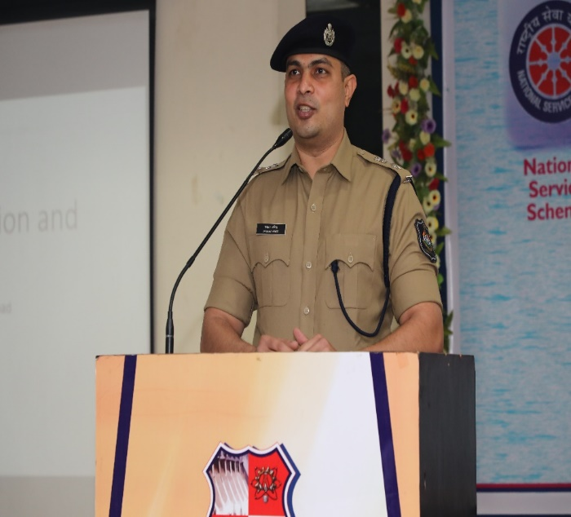
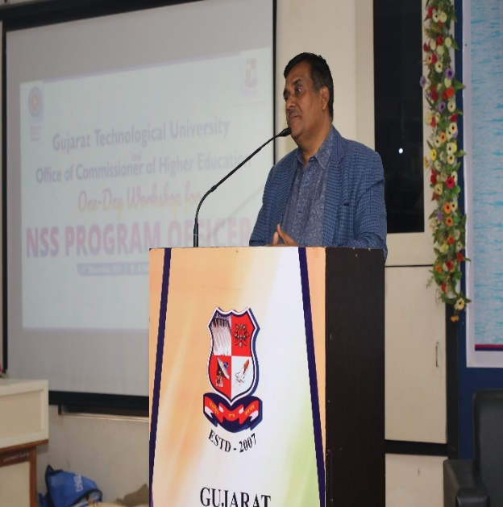
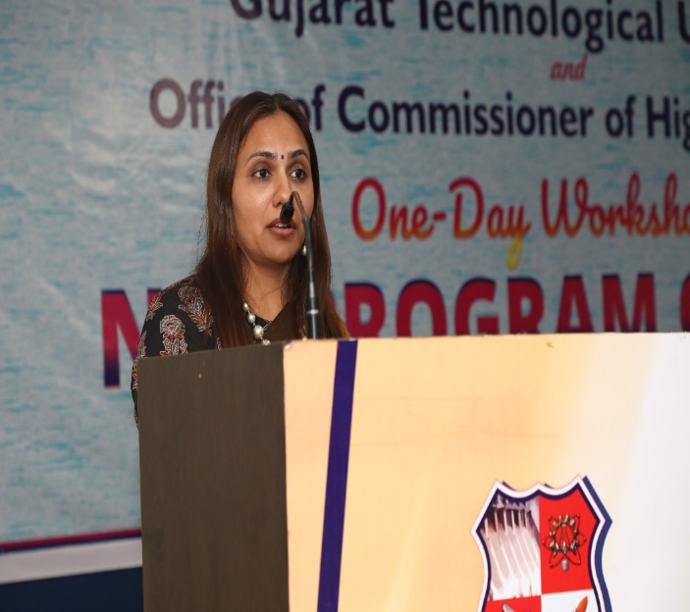
Press Note:

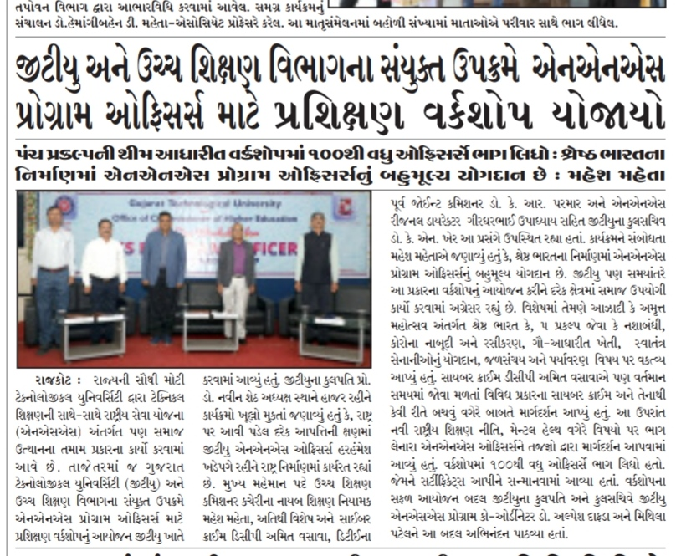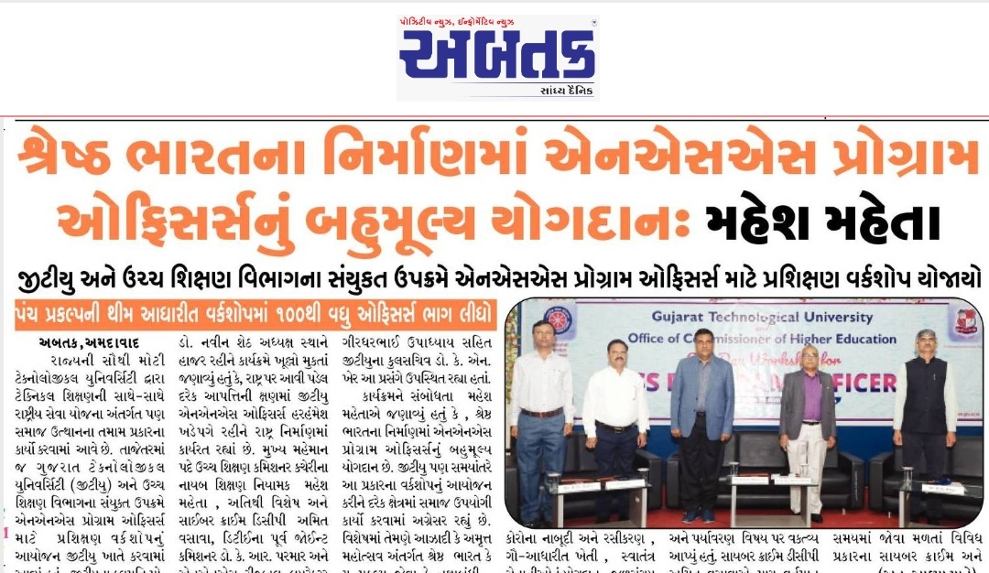

J. 8th International yoga day celebration on 21st June 2022

NSS Unit Name/College Name: GTU NSS
Event NAME: Yoga Day Celebration
Event Date, Time and Location: 21/6/2022, 6:00AM as per protocol given by Government GTU Chandkheda campus

Brief Description of the Event:

International Day of Yoga, or commonly and officially referred to as Yoga Day, is celebrated annually on 21st June since its inception in 2015. An international day for yoga was declared unanimously by the United Nations General Assembly (UNGA). Yoga is a physical, mental and spiritual practice originated in Bharat or India. The Indian Prime MinisterNarendra Modi in his UN address suggested the date of 21 June, as it is the longest day of the year in the Northern Hemisphere and shares special significance in many parts of the world.
The idea of International Day of Yoga was first proposed by the current Prime Minister of India, Mr. Narendra Modi during his speech at the UNGA, on 27 September 2014.He stated:

Yoga is an invaluable gift of India's ancient tradition. It embodies unity of mind and body; thought and action; restraint and fulfillment; harmony between man and nature; a holistic approach to health and well-being. It is not about exercise but to discover the sense of oneness with yourself, the world and the nature. By changing our lifestyle and creating consciousness, it can help in well-being. Let us work towards adopting an International Yoga Day.
— Narendra Modi, UN General Assembly

The ultimate goal of Yoga is moksha (liberation), although the exact definition of what form this takes depends on the philosophical or theological system with which it is conjugated.

Yoga Day Celebration
21st June, 2022
The early morning, the campus of GTU chandkheda witnessed the presence of energetic faculties, excited NSS volunteers at GTU chandkheda campus 6:00 am, on 21st of June 2022. Starting of this day was done by prayer as mentioned in the guide of yoga provided by government of India. Every activity was done according to the yoga guide. Faculties and students began with basic exercise and warmup. Several asanas were performed through this session with the support and instructions from our GTU Yog Trainer. This is recommended to every age of people must do yoga, which helps them to bring energy and potential for their goals. Day end but not the intentions, this was the end of 21st June, but we will continue to practice.

This was the great achievement to our GTU NSS, making things going perfectly as planned and accomplishing some great skills, through this very joyful and exciting event.

“International Yoga Day” was celebrated by Gujarat Technological University at GTU, Chandkheda Campus (Garden Area) in which Vice Chancellor Of GTU Shri Prof.(Dr). Navin Sheth Sir, Registrar Sir GTU Dr.K.N.Kher were remain presence in this Program. GTU Staff, Faculty, Students participated in “International Yoga Day” Programme. More Than 300 People were joined in celebration of “International Yoga Day”.

“Yoga for Humanity”

Photographs of the Event:
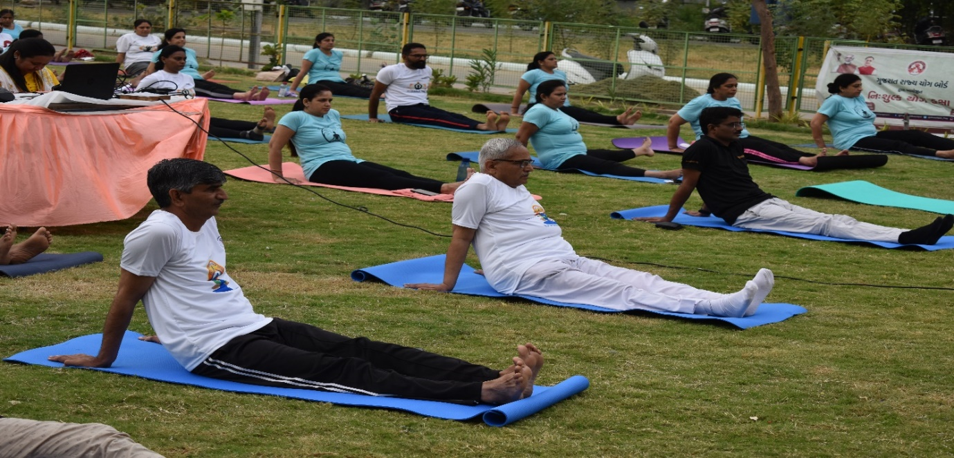
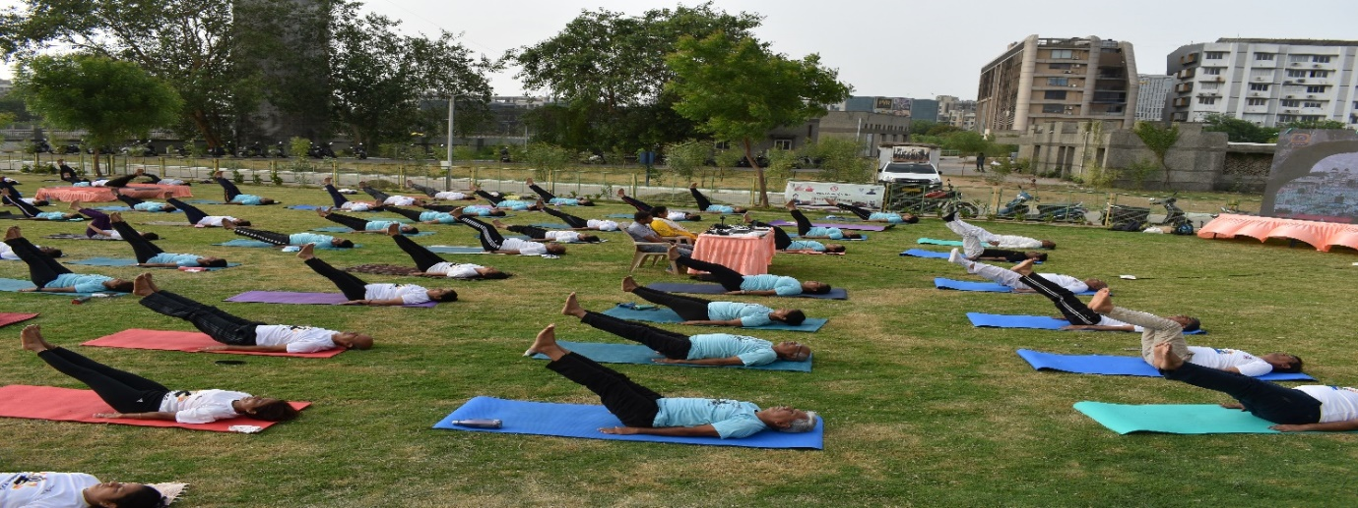
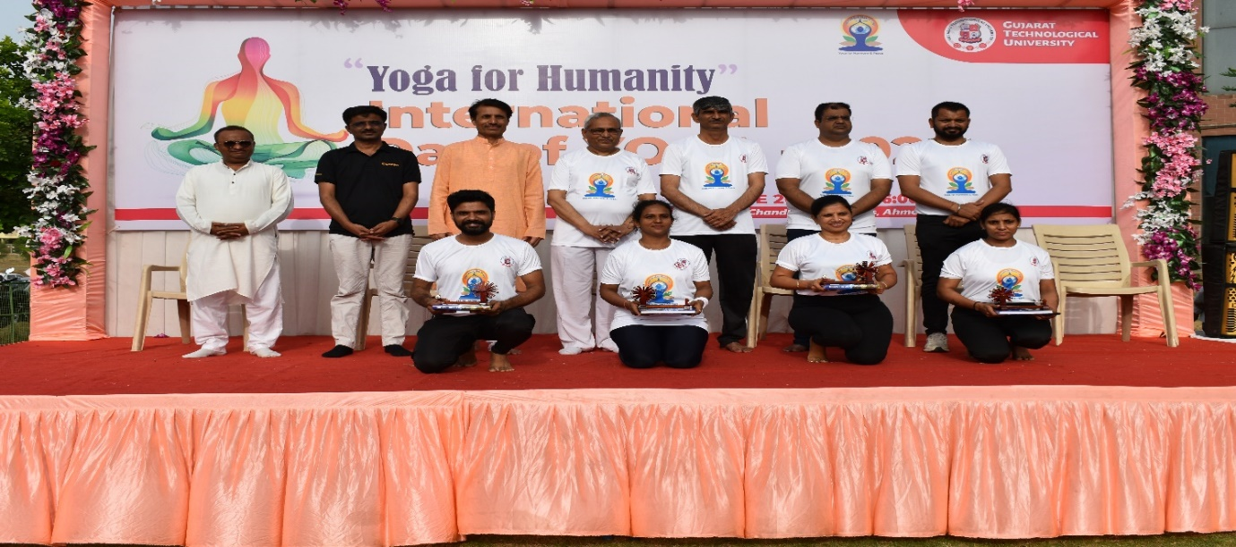
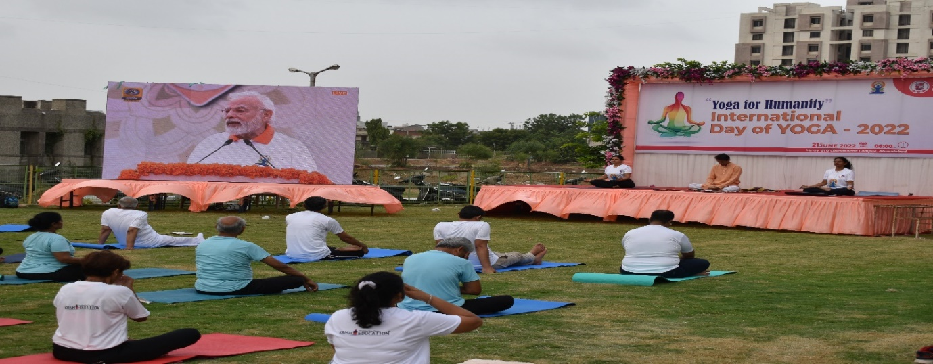
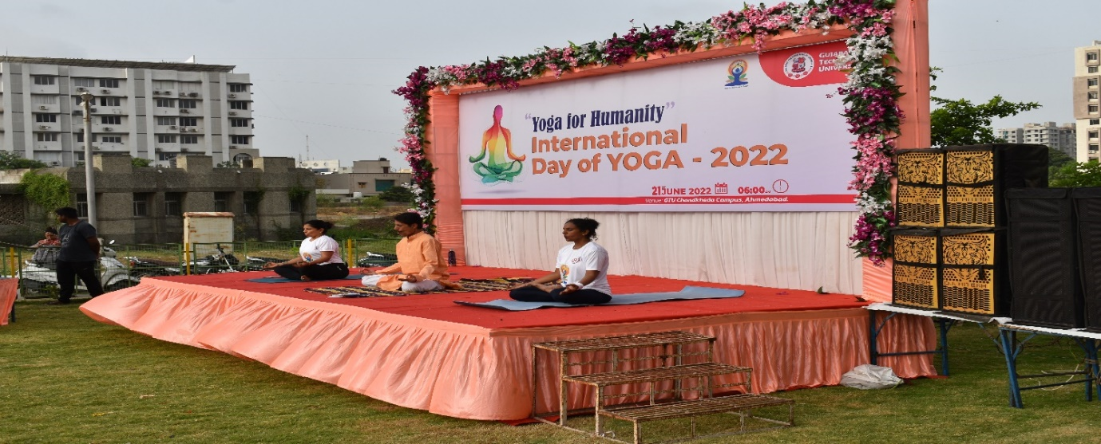
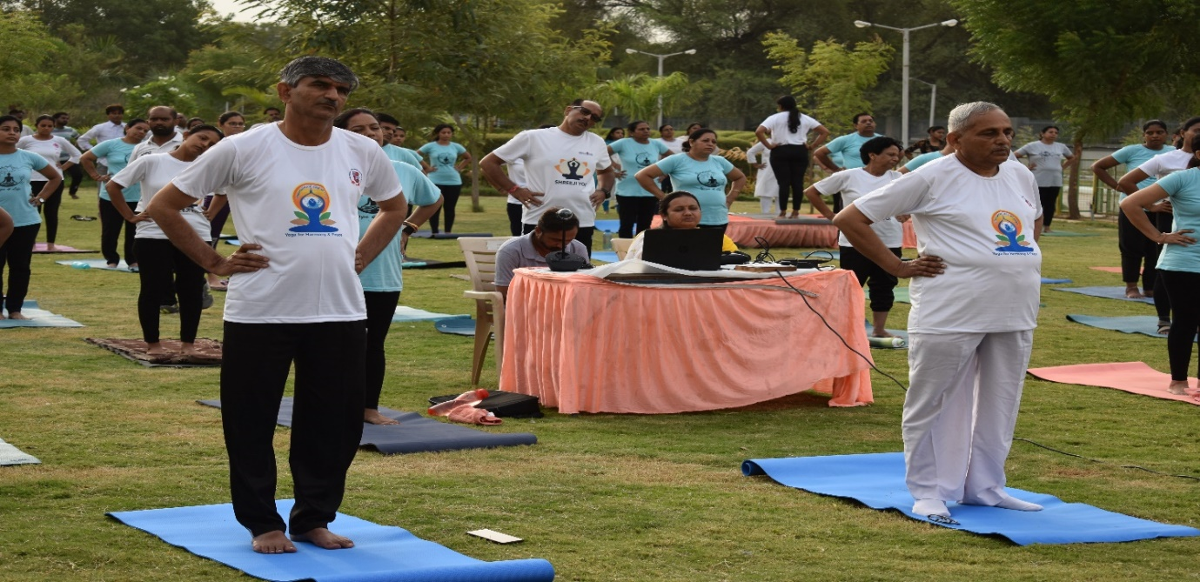
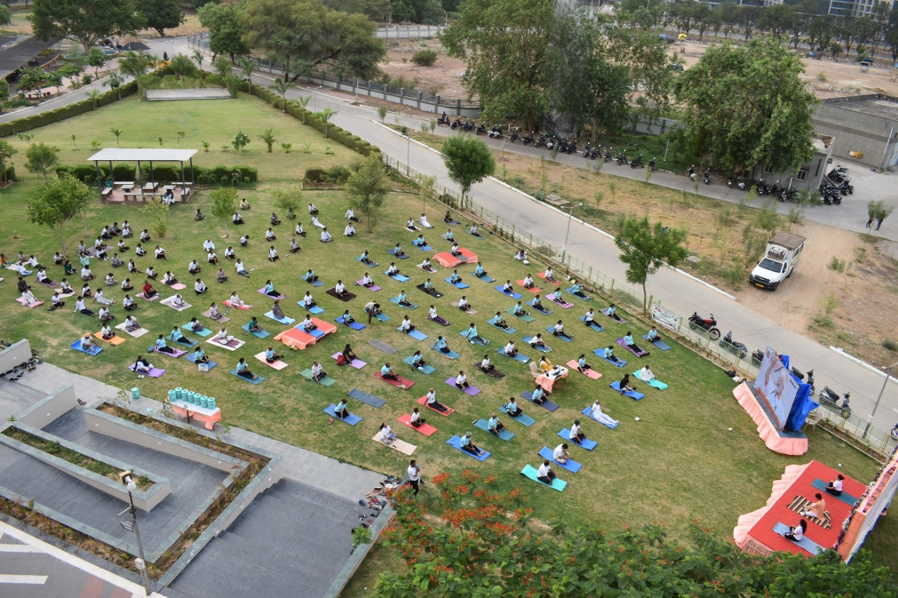
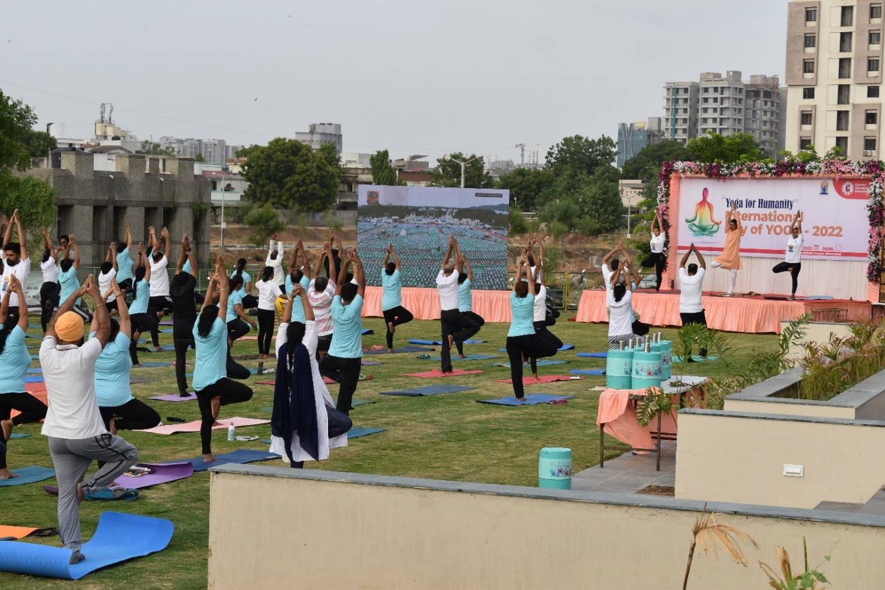

K. Seed ball project
NSS Unit Name/College Name: GTU NSS UNITS
Event NAME: Seed Balls Making Project
Event Date, Time and Location: 5/06/2022 to till date project is continue
Number of the volunteers participated: approx. 6500
Number of NSS Units participated: 35
Number of the seed balls: 10379

On Occasion of World Environment day GTU NSS announced and send e mail all GTU NSS units on 5th June, 2022 environment day celebration and seedball making project. Seedball preparation and plantation programme encouraged NSS Volunteers and informed them about the importance of the preservation of the environment.NSS Programme officer’s guided them to prepare the seedball and these seedballs were planted on the road side and on the land with scarcity of trees. NSS volunteers triggered the programme and concluded the same with great enthusiasm.
How to make seedball:
Seed ball is a seed which has been wrapped with the mixture of the soil, clay and compost. After that it will be dry up for the few times and it can be deposit anywhere suitable for the species, keeping the seed safely until the proper germination window arises. Seed balls are an easy and sustainable way to cultivate plants in a way that provides a larger window of time when the sowing can occur. On the World Environment Day, it can be planted in the monsoon season... We had taken soil, Clay and Compost and mix it thoroughly also added some water for the homogenise. From that 8514 Seed balls has been made.

Brief Description of the Event:
Many NSS units have done an activity to create seed balls. This activity include different parts like collection of the seeds from different places, then being together for making of a seed ball in their institute campus. The balls made out of clay embedded with seeds of trees to be grown. The different seeds that were procured for planting included blue berries, lemon, gulmohar. All these trees are common to the region and therefore require little maintenance and no special care. Seeds like jamboon, mango, dates, bael fruit, amaltas,
Cherry, plum etc. With the help of the NSS volunteers making of 8514 seed balls was possible. Some of the faculty members also participated into this activity.

Outcomes of the Event:
Awareness regarding the importance of environment was learned by the students.
Importance of the trees for the soil and environment was learned by all.
Students were become aware about to make the earth greener.
Student has learnt about the making of the seed balls
All the seed balls can be thrown on suitable site for the plantation after first rain in the area.
It will help in the enhancement of the Green Cover.

Photographs of the Event:
