Report AKAM Sanklap Day events
Particulars | Details
Name of Department/ Agency | Gujarat Technological University
Name of Ministry | Education
Name of event | Sanklap Day
Start Date of event | 14/09/2021
End date of event | Till Date and Continue
Theme of event | Freedom Struggle  Ideas@75  Achievements@75  Actions@75  Resolve@75
Description of event (150 word limit) | Under Sankalp day celebration GTU Affilated 31 colleges were participated in “Sanklap Day.” More than 2400 Students,Faculty and Staff were enthusiastically Participated in “Sankalp Day.”.Different colleges taken different Pledge on Occasion of Sankalp day. “Atmanirbhar Bharat”,”Plastic Free Campus”,Human Welfare,Pollution Free Earth etc Topics Pledge taking ceremony has been organized by GTU and GTU Affilated College staff,Students,Faculty were taking a pledge not to use Plastic and also make our campus Plastic Free.
Nature of participation in event | Jan Bhagidari (open to public)  Only participation from within department/Ministry (no public)
Expected number of participants in event | 2400
VIP attendees (if any) | -----
Associate partners | State/UT #1: | ---
 | State/UT #2: | ---
 | State/UT #3: | ----
Mode of event | Online event (webinar, virtual event)  Offline event (in-person participation)  Hybrid event (mix of online and offline modes)
Mode of advertisement of event | Website  Social Media  Newspapers  Television media  Other mode
Nodal officer | Name: |  | Dr.S.K.Hadia
 | Designation: |  | Associate Professor
 | Email ID: |  | asso_s_k_hadia@gtu.edu.in
 | Phone number: |  | 9427062772

Event Photograph
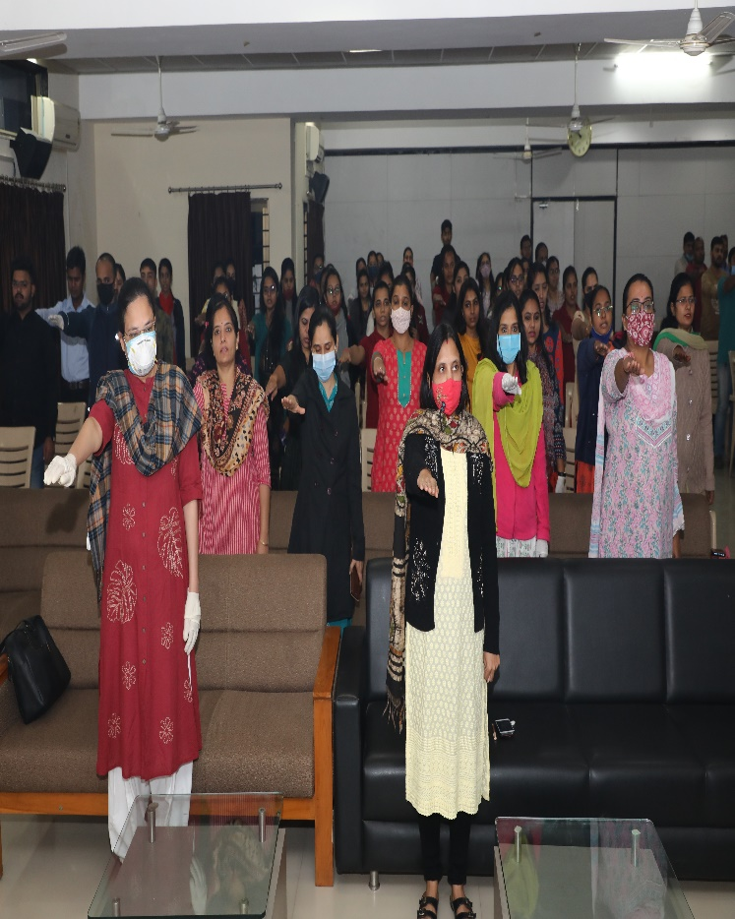 | 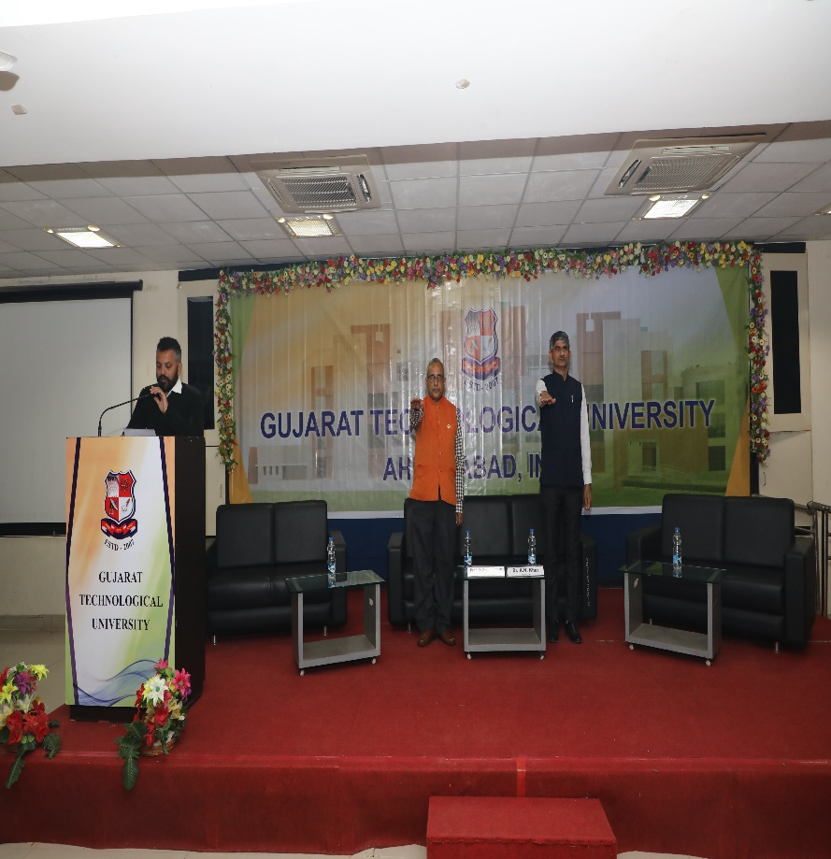
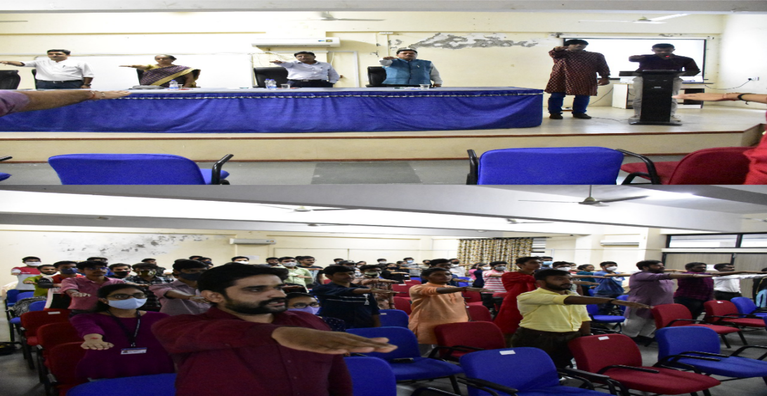
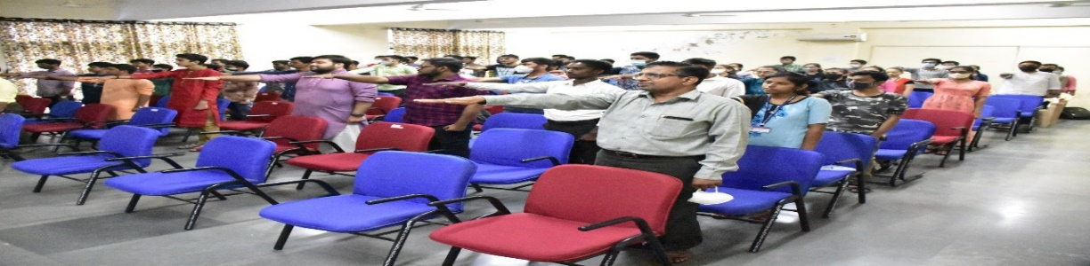

Report AKAM National Anthem events
Particulars | Details
Name of Department/ Agency | Gujarat Technological University
Name of Ministry | Education
Name of event | National Anthem
Start Date of event | 14/09/2021
End date of event | Till Date and Continue
Theme of event | Freedom Struggle  Ideas@75  Achievements@75  Actions@75  Resolve@75
Description of event (150 word limit) | As a part of Azadi Ka Amrut mahotsav celebration, Rastragan video Recording had organized by ministry of youth affairs and sports, central government ofIndia. GTU Affiliated 33 Colleges and 3200 Students,staff, family member,faculty actively and proudly participated in this activity.” GTU had celebrated Independence day-2021 and under this Activity all GTU Staff/Faculty/Students/Family members actively and proudly participated in this activity.
Nature of participation in event | Jan Bhagidari (open to public)  Only participation from within department/Ministry (no public)
Expected number of participants in event | 3200
VIP attendees (if any) | -----
Associate partners | State/UT #1: | ---
 | State/UT #2: | ---
 | State/UT #3: | ----
Mode of event | Online event (webinar, virtual event)  Offline event (in-person participation)  Hybrid event (mix of online and offline modes)
Moe of advertisement of event | Website  Social Media  Newspapers  Television media  Other mode
Nodal officer | Name: |  | Dr.S.K.Hadia
 | Designation: |  | Associate Professor
 | Email ID: |  | asso_s_k_hadia@gtu.edu.in
 | Phone number: |  | 9427062772

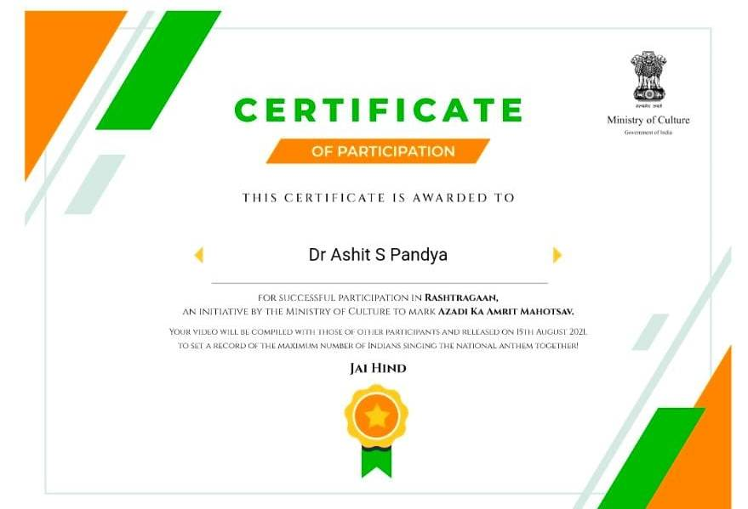 | 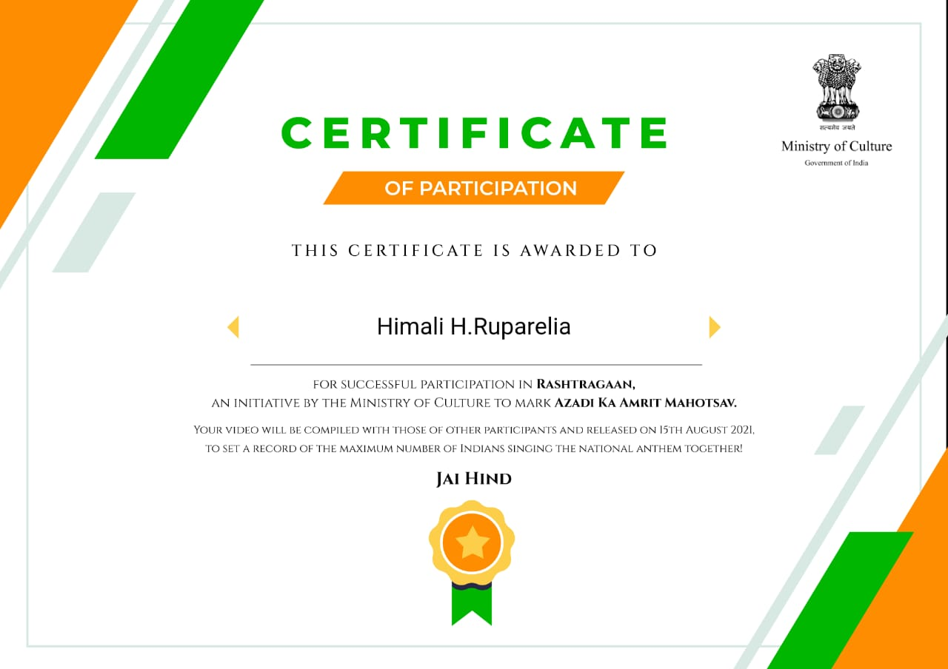
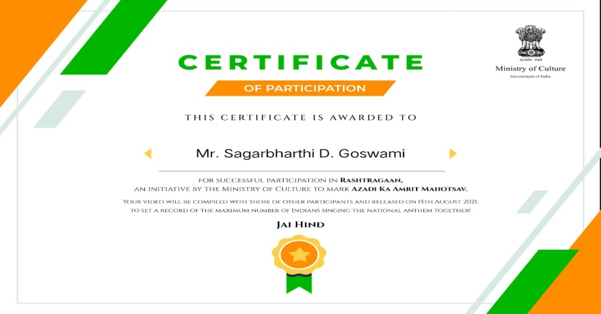 | 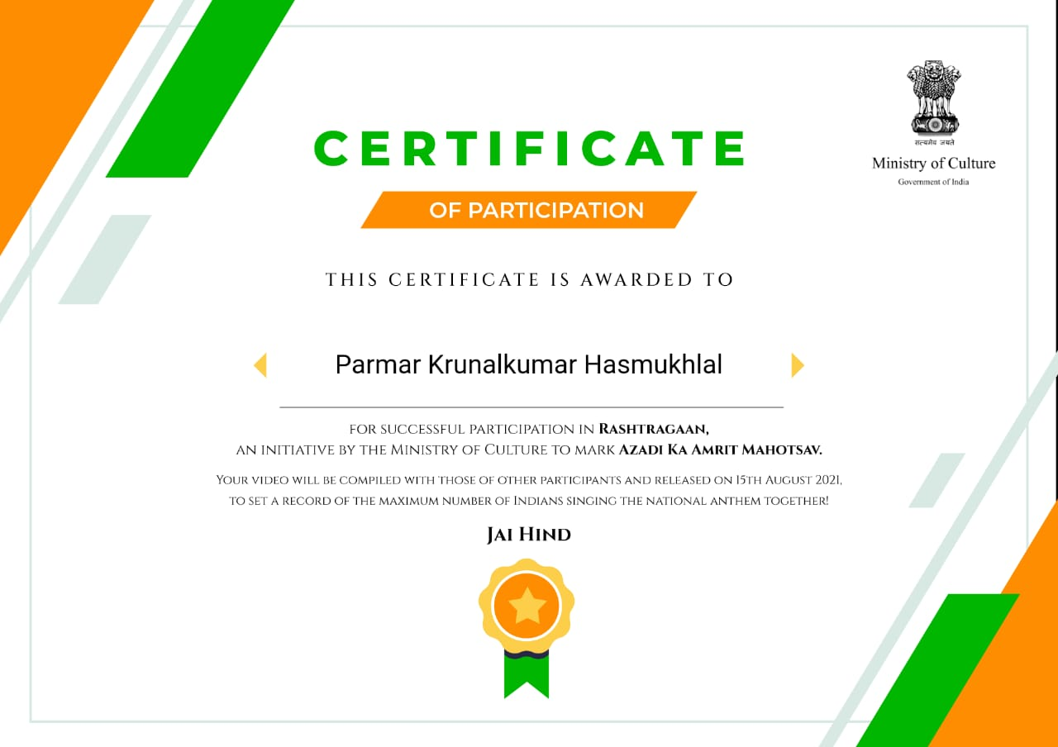

Particulars | Details
Name of Department/ Agency | Gujarat Technological University
Name of Ministry | Education
Name of event | Triranga Yatra
Start Date of event | 14/09/2021
End date of event | Till Date and Continue
Theme of event | Freedom Struggle  Ideas@75  Achievements@75  Actions@75  Resolve@75
Description of event (150 word limit) | AzadiKaAmrut Mahotsav is a series of events to be organised by the Government of India to commemorate the 75th Anniversary of India’sIndependence.GTUAffilated 15 College has Organized “TrirangaYatra”. In Triranga Yatra 1100 Studnts,Faculty and Staff were participated in Triranga Yatra.
Nature of participation in event | Jan Bhagidari (open to public)  Only participation from within department/Ministry (no public)
Expected number of participants in event | 1100
VIP attendees (if any) | -----
Associate partners | State/UT #1: | ---
 | State/UT #2: | ---
 | State/UT #3: | ----
Mode of event | Online event (webinar, virtual event)  Offline event (in-person participation)  Hybrid event (mix of online and offline modes)
Moe of advertisement of event | Website  Social Media  Newspapers  Television media  Other mode
Nodal officer | Name: |  | Dr.S.K.Hadia
 | Designation: |  | Associate Professor
 | Email ID: |  | asso_s_k_hadia@gtu.edu.in
 | Phone number: |  | 9427062772
Report AKAM Triranga Yatra events

Event Photograph
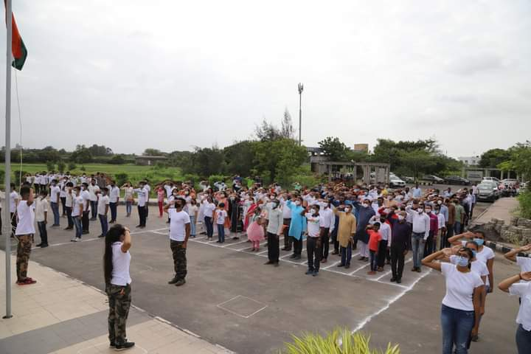 | 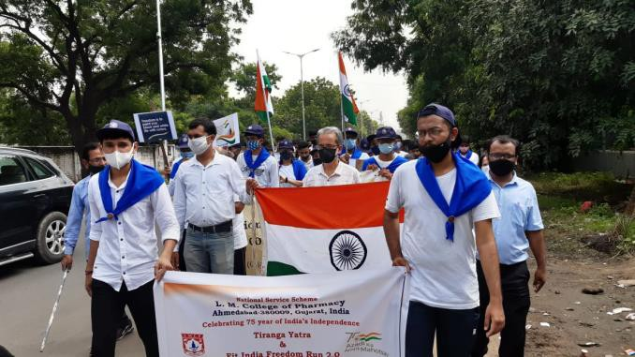
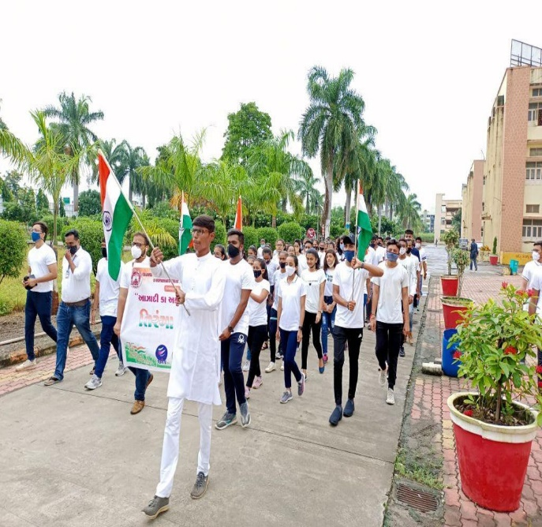 | 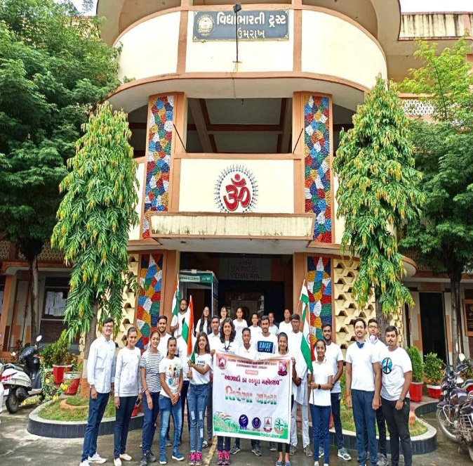

Report AKAM Fit India Freedom Run 2.0 events
Particulars | Details
Name of Department/ Agency | Gujarat Technological University
Name of Ministry | Education
Name of event | Fit India Freedom Run
Start Date of event | 14/09/2021
End date of event | Till Date and Continue
Theme of event | Freedom Struggle  Ideas@75  Achievements@75  Actions@75  Resolve@75
Description of event (150 word limit) | Under “Fit India Freedom Run” GTU Affiliated 26 Colleges and 1850 Students/Staff/Faculty/Family members had participated in AzadiKaAmrut Mahotsav with GujaratTechnological University. All the students and staff members have enthusiastically participate in “Fit India Freedom Run-2:0”.The Purpose of the Event was to spread awareness on health and fitness among the people” associated with the institute.  On Occasion of "Azad Hind Sarkar Divas" Gujarat Technological University had organized “Fit India Freedom Run 2.0" to embody the "Azadi ka Amrut Mahotsav" programme. more than 820 GTU Students/Faculty/Staff were participated in ““Fit India Freedom Run 2.0".The aim of “Fit India Freedom Run 2.0" give message to society aware for fitness and remember the Freedom fighters who sacrifice their lives for freedom of our Nation.Hon’ble Education Minister shri Jitubhai Vaghani were come as a Chief Guest in “FIT INDIA FREEDOM RUN 2.0”.
Nature of participation in event | Jan Bhagidari (open to public)  Only participation from within department/Ministry (no public)
Expected number of participants in event | (1850+820)2076
VIP attendees (if any) | -----
Associate partners | State/UT #1: | ---
 | State/UT #2: | ---
 | State/UT #3: | ----
Mode of event | Online event (webinar, virtual event)  Offline event (in-person participation)  Hybrid event (mix of online and offline modes)
Moe of advertisement of event | Website  Social Media  Newspapers  Television media  Other mode
Nodal officer | Name: |  | Dr.S.K.Hadia
 | Designation: |  | Associate Professor
 | Email ID: |  | asso_s_k_hadia@gtu.edu.in
 | Phone number: |  | 9427062772

Event Photograph
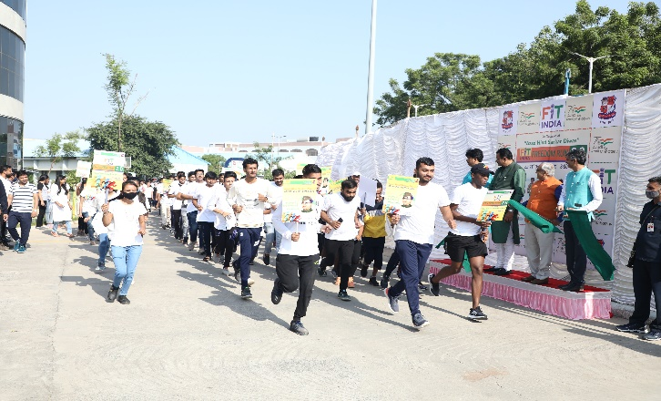 | 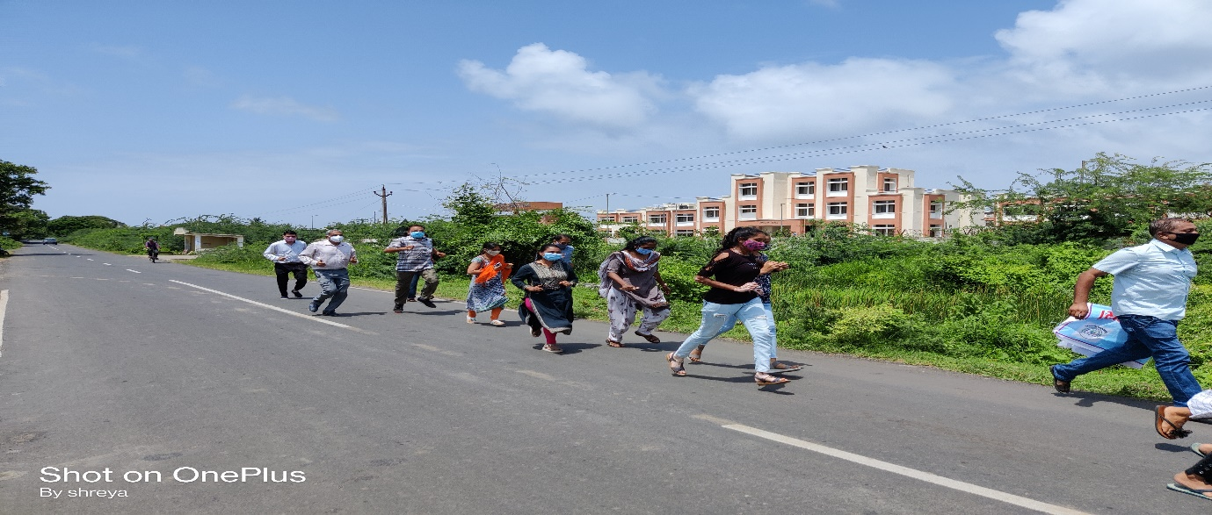
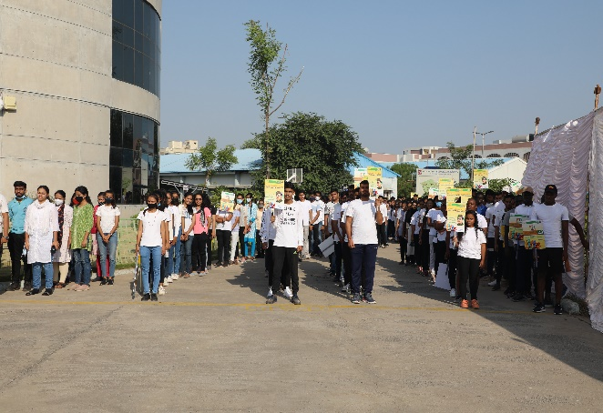 | 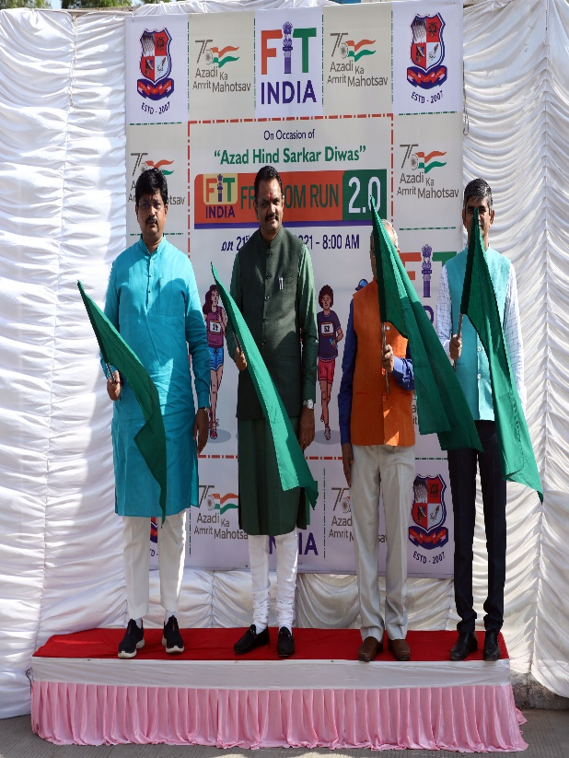

Report AKAM Ek Bharat Shrestha Bharat events
Particulars | Details
Name of Department/ Agency | Gujarat Technological University
Name of Ministry | Education
Name of event | Ek Bharat Shrestha Bharat
Start Date of event | 14/09/2021
End date of event | Till Date and Continue
Theme of event | Freedom Struggle  Ideas@75  Achievements@75  Actions@75  Resolve@75
Description of event (150 word limit) | The intent of Ek Bharat Shresth Bharat is to further the idea of a sustained and structured frameworkof connection between people of different regions of India. The Mahotsav was celebrated to enhance interaction and promote mutual understanding between people of different States & Union Territories conducting activities in the areas of language, learning, tangible as well as intangible culture and heritage, paving the way for systematic process of mutual engagement and appreciation amongst people. Under “Ek Bharat Shresth Bharat” GTU Affiliated 14 Colleges and 800 Students/Staff/Faculty/Family members had participated in Azadi Ka Amrut Mahotsav with Gujarat Technological University.
Nature of participation in event | Jan Bhagidari (open to public)  Only participation from within department/Ministry (no public)
Expected number of participants in event | 800
VIP attendees (if any) | -----
Associate partners | State/UT #1: | ---
 | State/UT #2: | ---
 | State/UT #3: | ----
Mode of event | Online event (webinar, virtual event)  Offline event (in-person participation)  Hybrid event (mix of online and offline modes)
Moe of advertisement of event | Website  Social Media  Newspapers  Television media  Other mode
Nodal officer | Name: |  | Dr.S.K.Hadia
 | Designation: |  | Associate Professor
 | Email ID: |  | asso_s_k_hadia@gtu.edu.in
 | Phone number: |  | 9427062772

Event Photograph
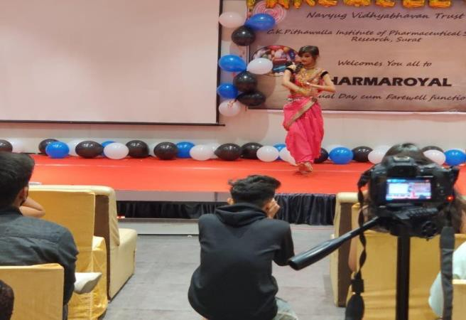 | 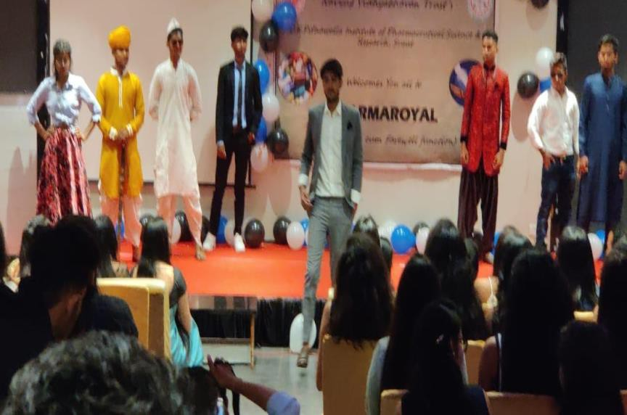
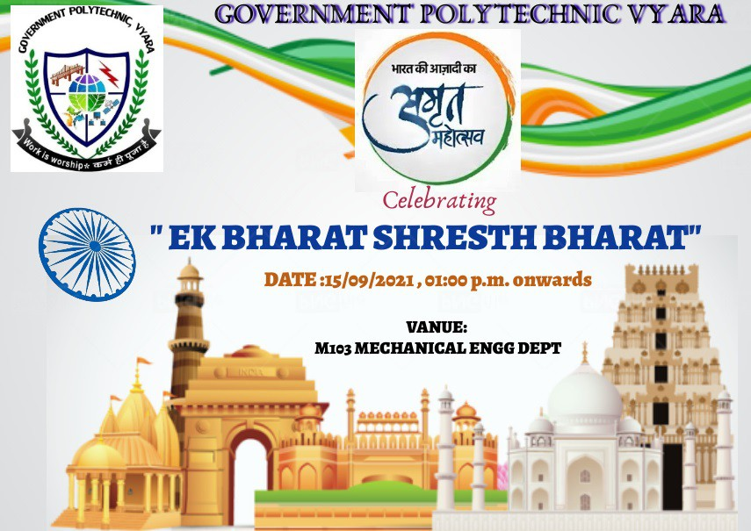 | 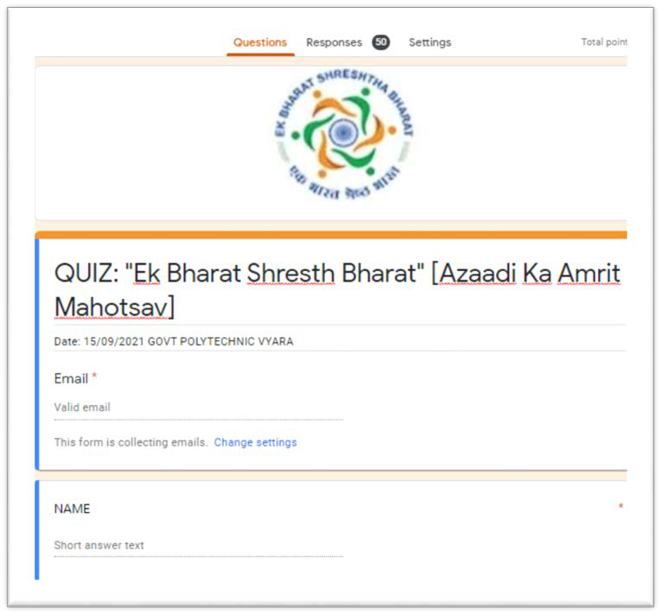

Report AKAM Cultural Event events
Particulars | Details
Name of Department/ Agency | Gujarat Technological University
Name of Ministry | Education
Name of event | Cultural Event
Start Date of event | 14/09/2021
End date of event | Till Date and Continue
Theme of event | Freedom Struggle  Ideas@75  Achievements@75  Actions@75  Resolve@75
Description of event (150 word limit) | Under “Cultural Event” GTU Affiliated 26 Colleges and 1400 Students/Staff/Faculty/Family members had participated in AzadiKaAmrut Mahotsav with Gujarat Technological University.Various Activities Like “Abhivyakti,DeshbhaktiSong,Mime,etc were organized by various Colleges.  “Kasumbi No Rang” Rashtriya Shayar Shri Zaverchand Meghaniji’s 125th Birth Anniversary was celebrated by Government Of Gujarat and Gujarat Technological University at Babasaheb Ambedkar University in which Chief Guest Hon.Deputy Chief Minister Shri Nitinbhai Patel Sir, Vice Chancellor Of GTU Shri Prof.(Dr). Navin Sheth Sir, Vice Chancellor Of BAOU Shri Amiben Upadhyayji,BOG of GTU Shri Amitbhai Thaker Sir,Registrar Sir GTU Dr.K.N.Kher and Ahmedabad Collector Shri Sandeepbhai Sangleji were remain presence in this Program. GTU Staff, Faculty, Students participated in “Kasumbi no Rang” Programme. More Than 500 People were joined in celebration of 125th Birth Anniversary Of Shri Zaverchand meghaniji.The Group of Singers sang Shri Zaverchand Meghaniji folk song and various other songs. All Dignitories were distributed Zaverchand Meghaniji’s Book to various Liabrary's Liabrian. The Proudawared Artists were Honoured by chief Guest and all dignitaries with book.
Nature of participation in event | Jan Bhagidari (open to public)  Only participation from within department/Ministry (no public)
Expected number of participants in event | 1400
VIP attendees (if any) | -----
Associate partners | State/UT #1: | ---
 | State/UT #2: | ---
 | State/UT #3: | ----
Mode of event | Online event (webinar, virtual event)  Offline event (in-person participation)  Hybrid event (mix of online and offline modes)
Moe of advertisement of event | Website  Social Media  Newspapers  Television media  Other mode
Nodal officer | Name: |  | Dr.S.K.Hadia
 | Designation: |  | Associate Professor
 | Email ID: |  | asso_s_k_hadia@gtu.edu.in
 | Phone number: |  | 9427062772

Event Photograph
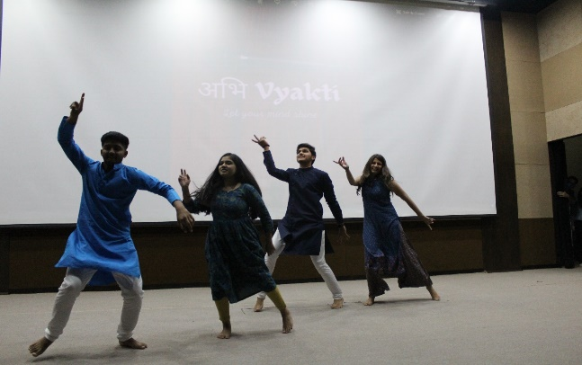 | 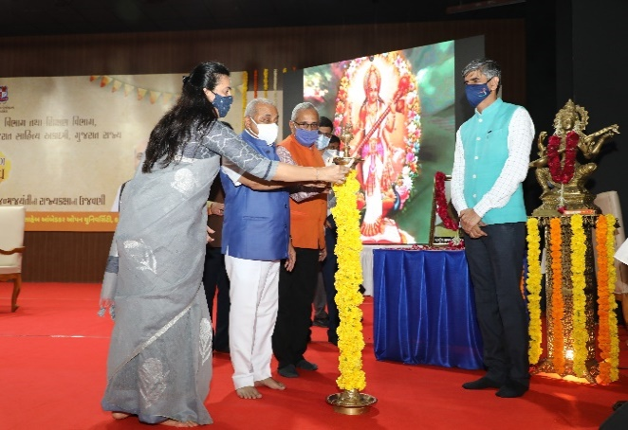
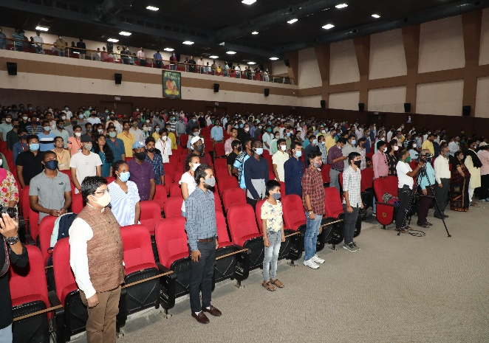 | 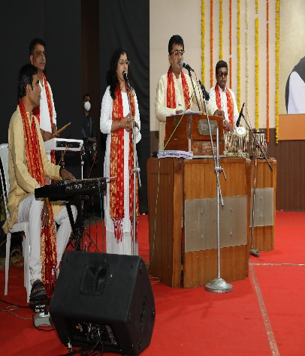

Report AKAM Swachh Bharat (SwachhtaPakhwada) events
Particulars | Details
Name of Department/ Agency | Gujarat Technological University
Name of Ministry | Education
Name of event | Swachh Bharat (SwachhtaPakhwada)
Start Date of event | 14/09/2021
End date of event | Till Date and Continue
Theme of event | Freedom Struggle  Ideas@75  Achievements@75  Actions@75  Resolve@75
Description of event (150 word limit) | SwachhtaAbhiyan was a moment started by Shri Narendra Modi and gave a mantra of “Na Gandagi Karenge, Na GandagiKarneDenge”. Under “Swachh Bharat” GTU Affiliated 34 Colleges and 2100 Students/Staff/Faculty/Family members had participated in AzadiKaAmrut Mahotsav with GujaratTechnologicalUniversity.Various Activities Like “SwachhataAbhiyan” etc were organized by various Colleges.
Nature of participation in event | Jan Bhagidari (open to public)  Only participation from within department/Ministry (no public)
Expected number of participants in event | 2100
VIP attendees (if any) | -----
Associate partners | State/UT #1: | ---
 | State/UT #2: | ---
 | State/UT #3: | ----
Mode of event | Online event (webinar, virtual event)  Offline event (in-person participation)  Hybrid event (mix of online and offline modes)
Moe of advertisement of event | Website  Social Media  Newspapers  Television media  Other mode
Nodal officer | Name: |  | Dr.S.K.Hadia
 | Designation: |  | Associate Professor
 | Email ID: |  | asso_s_k_hadia@gtu.edu.in
 | Phone number: |  | 9427062772

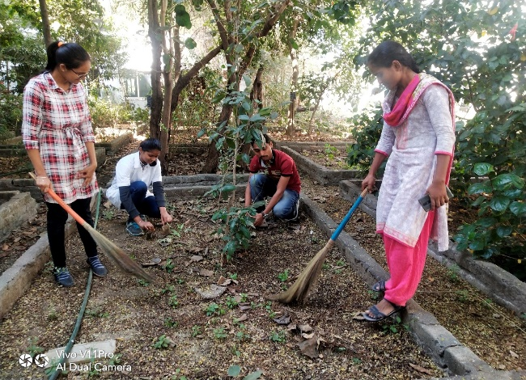 | 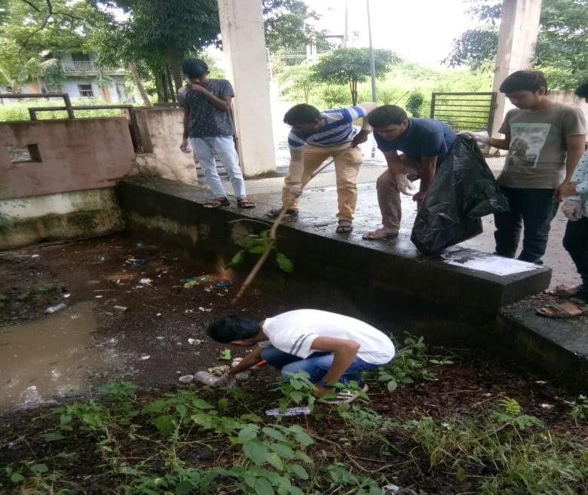  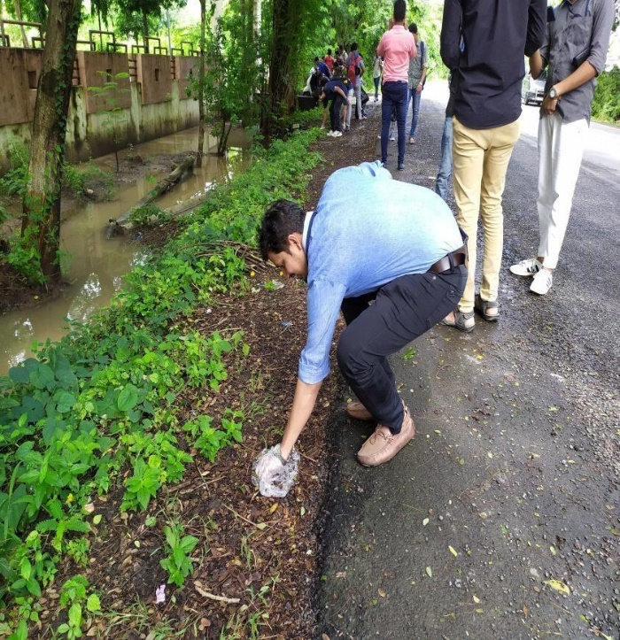
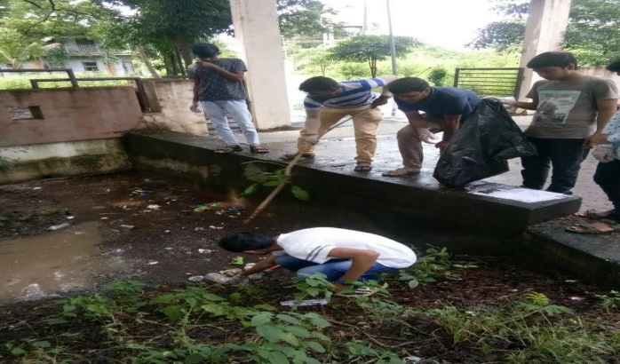 | 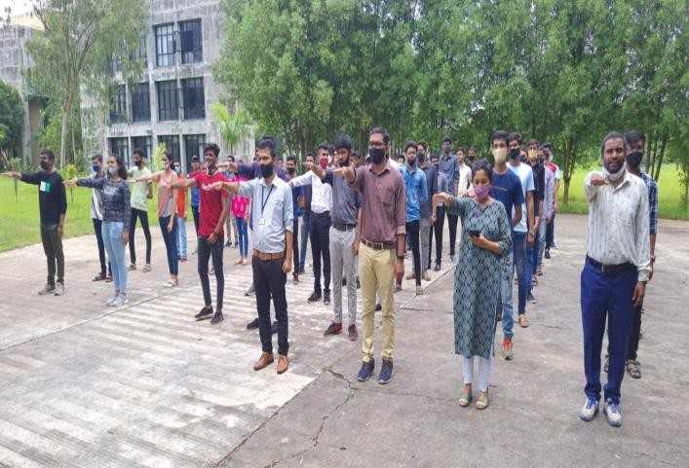
Event Photograph

Report AKAM Sadbhavna Day events
Particulars | Details
Name of Department/ Agency | Gujarat Technological University
Name of Ministry | Education
Name of event | Sadbhavna Day
Start Date of event | 14/09/2021
End date of event | Till Date and Continue
Theme of event | Freedom Struggle  Ideas@75  Achievements@75  Actions@75  Resolve@75
Description of event (150 word limit) | To mark the 75th Anniversary of India’s Independence, SadbhavanaDiwas or Harmony Day was observed at GTU Affiliated Institutes. Under “Sadbhavna Day” GTU Affiliated 11 Colleges and 727 Students/Staff/Faculty/Family members had participated in AzadiKaAmrut Mahotsav with Gujarat Technological University. Various Activities Like “Gau Mata Pujan and Various” etc were organized by various Colleges.
Nature of participation in event | Jan Bhagidari (open to public)  Only participation from within department/Ministry (no public)
Expected number of participants in event | 727
VIP attendees (if any) | -----
Associate partners | State/UT #1: | ---
 | State/UT #2: | ---
 | State/UT #3: | ----
Mode of event | Online event (webinar, virtual event)  Offline event (in-person participation)  Hybrid event (mix of online and offline modes)
Moe of advertisement of event | Website  Social Media  Newspapers  Television media  Other mode
Nodal officer | Name: |  | Dr.S.K.Hadia
 | Designation: |  | Associate Professor
 | Email ID: |  | asso_s_k_hadia@gtu.edu.in
 | Phone number: |  | 9427062772

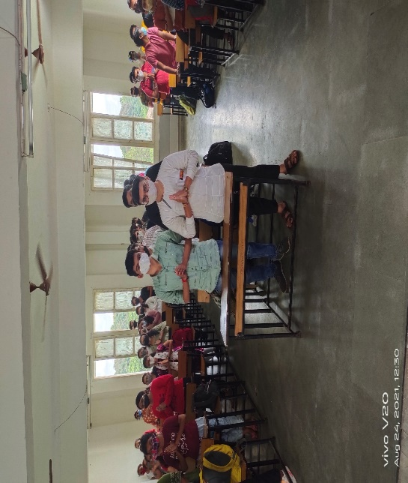 | 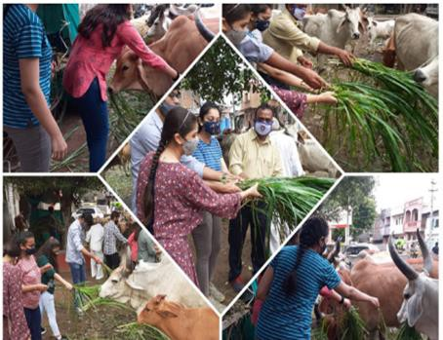  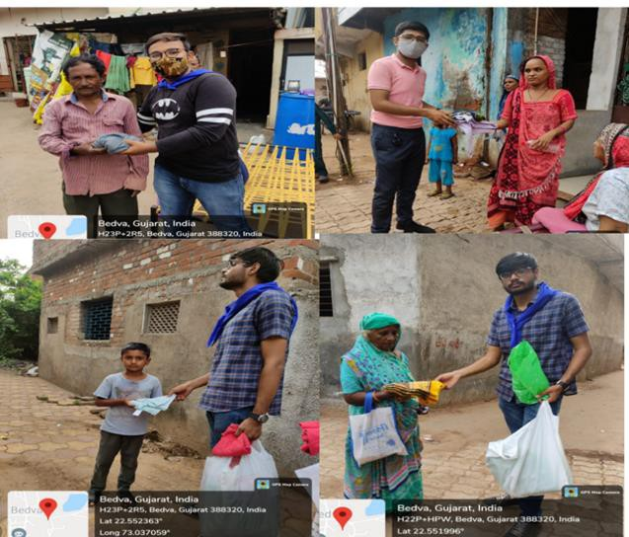
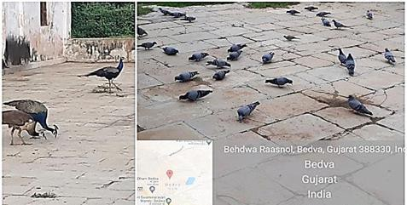
Event Photograph

Report AKAM Speech/Debate Competition events
Particulars | Details
Name of Department/ Agency | Gujarat Technological University
Name of Ministry | Education
Name of event | Speech/Debate Competition
Start Date of event | 14/09/2021
End date of event | Till Date and Continue
Theme of event | Freedom Struggle  Ideas@75  Achievements@75  Actions@75  Resolve@75
Description of event (150 word limit) | Speech Competition On Freedom Fighter Celebrated in GTU Affiliated Institutes. Under “Speech Compitition” GTU Affiliated 34 Colleges and 674 Students/Staff/Faculty/Family members had participated in AzadiKaAmrut Mahotsav with Gujarat Technological University. Various Activities Like on Different Subject were organized by various Colleges.
Nature of participation in event | Jan Bhagidari (open to public)  Only participation from within department/Ministry (no public)
Expected number of participants in event | 674
VIP attendees (if any) | -----
Associate partners | State/UT #1: | ---
 | State/UT #2: | ---
 | State/UT #3: | ----
Mode of event | Online event (webinar, virtual event)  Offline event (in-person participation)  Hybrid event (mix of online and offline modes)
Moe of advertisement of event | Website  Social Media  Newspapers  Television media  Other mode
Nodal officer | Name: |  | Dr.S.K.Hadia
 | Designation: |  | Associate Professor
 | Email ID: |  | asso_s_k_hadia@gtu.edu.in
 | Phone number: |  | 9427062772

Event Photograph
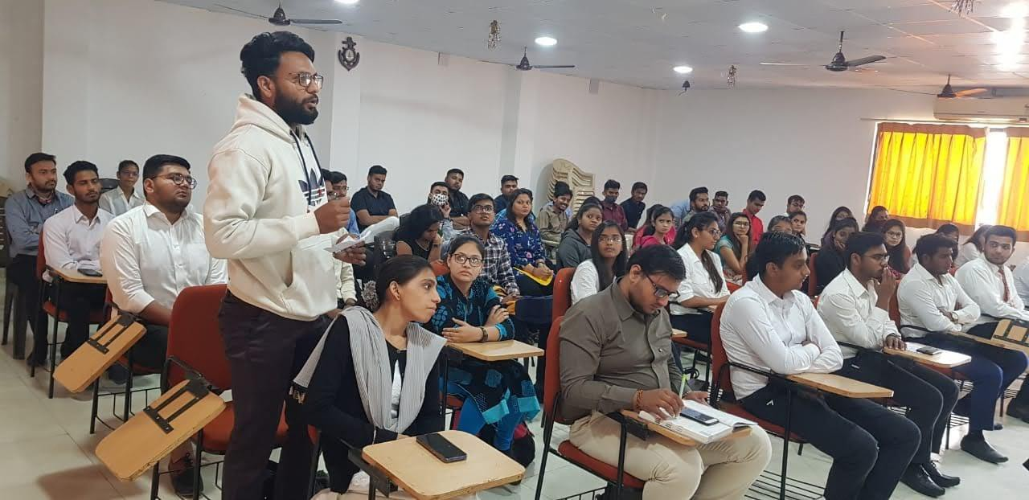 | 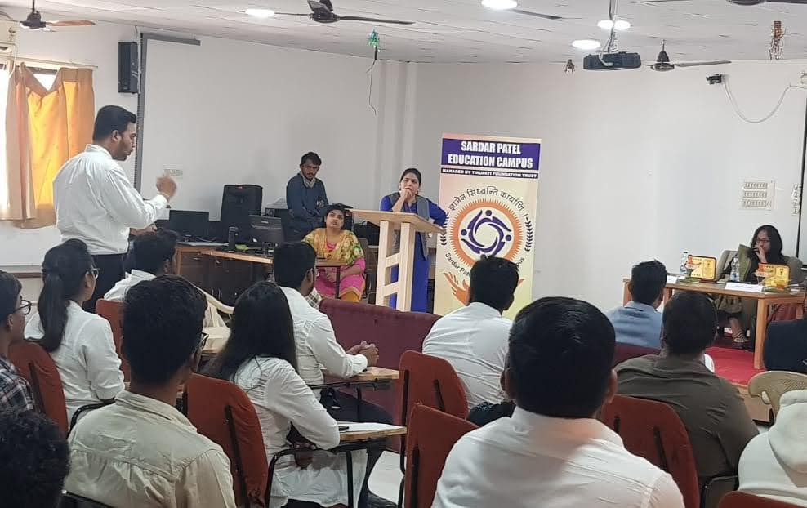
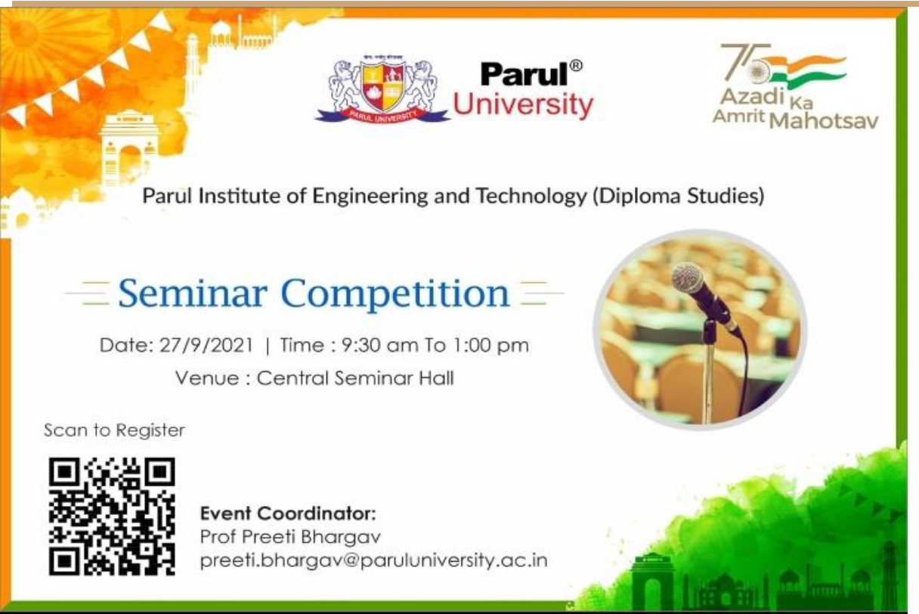 | 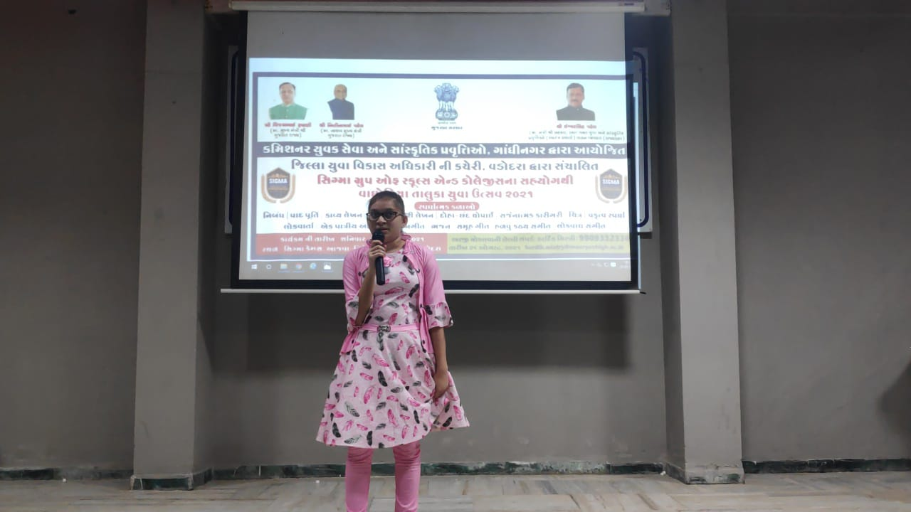

Report AKAM Green Village Clean Village events
Particulars | Details
Name of Department/ Agency | Gujarat Technological University
Name of Ministry | Education
Name of event | Green Village Clean Village
Start Date of event | 14/09/2021
End date of event | Till Date and Continue
Theme of event | Freedom Struggle  Ideas@75  Achievements@75  Actions@75  Resolve@75
Description of event (150 word limit) | GTU Affilated 23 Colleges has organized a camp in the adopted village under “AzadiKaAmrutMahotsav”.More than 829 Students/Faculty/Staff Participated in “Green Village Clean Village.”
Nature of participation in event | Jan Bhagidari (open to public)  Only participation from within department/Ministry (no public)
Expected number of participants in event | 829
VIP attendees (if any) | -----
Associate partners | State/UT #1: | ---
 | State/UT #2: | ---
 | State/UT #3: | ----
Mode of event | Online event (webinar, virtual event)  Offline event (in-person participation)  Hybrid event (mix of online and offline modes)
Moe of advertisement of event | Website  Social Media  Newspapers  Television media  Other mode
Nodal officer | Name: |  | Dr.S.K.Hadia
 | Designation: |  | Associate Professor
 | Email ID: |  | asso_s_k_hadia@gtu.edu.in
 | Phone number: |  | 9427062772

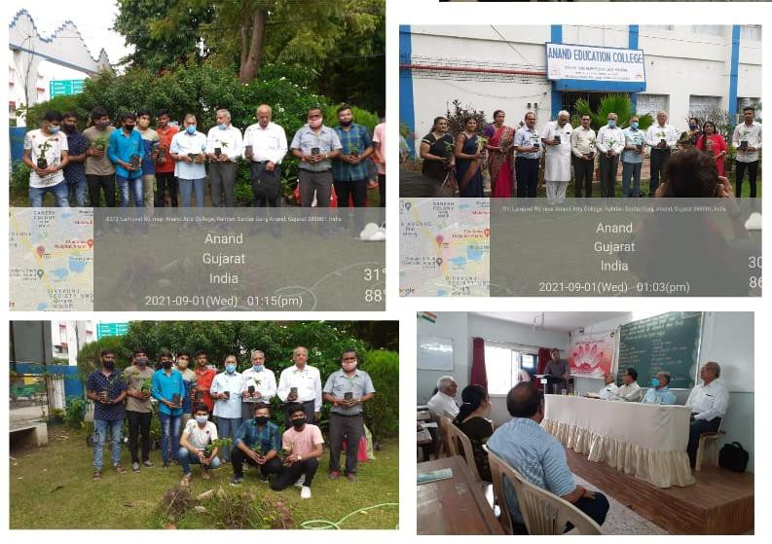
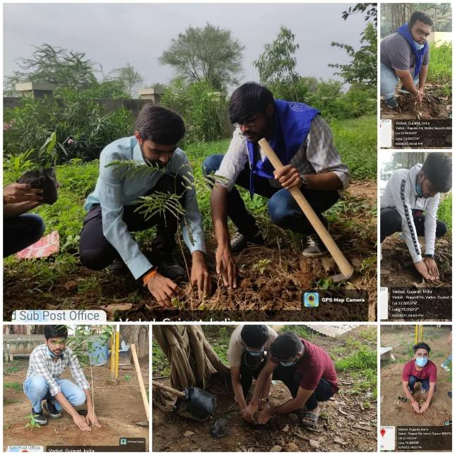
Event Photograph

Report AKAM Blood Donation Camp events
Particulars | Details
Name of Department/ Agency | Gujarat Technological University
Name of Ministry | Education
Name of event | Blood Donation Camp
Start Date of event | 14/09/2021
End date of event | Till Date and Continue
Theme of event | Freedom Struggle  Ideas@75  Achievements@75  Actions@75  Resolve@75
Description of event (150 word limit) | GTU Affiliated 14 Colleges organized a Blood Donation Camp in their Institute under “Azadi Ka Amrut Mahotsav”.More Than 750 Students/Faculty/Staff and Family members donate blood and fulfil their social responsibility.  GTU &SMS Hospital jointly Organized Blood Donation Camp On the Occasion of 71st Birth Anniversary of Our Hon’Ble Prime Minister Shri Narendrabhai Modi .GTU has Organized Blood Donation Camp in B-0 Hall GTU Chandkheda Campus. Large No Of Students, Staff and Family members were participated in Blood Donation Camp. This Event had organized by ​Dept. Of Sports, Youth Affairs & Cultural Activities
Nature of participation in event | Jan Bhagidari (open to public)  Only participation from within department/Ministry (no public)
Expected number of participants in event | 750
VIP attendees (if any) | -----
Associate partners | State/UT #1: | ---
 | State/UT #2: | ---
 | State/UT #3: | ----
Mode of event | Online event (webinar, virtual event)  Offline event (in-person participation)  Hybrid event (mix of online and offline modes)
Moe of advertisement of event | Website  Social Media  Newspapers  Television media  Other mode
Nodal officer | Name: |  | Dr.S.K.Hadia
 | Designation: |  | Associate Professor
 | Email ID: |  | asso_s_k_hadia@gtu.edu.in
 | Phone number: |  | 9427062772

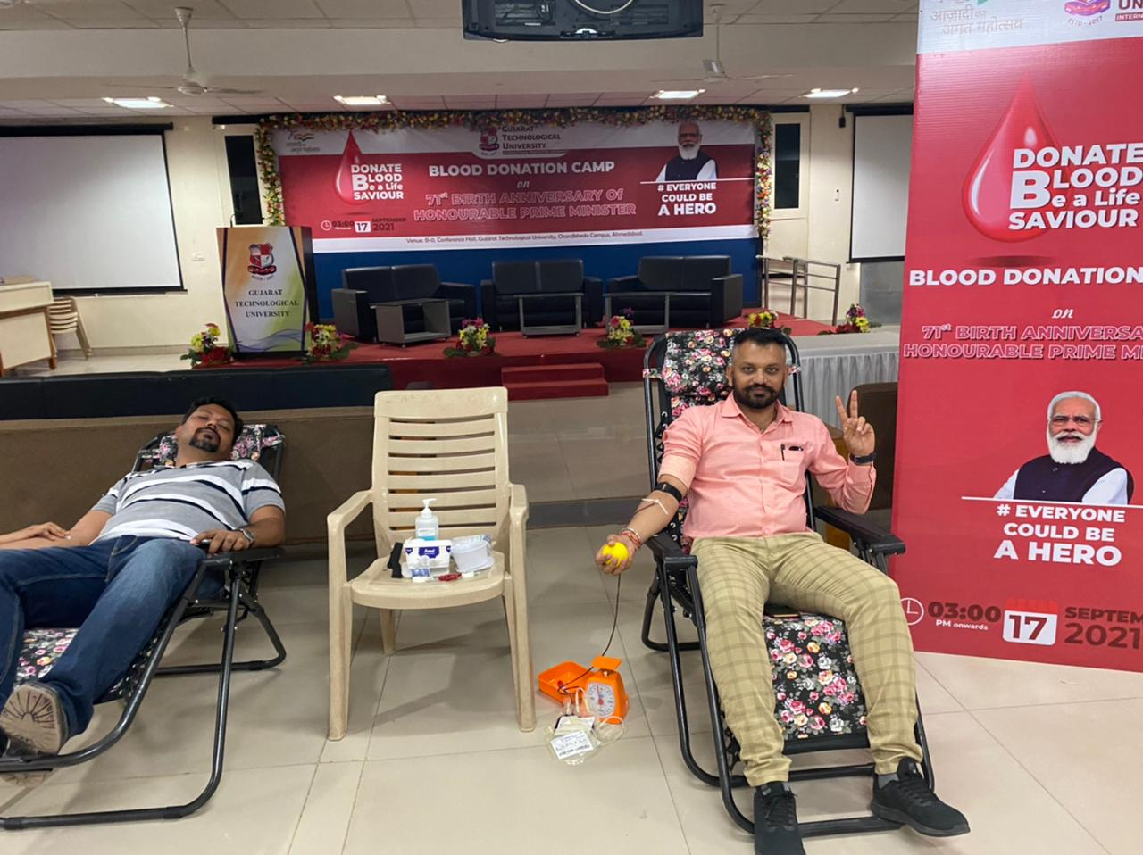 | 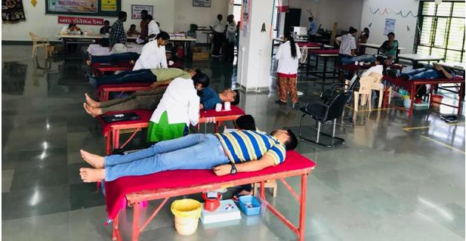
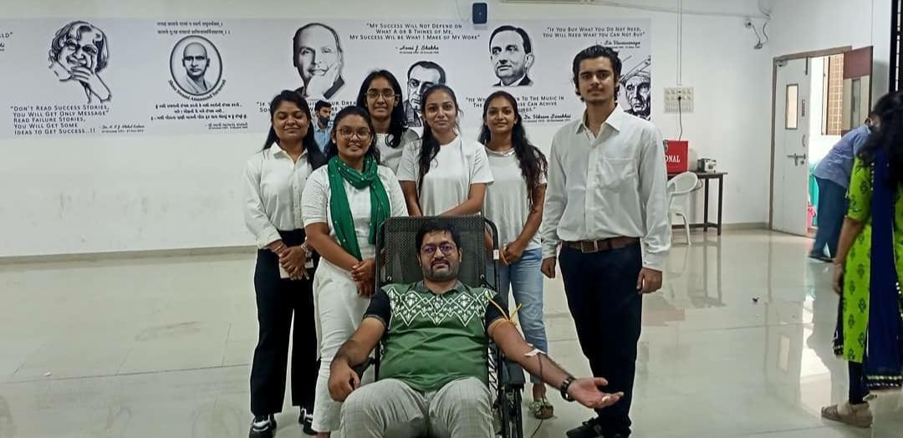 | 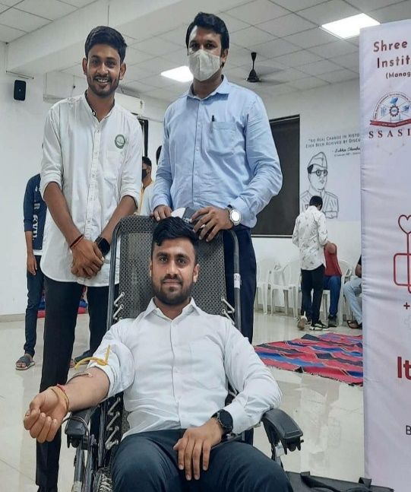

Report AKAM Painting Competition events
Particulars | Details
Name of Department/ Agency | Gujarat Technological University
Name of Ministry | Education
Name of event | Painting Competition
Start Date of event | 14/09/2021
End date of event | Till Date and Continue
Theme of event | Freedom Struggle  Ideas@75  Achievements@75  Actions@75  Resolve@75
Description of event (150 word limit) | GTU Affilated Colleges organized a Painting Competition in their Institute under “AzadiKaAmrutMahotsav”.More Than 65 Students Participated in Painting Competition.The Theme on Painting Competition is freedom.
Nature of participation in event | Jan Bhagidari (open to public)  Only participation from within department/Ministry (no public)
Expected number of participants in event | 65
VIP attendees (if any) | -----
Associate partners | State/UT #1: | ---
 | State/UT #2: | ---
 | State/UT #3: | ----
Mode of event | Online event (webinar, virtual event)  Offline event (in-person participation)  Hybrid event (mix of online and offline modes)
Moe of advertisement of event | Website  Social Media  Newspapers  Television media  Other mode
Nodal officer | Name: |  | Dr.S.K.Hadia
 | Designation: |  | Associate Professor
 | Email ID: |  | asso_s_k_hadia@gtu.edu.in
 | Phone number: |  | 9427062772

Event Photograph
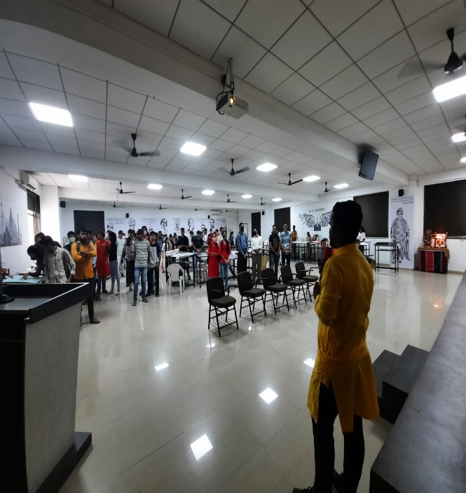 | 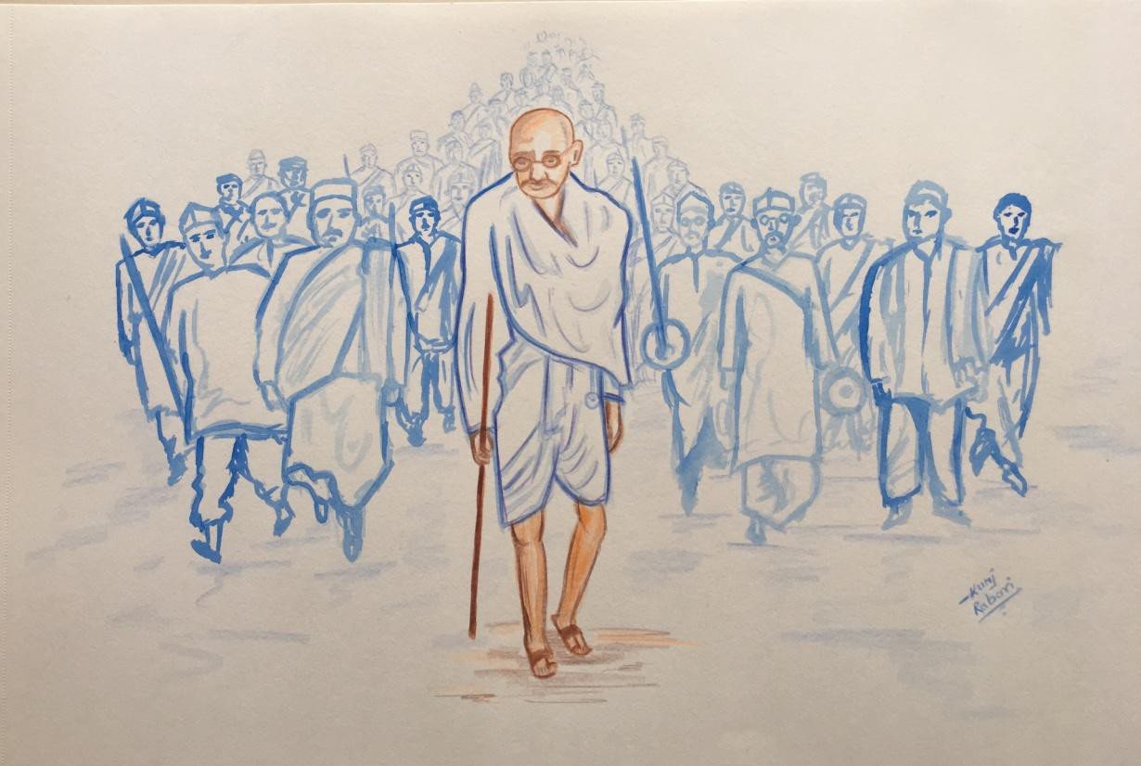
 | 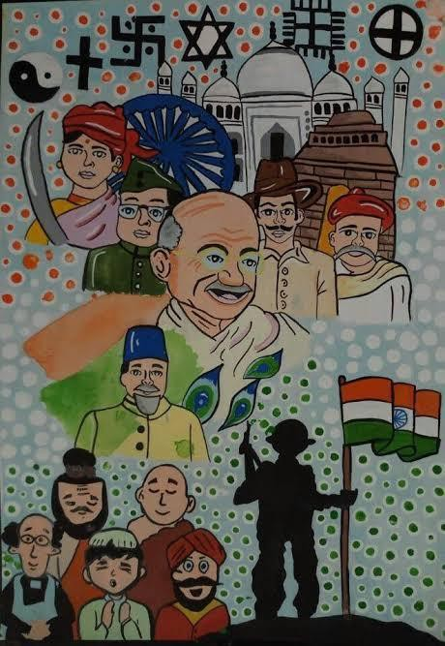

Report AKAM Poster Making Competition events
Particulars | Details
Name of Department/ Agency | Gujarat Technological University
Name of Ministry | Education
Name of event | Poster Making Competition
Start Date of event | 14/09/2021
End date of event | Till Date and Continue
Theme of event | Freedom Struggle  Ideas@75  Achievements@75  Actions@75  Resolve@75
Description of event (150 word limit) | GTU Affiliated 29 colleges Organized Poster Making Competition in their Institute. Poster competition of Freedom Fighters who have made significant contribution to the independence of India. More than 393 students participate in poster making competition.
Nature of participation in event | Jan Bhagidari (open to public)  Only participation from within department/Ministry (no public)
Expected number of participants in event | 393
VIP attendees (if any) | -----
Associate partners | State/UT #1: | ---
 | State/UT #2: | ---
 | State/UT #3: | ----
Mode of event | Online event (webinar, virtual event)  Offline event (in-person participation)  Hybrid event (mix of online and offline modes)
Moe of advertisement of event | Website  Social Media  Newspapers  Television media  Other mode
Nodal officer | Name: |  | Dr.S.K.Hadia
 | Designation: |  | Associate Professor
 | Email ID: |  | asso_s_k_hadia@gtu.edu.in
 | Phone number: |  | 9427062772

Event Photograph
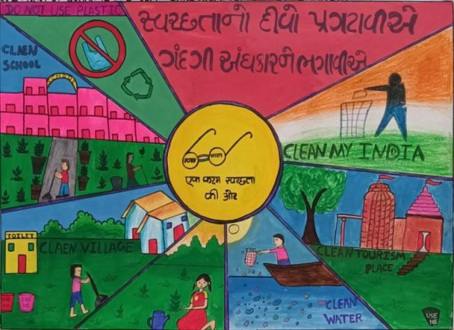 | 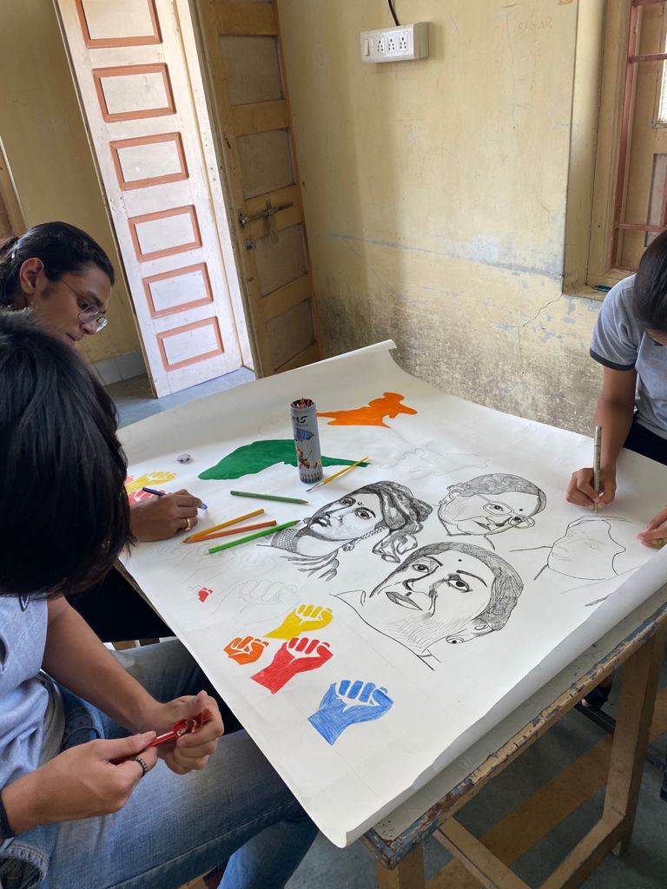
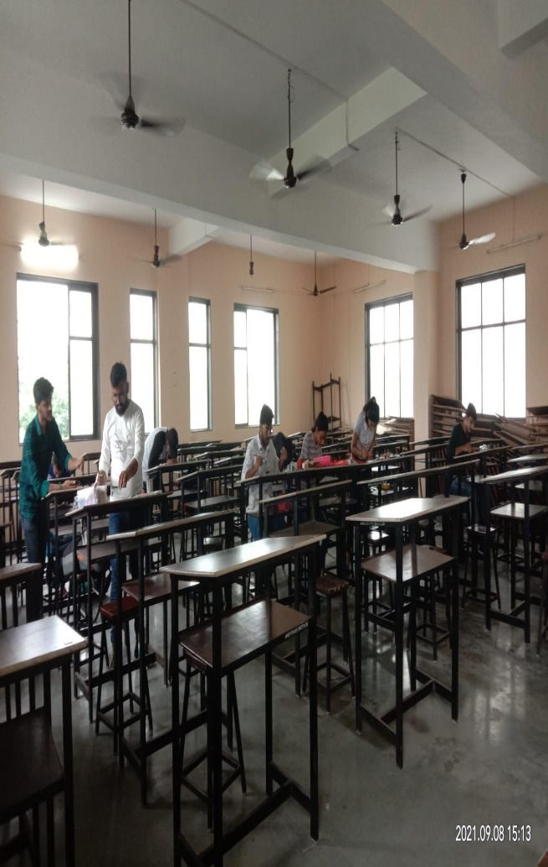 | 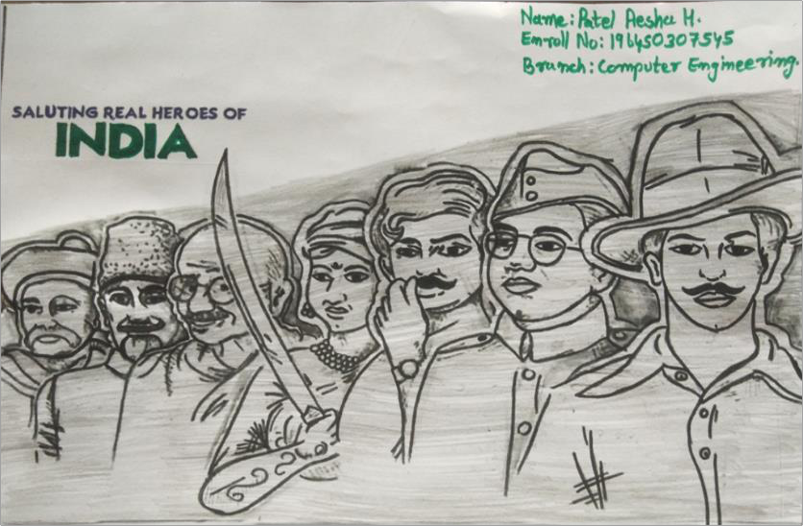

Report AKAM Special Day events
Particulars | Details
Name of Department/ Agency | Gujarat Technological University
Name of Ministry | Education
Name of event | Special day
Start Date of event | 14/09/2021
End date of event | Till Date and Continue
Theme of event | Freedom Struggle  Ideas@75  Achievements@75  Actions@75  Resolve@75
Description of event (150 word limit) | GTU Affiliated 25 colleges Organized Special Day Under “Azadi ka Amrit Mahotsav”Various colleges doing Activity like Poster Exhibition,Reels making competition,Quiz ,competition,Teachers day,Engineers day were celebrated.More Than 1893 Students/Faculty/Staff were Participate in Special Day.
Nature of participation in event | Jan Bhagidari (open to public)  Only participation from within department/Ministry (no public)
Expected number of participants in event | 1893
VIP attendees (if any) | -----
Associate partners | State/UT #1: | ---
 | State/UT #2: | ---
 | State/UT #3: | ----
Mode of event | Online event (webinar, virtual event)  Offline event (in-person participation)  Hybrid event (mix of online and offline modes)
Moe of advertisement of event | Website  Social Media  Newspapers  Television media  Other mode
Nodal officer | Name: |  | Dr.S.K.Hadia
 | Designation: |  | Associate Professor
 | Email ID: |  | asso_s_k_hadia@gtu.edu.in
 | Phone number: |  | 9427062772

Event Photograph
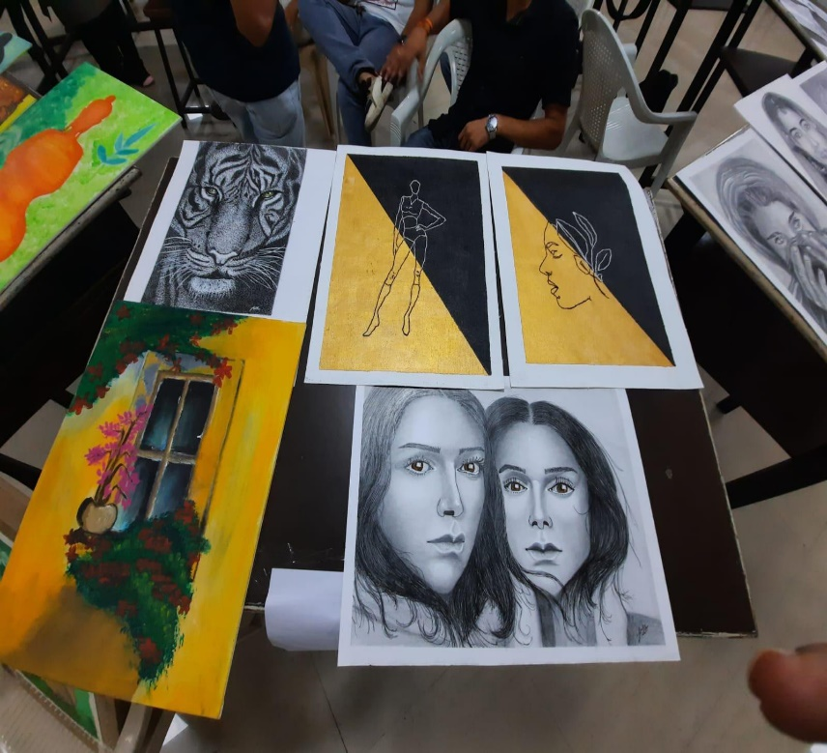 | 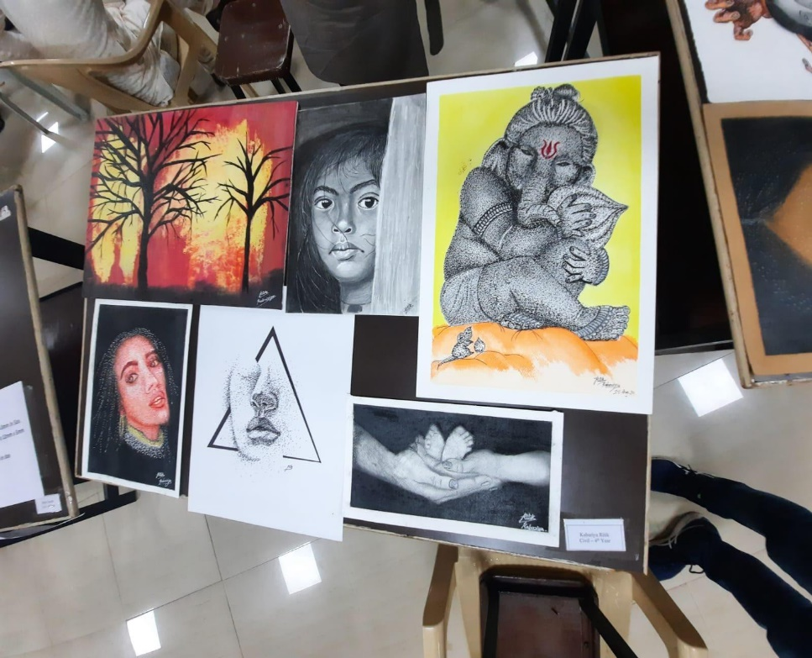
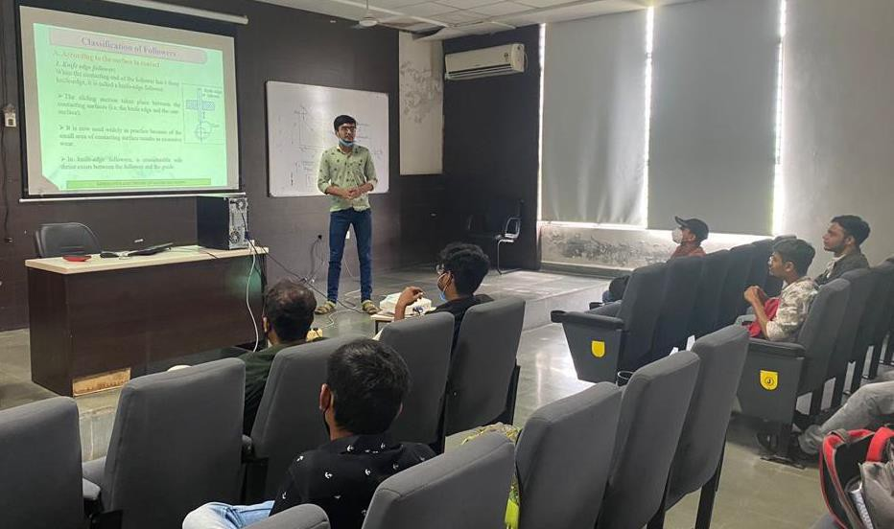 | 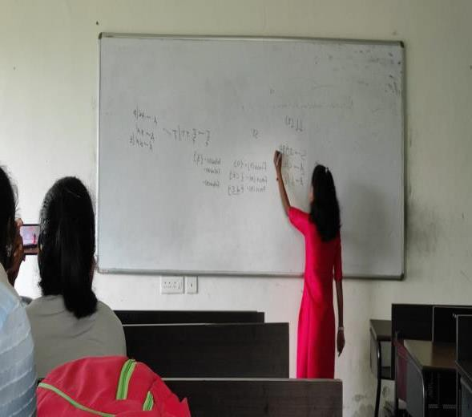

Report AKAM GIF Creativity Competition events
Particulars | Details
Name of Department/ Agency | Gujarat Technological University
Name of Ministry | Education
Name of event | GIF Creativity Competition
Start Date of event | 14/09/2021
End date of event | Till Date and Continue
Theme of event | Freedom Struggle  Ideas@75  Achievements@75  Actions@75  Resolve@75
Description of event (150 word limit) | GTU Affiliated 22 colleges Organized Special Day Under “Azadi ka Amrit Mahotsav.More than 360 Students participated in GIF Creativity Competition. Gif Creativity Competition was organized for students on topics: “75th independence day gif. All the students enthusiastically participated in that competition to make it a successful event.
Nature of participation in event | Jan Bhagidari (open to public)  Only participation from within department/Ministry (no public)
Expected number of participants in event | 360
VIP attendees (if any) | -----
Associate partners | State/UT #1: | ---
 | State/UT #2: | ---
 | State/UT #3: | ----
Mode of event | Online event (webinar, virtual event)  Offline event (in-person participation)  Hybrid event (mix of online and offline modes)
Moe of advertisement of event | Website  Social Media  Newspapers  Television media  Other mode
Nodal officer | Name: |  | Dr.S.K.Hadia
 | Designation: |  | Associate Professor
 | Email ID: |  | asso_s_k_hadia@gtu.edu.in
 | Phone number: |  | 9427062772

Event Photograph
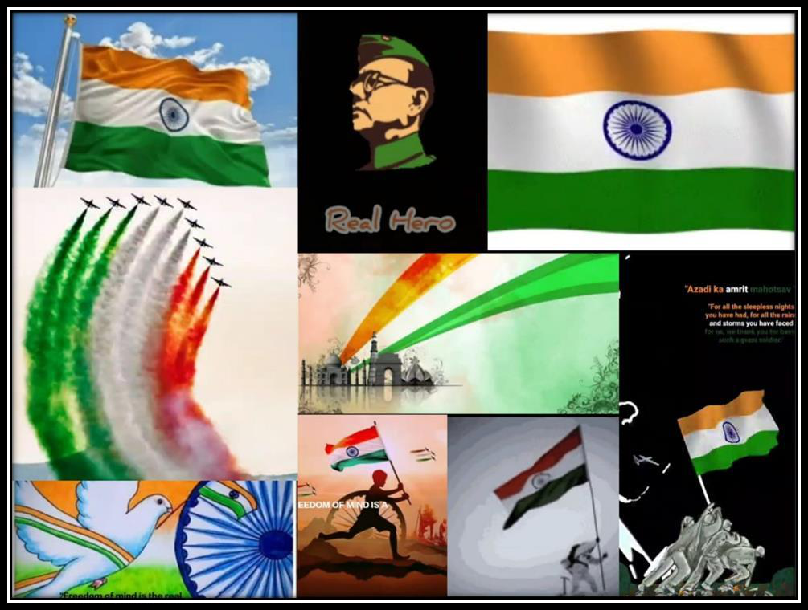

Report AKAM Slogan Competition events

Particulars | Details
Name of Department/ Agency | Gujarat Technological University
Name of Ministry | Education
Name of event | Slogan Competition
Start Date of event | 14/09/2021
End date of event | Till Date and Continue
Theme of event | Freedom Struggle  Ideas@75  Achievements@75  Actions@75  Resolve@75
Description of event (150 word limit) | GTU Affiliated 26 colleges Organized Slogan Competition Under “Azadi ka Amrit Mahotsav.More than 477 Students participated in Slogan Competition.Slogan Competition was organized for students on topics: “75th independence day Slogan. All the students enthusiastically participated in that competition to make it a successful event.
Nature of participation in event | Jan Bhagidari (open to public)  Only participation from within department/Ministry (no public)
Expected number of participants in event | 477
VIP attendees (if any) | -----
Associate partners | State/UT #1: | ---
 | State/UT #2: | ---
 | State/UT #3: | ----
Mode of event | Online event (webinar, virtual event)  Offline event (in-person participation)  Hybrid event (mix of online and offline modes)
Moe of advertisement of event | Website  Social Media  Newspapers  Television media  Other mode
Nodal officer | Name: |  | Dr.S.K.Hadia
 | Designation: |  | Associate Professor
 | Email ID: |  | asso_s_k_hadia@gtu.edu.in
 | Phone number: |  | 9427062772

Event Photograph
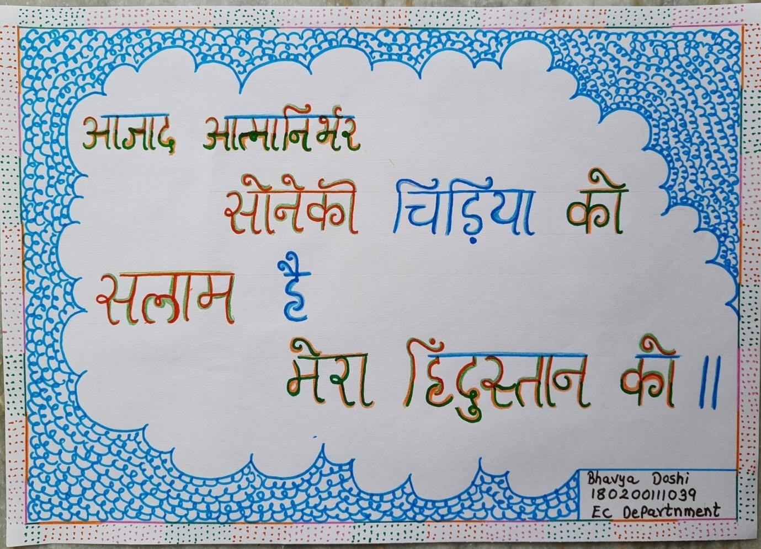 | 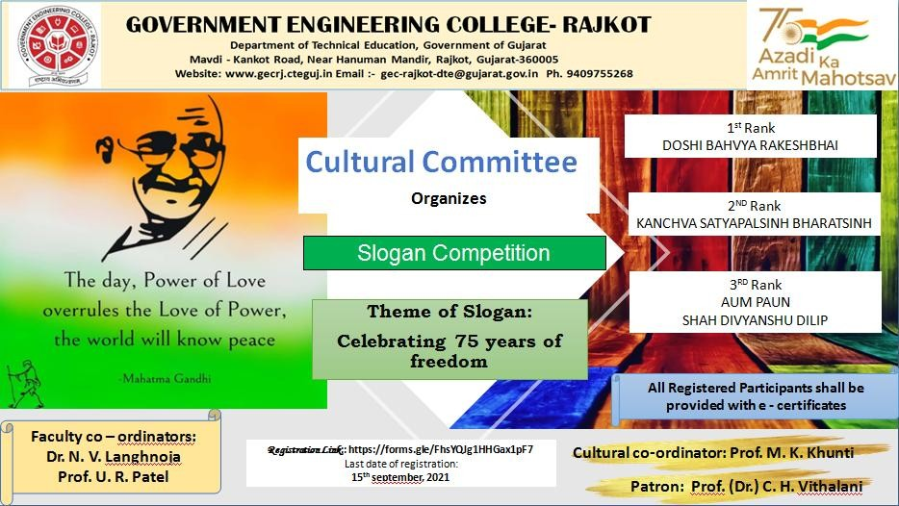
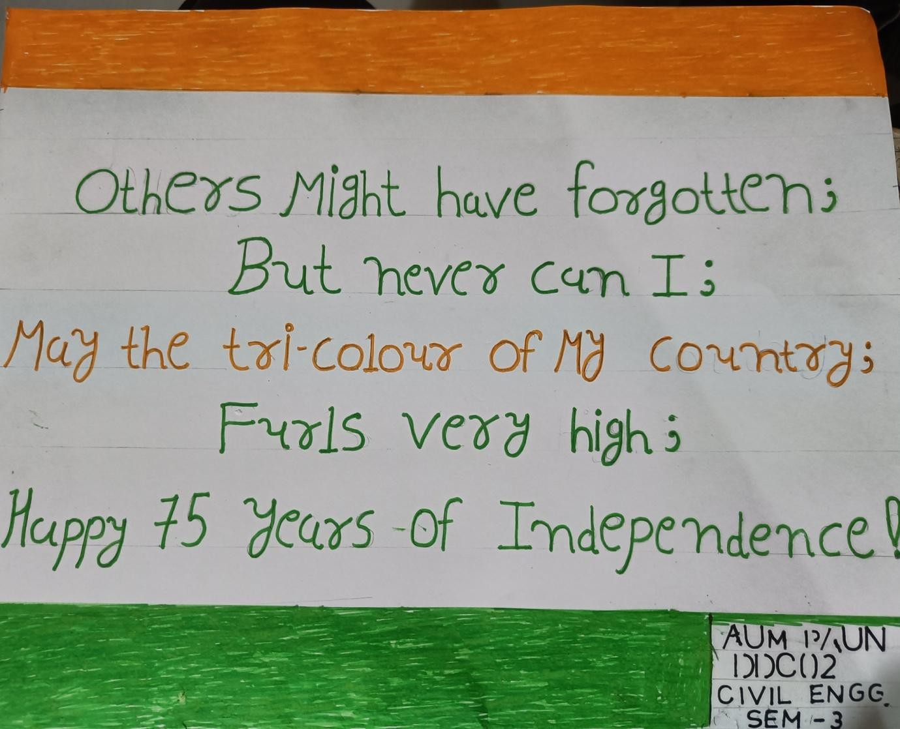 | 